Barry G. Johnson, Sr. / www.BarrysBureau.com
Wrestling with God / Conflict; Fear; Suffering; Past; Present; Future; Steadfast; Wrestle / Genesis 32:22–28
Jacob like us need to struggle with the proper mindset and goals facing our fears in faith to make heaven our home.
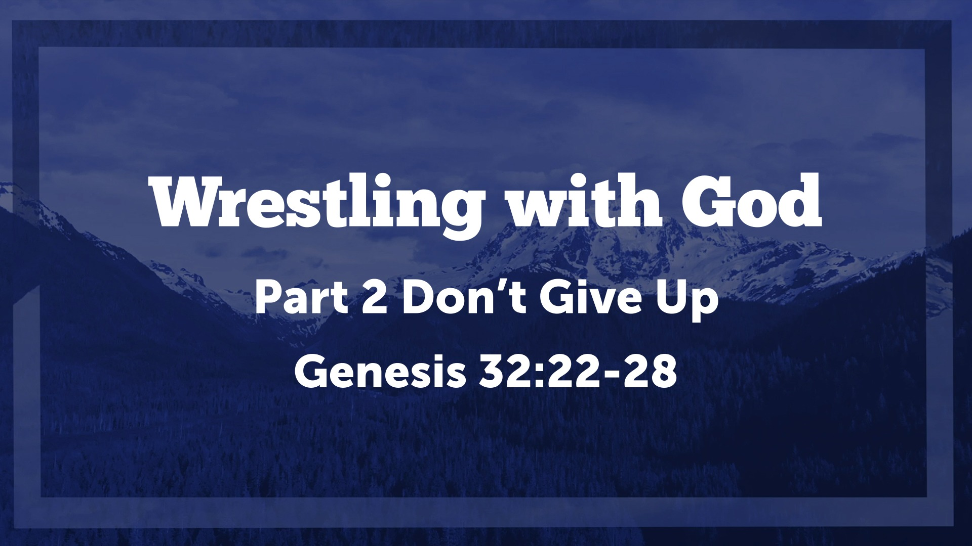
Genesis 32:22–28 ESV
²² The same night he arose and took his two wives, his two female servants, and his eleven children, and crossed the ford of the Jabbok. ²³ He took them and sent them across the stream, and everything else that he had. ²⁴ And Jacob was left alone. And a man wrestled with him until the breaking of the day. ²⁵ When the man saw that he did not prevail against Jacob, he touched his hip socket, and Jacob’s hip was put out of joint as he wrestled with him. ²⁶ Then he said, “Let me go, for the day has broken.” But Jacob said, “I will not let you go unless you bless me.” ²⁷ And he said to him, “What is your name?” And he said, “Jacob.” ²⁸ Then he said, “Your name shall no longer be called Jacob, but Israel, for you have striven with God and with men, and have prevailed.”

I. The Struggle - What’s your mindset?
Genesis 32:1–2 ESV
¹ Jacob went on his way, and the angels of God met him. ² And when Jacob saw them he said, “This is God’s camp!” So he called the name of that place Mahanaim.
Genesis 32:9–12 ESV
⁹ And Jacob said, “O God of my father Abraham and God of my father Isaac, O Lord who said to me, ‘Return to your country and to your kindred, that I may do you good,’ ¹⁰ I am not worthy of the least of all the deeds of steadfast love and all the faithfulness that you have shown to your servant, for with only my staff I crossed this Jordan, and now I have become two camps. ¹¹ Please deliver me from the hand of my brother, from the hand of Esau, for I fear him, that he may come and attack me, the mothers with the children. ¹² But you said, ‘I will surely do you good, and make your offspring as the sand of the sea, which cannot be numbered for multitude.’ ”
1 Chronicles 22:19 ESV
¹⁹ Now set your mind and heart to seek the Lord your God. Arise and build the sanctuary of the Lord God, so that the ark of the covenant of the Lord and the holy vessels of God may be brought into a house built for the name of the Lord.”
Colossians 3:2 ESV
² Set your minds on things that are above, not on things that are on earth.

II. The Struggle - What’s the Goal?
Philippians 3:17–21 ESV
¹⁷ Brothers, join in imitating me, and keep your eyes on those who walk according to the example you have in us. ¹⁸ For many, of whom I have often told you and now tell you even with tears, walk as enemies of the cross of Christ. ¹⁹ Their end is destruction, their god is their belly, and they glory in their shame, with minds set on earthly things. ²⁰ But our citizenship is in heaven, and from it we await a Savior, the Lord Jesus Christ, ²¹ who will transform our lowly body to be like his glorious body, by the power that enables him even to subject all things to himself.
1 Timothy 1:5 ESV
⁵ The aim of our charge is love that issues from a pure heart and a good conscience and a sincere faith.
Ephesians 3:14–19 ESV
¹⁴ For this reason I bow my knees before the Father, ¹⁵ from whom every family in heaven and on earth is named, ¹⁶ that according to the riches of his glory he may grant you to be strengthened with power through his Spirit in your inner being, ¹⁷ so that Christ may dwell in your hearts through faith—that you, being rooted and grounded in love, ¹⁸ may have strength to comprehend with all the saints what is the breadth and length and height and depth, ¹⁹ and to know the love of Christ that surpasses knowledge, that you may be filled with all the fullness of God.

III. The Struggle - What has changed?
Genesis 33:1–3 ESV
¹ And Jacob lifted up his eyes and looked, and behold, Esau was coming, and four hundred men with him. So he divided the children among Leah and Rachel and the two female servants. ² And he put the servants with their children in front, then Leah with her children, and Rachel and Joseph last of all. ³ He himself went on before them, bowing himself to the ground seven times, until he came near to his brother.
Genesis 33:4–9 ESV
⁴ But Esau ran to meet him and embraced him and fell on his neck and kissed him, and they wept. ⁵ And when Esau lifted up his eyes and saw the women and children, he said, “Who are these with you?” Jacob said, “The children whom God has graciously given your servant.” ⁶ Then the servants drew near, they and their children, and bowed down. ⁷ Leah likewise and her children drew near and bowed down. And last Joseph and Rachel drew near, and they bowed down. ⁸ Esau said, “What do you mean by all this company that I met?” Jacob answered, “To find favor in the sight of my lord.” ⁹ But Esau said, “I have enough, my brother; keep what you have for yourself.”
Hebrews 10:23 ESV
²³ Let us hold fast the confession of our hope without wavering, for he who promised is faithful.

