Barry G. Johnson, Sr. / www.barrysbureau.com
Fear; Suffering / Genesis 32:22–28
Central Idea: Jacob, just like the child of God, must face the past, struggle in the present to avoid a future of fear.
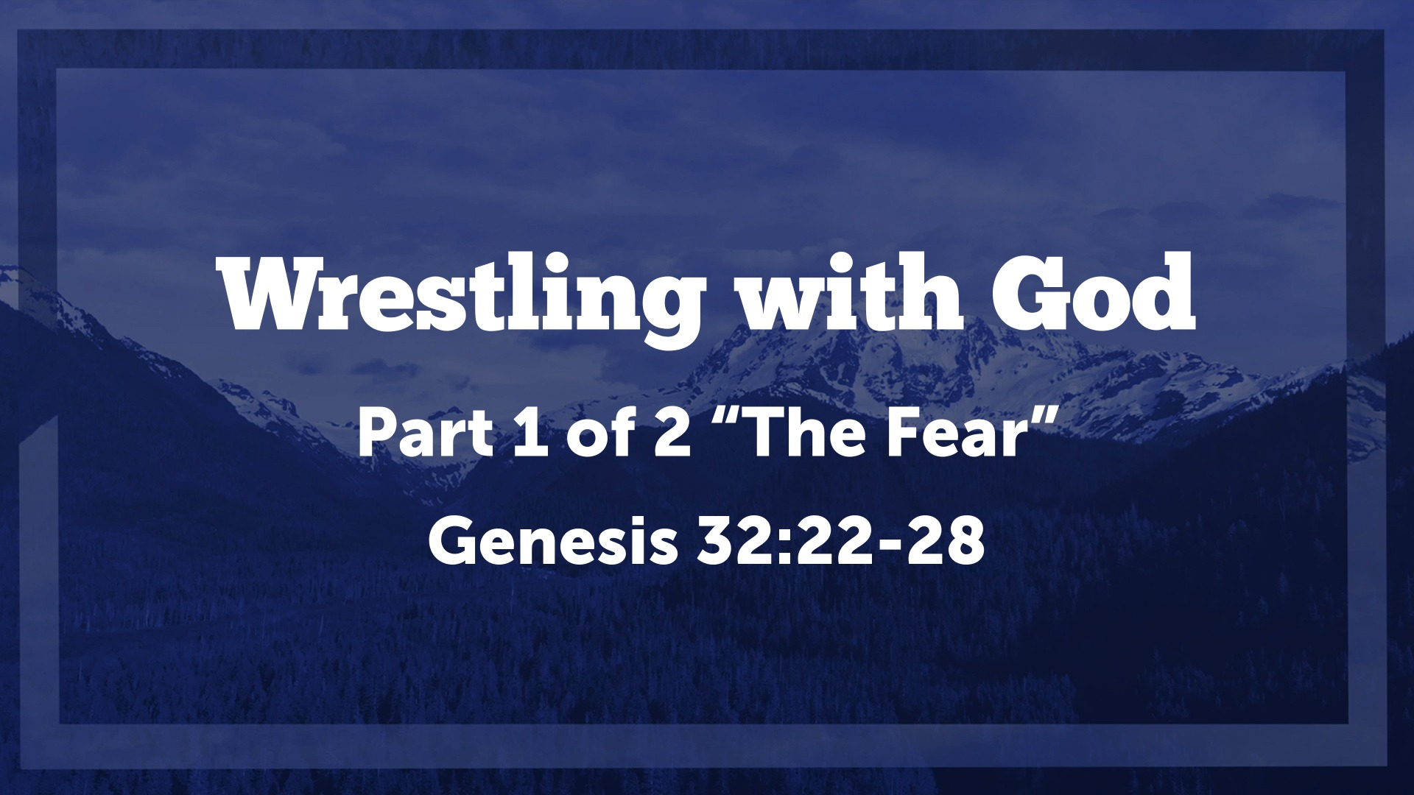
Genesis 32:22–28 ESV
²² The same night he arose and took his two wives, his two female servants, and his eleven children, and crossed the ford of the Jabbok. ²³ He took them and sent them across the stream, and everything else that he had. ²⁴ And Jacob was left alone. And a man wrestled with him until the breaking of the day. ²⁵ When the man saw that he did not prevail against Jacob, he touched his hip socket, and Jacob’s hip was put out of joint as he wrestled with him. ²⁶ Then he said, “Let me go, for the day has broken.” But Jacob said, “I will not let you go unless you bless me.” ²⁷ And he said to him, “What is your name?” And he said, “Jacob.” ²⁸ Then he said, “Your name shall no longer be called Jacob, but Israel, for you have striven with God and with men, and have prevailed.”

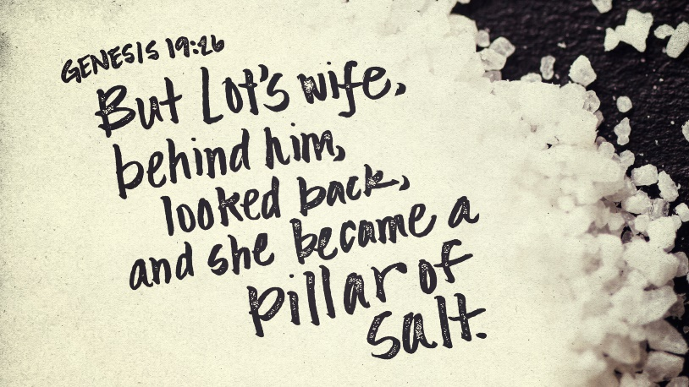
I. The Past
Figure 1Don't look back at the past as to affect the future
Isaiah 43:18–19 ESV
¹⁸ “Remember not the former things,
nor consider the things of old.
¹⁹ Behold, I am doing a new thing;
now it springs forth, do you not perceive it?
I will make a way in the wilderness
and rivers in the desert.
Philippians 3:13–14 ESV
¹³ Brothers, I do not consider that I have made it my own. But one thing I do: forgetting what lies behind and straining forward to what lies ahead, ¹⁴ I press on toward the goal for the prize of the upward call of God in Christ Jesus.
2 Corinthians 12:9–10 ESV
⁹ But he said to me, “My grace is sufficient for you, for my power is made perfect in weakness.” Therefore I will boast all the more gladly of my weaknesses, so that the power of Christ may rest upon me. ¹⁰ For the sake of Christ, then, I am content with weaknesses, insults, hardships, persecutions, and calamities. For when I am weak, then I am strong.
Hosea 12:3–4 ESV
³ In the womb he took his brother by the heel,
and in his manhood he strove with God.
⁴ He strove with the angel and prevailed;
he wept and sought his favor.
He met God at Bethel,
and there God spoke with us—

II. The Present
Matthew 6:34 ESV
³⁴ “Therefore do not be anxious about tomorrow, for tomorrow will be anxious for itself. Sufficient for the day is its own trouble.
Proverbs 15:22 ESV
²² Without counsel plans fail,
but with many advisers they succeed.
Ephesians 5:15–16 ESV
¹⁵ Look carefully then how you walk, not as unwise but as wise, ¹⁶ making the best use of the time, because the days are evil.
Romans 12:2 ESV
² Do not be conformed to this world, but be transformed by the renewal of your mind, that by testing you may discern what is the will of God, what is good and acceptable and perfect.
Galatians 2:20 ESV
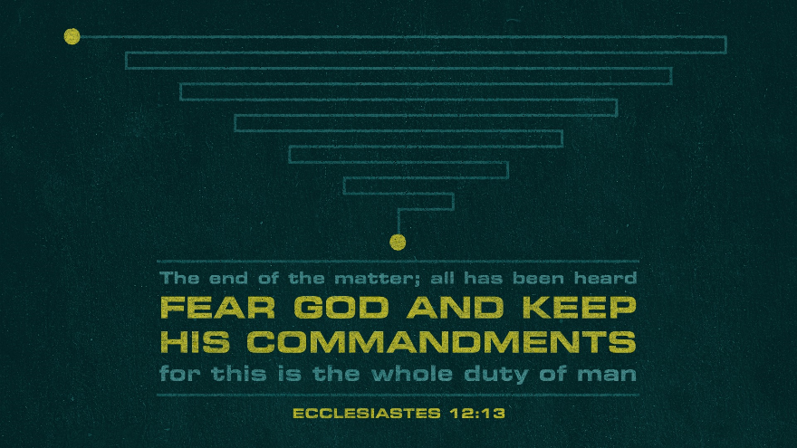
²⁰ I have been crucified with Christ. It is no longer I who live, but Christ who lives in me. And the life I now live in the flesh I live by faith in the Son of God, who loved me and gave himself for me.

III. The “Fear-ture”
1 John 4:18 ESV
¹⁸ There is no fear in love, but perfect love casts out fear. For fear has to do with punishment, and whoever fears has not been perfected in love.
1 Peter 4:8 ESV
⁸ Above all, keep loving one another earnestly, since love covers a multitude of sins.
1 Corinthians 13:7 ESV
⁷ Love bears all things, believes all things, hopes all things, endures all things.
Isaiah 41:10 ESV
¹⁰ fear not, for I am with you; be not dismayed, for I am your God;
I will strengthen you, I will help you, I will uphold you with my righteous right hand.
Philippians 4:6–7 ESV
⁶ do not be anxious about anything, but in everything by prayer and supplication with thanksgiving let your requests be made known to God. ⁷ And the peace of God, which surpasses all understanding, will guard your hearts and your minds in Christ Jesus.
Romans 8:38–39 ESV
³⁸ For I am sure that neither death nor life, nor angels nor rulers, nor things present nor things to come, nor powers, ³⁹ nor height nor depth, nor anything else in all creation, will be able to separate us from the love of God in Christ Jesus our Lord.
