Barry G. Johnson, Sr. / www.barrygjohnsonsr.com
Proverbs / Influence; Persuade; Tempt / Proverbs 1:8–9
The ability to affect others or events. Also, the experience of being affected by someone or something else. Scripture recognizes the wide-ranging power of influence for both good and evil.
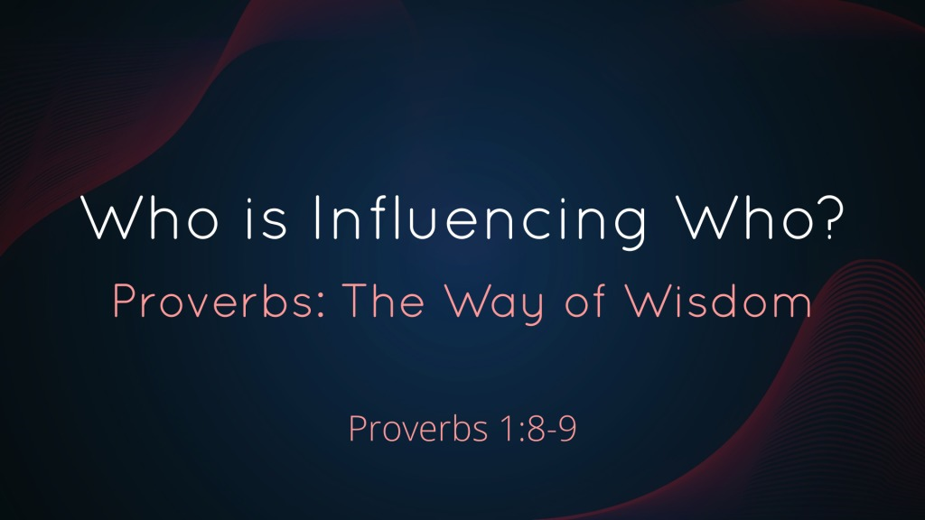
Proverbs 1:8–9 ESV
⁸ Hear, my son, your father’s instruction, and forsake not your mother’s teaching, ⁹ for they are a graceful garland for your head and pendants for your neck.

Teaching on influence

Be influenced by good and influence others for good
Matthew 5:13–16 ESV
¹³ “You are the salt of the earth, but if salt has lost its taste, how shall its saltiness be restored? It is no longer good for anything except to be thrown out and trampled under people’s feet. ¹⁴ “You are the light of the world. A city set on a hill cannot be hidden. ¹⁵ Nor do people light a lamp and put it under a basket, but on a stand, and it gives light to all in the house. ¹⁶ In the same way, let your light shine before others, so that they may see your good works and give glory to your Father who is in heaven.

Resist evil influence and do not be a bad influence
Romans 12:2 ESV
² Do not be conformed to this world, but be transformed by the renewal of your mind, that by testing you may discern what is the will of God, what is good and acceptable and perfect.

Good influences

The influence of the Holy Spirit
1 Corinthians 2:10–16 ESV
¹⁰ these things God has revealed to us through the Spirit. For the Spirit searches everything, even the depths of God. ¹¹ For who knows a person’s thoughts except the spirit of that person, which is in him? So also no one comprehends the thoughts of God except the Spirit of God. ¹² Now we have received not the spirit of the world, but the Spirit who is from God, that we might understand the things freely given us by God. ¹³ And we impart this in words not taught by human wisdom but taught by the Spirit, interpreting spiritual truths to those who are spiritual. ¹⁴ The natural person does not accept the things of the Spirit of God, for they are folly to him, and he is not able to understand them because they are spiritually discerned. ¹⁵ The spiritual person judges all things, but is himself to be judged by no one. ¹⁶ “For who has understood the mind of the Lord so as to instruct him?” But we have the mind of Christ.

People of good influence
2 Timothy 1:5 ESV
⁵ I am reminded of your sincere faith, a faith that dwelt first in your grandmother Lois and your mother Eunice and now, I am sure, dwells in you as well.

Evil influence in its various contexts

People of evil influence
2 Kings 9:22 ESV
²² And when Joram saw Jehu, he said, “Is it peace, Jehu?” He answered, “What peace can there be, so long as the whorings and the sorceries of your mother Jezebel are so many?”

Corrupting influence of evil cultures
1 Corinthians 15:33 ESV
³³ Do not be deceived: “Bad company ruins good morals.”

The influence of Satan
Matthew 16:23 ESV
²³ But he turned and said to Peter, “Get behind me, Satan! You are a hindrance to me. For you are not setting your mind on the things of God, but on the things of man.”

Further aspects of influence

The influence of prayer
Jonah 3:3–10 ESV
³ So Jonah arose and went to Nineveh, according to the word of the Lord. Now Nineveh was an exceedingly great city, three days’ journey in breadth. ⁴ Jonah began to go into the city, going a day’s journey. And he called out, “Yet forty days, and Nineveh shall be overthrown!” ⁵ And the people of Nineveh believed God. They called for a fast and put on sackcloth, from the greatest of them to the least of them. ⁶ The word reached the king of Nineveh, and he arose from his throne, removed his robe, covered himself with sackcloth, and sat in ashes. ⁷ And he issued a proclamation and published through Nineveh, “By the decree of the king and his nobles: Let neither man nor beast, herd nor flock, taste anything. Let them not feed or drink water, ⁸ but let man and beast be covered with sackcloth, and let them call out mightily to God. Let everyone turn from his evil way and from the violence that is in his hands. ⁹ Who knows? God may turn and relent and turn from his fierce anger, so that we may not perish.” ¹⁰ When God saw what they did, how they turned from their evil way, God relented of the disaster that he had said he would do to them, and he did not do it.

The influence of words
Proverbs 12:18 ESV
¹⁸ There is one whose rash words are like sword thrusts, but the tongue of the wise brings healing.

The influence of parents

Influence Man with God’s Plan of Salvation

Hear
John 8:47 ESV
⁴⁷ Whoever is of God hears the words of God. The reason why you do not hear them is that you are not of God.”

Believe
John 9:35–41 ESV
³⁵ Jesus heard that they had cast him out, and having found him he said, “Do you believe in the Son of Man?” ³⁶ He answered, “And who is he, sir, that I may believe in him?” ³⁷ Jesus said to him, “You have seen him, and it is he who is speaking to you.” ³⁸ He said, “Lord, I believe,” and he worshiped him. ³⁹ Jesus said, “For judgment I came into this world, that those who do not see may see, and those who see may become blind.” ⁴⁰ Some of the Pharisees near him heard these things, and said to him, “Are we also blind?” ⁴¹ Jesus said to them, “If you were blind, you would have no guilt; but now that you say, ‘We see,’ your guilt remains.

Confess
Acts 19:18 ESV
¹⁸ Also many of those who were now believers came, confessing and divulging their practices.

Repent
Matthew 12:41 ESV
⁴¹ The men of Nineveh will rise up at the judgment with this generation and condemn it, for they repented at the preaching of Jonah, and behold, something greater than Jonah is here.

Be Baptized
Acts 8:36 ESV
³⁶ And as they were going along the road they came to some water, and the eunuch said, “See, here is water! What prevents me from being baptized?”

Remain Faithful
Hebrews 3:12 ESV
¹² Take care, brothers, lest there be in any of you an evil, unbelieving heart, leading you to fall away from the living God.

