DEFINITIONS
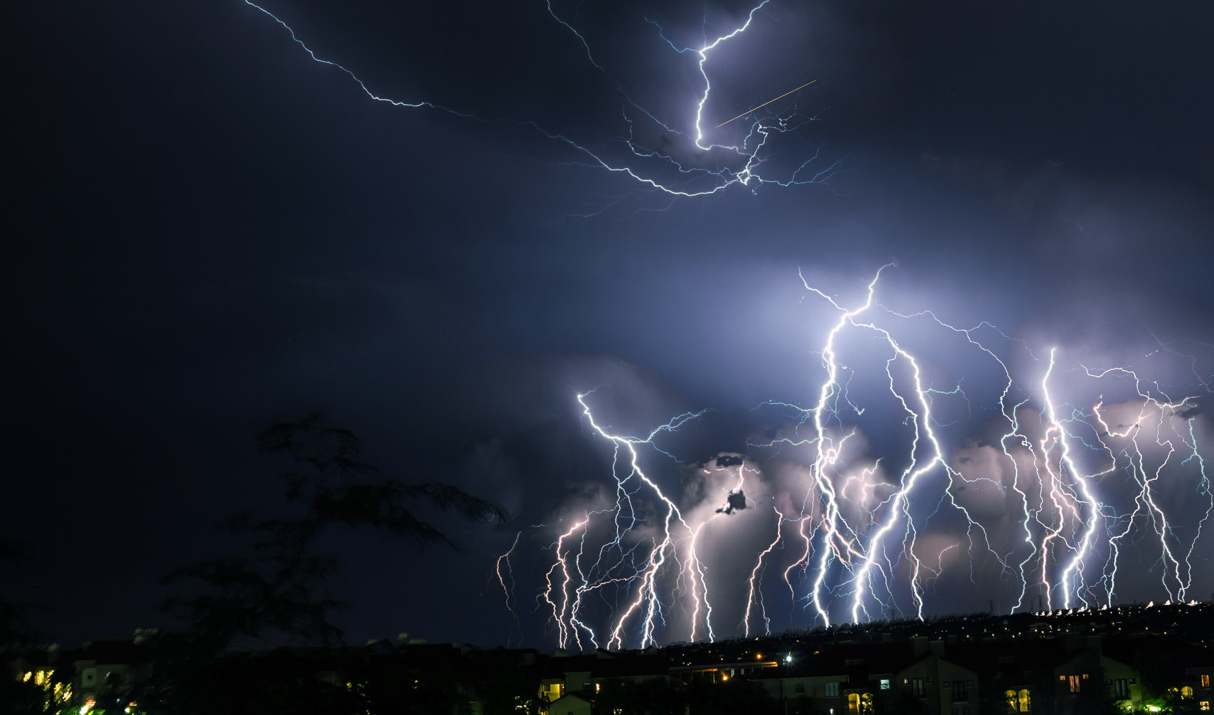
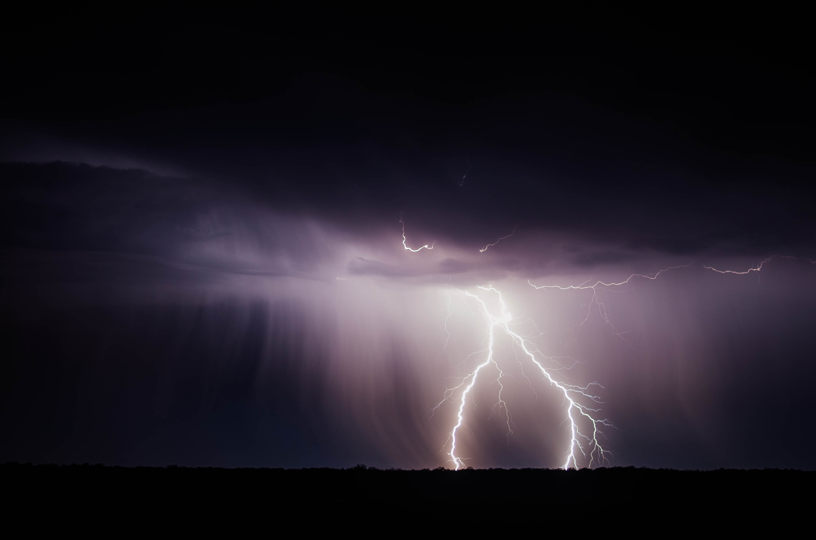
When you look at the life of Moses, you can see both the power and the potential problems inherent in anger. Has anger ever clouded your judgment to the point that you acted rashly … and lived to regret it? Ultimately, you have the choice to act wisely or to react foolishly. In his lifetime, Moses did both. (And like him, you can learn to keep your anger under control—you can learn how to act rather than react!)

What Is the Meaning of Anger?

What Is the Magnitude of Anger?

What Are Misconceptions about Anger?

What Is the Misuse of Anger?
“Moses thought that his own people would realize that God was using him to rescue them, but they did not.”
(Acts 7:25)

Walking Christian

On anger

What Is the Meaning of Anger?
- An _______________ man stirs up dissension, and a _______________ one commits many sins. (Proverbs 29:22)
- A hot-tempered man stirs up _______________, but a _______________ man calms a quarrel. (Proverbs 15:18)
- The Lord is _______________ and compassionate, _______________ to anger and rich in love. (Psalm 145:8)
- Do not make _______________ with a hot-tempered man, do not _______________ with one easily angered. (Proverbs 22:24)
- For those who are _______________ and who reject the truth and follow evil, there will be wrath and _______________. (Romans 2:8)

What Is the Magnitude of Anger?
- _______________
“When Jesus saw this, he was _______________. He said to them, ‘Let the little children come to me, and do not hinder them, for the kingdom of God belongs to such as these.’ ” (Mark 10:14)
- _______________
“The _______________ of God is being revealed from heaven against all the godlessness and wickedness of men who suppress the truth by their wickedness.” (Romans 1:18)
- _______________
“Anger is cruel and _______________ overwhelming.” (Proverbs 27:4)
- _______________
“A man’s own folly ruins his life, yet his heart _______________ against the Lord.” (Proverbs 19:3)

What Are Misconceptions about Anger?
Questions about Anger
- Question: “Is it a sin for me to be angry?”
Answer:

(Ephesians 4:26)
- Question: “How can I keep from feeling guilty when I’m angry?”
Answer:

(Mark 3:5)
- Question: “How can a God of love be a God of wrath at the same time?”
Answer:

(Psalm 30:5)
- Question: “Can people be really angry even when they don’t look or sound angry?”
Answer:

(1 Samuel 16:7)

What Is the Misuse of Anger?
• _______________ anger … the “simmering stew”
… is held in for a long time. This anger results from an _______________ _______________ toward some past offense and offender. Unforgiveness eventually results in a resentment and deep bitterness that harms other relationships.
Example:
“I’ll never _______________ the way he talked to me years ago.”
“See to it that no one misses the _______________ of God and that no bitter root grows up to cause trouble and defile many.” (Hebrews 12:15)
• _______________ _______________ anger … the “pressure cooker”
… is denied or hidden anger. Usually resulting from a fear of facing negative emotions, this kind of anger can create a _______________ _______________ and lead to untruthfulness with others. Failure to honestly confront and resolve angry feelings can result in self-pity, self-contempt, and self-doubt … ultimately sabotaging most relationships.
Example:
“I never get angry … maybe just a little _______________ at times.”
“Whoever would love life and see good days must keep his tongue from evil and his lips from _______________ speech.” (1 Peter 3:10)
• _______________ anger … the “short fuse”
… is quick and impatient, instantly irritated or incensed. A testy temper is often expressed with _______________ or _______________ under the guise of teasing.
Example:
“I can’t believe you said that! You’re so _______________!”
“Do not be quickly _______________ in your spirit, for anger resides in the lap of fools.” (Ecclesiastes 7:9)
• _______________ anger … the “volatile volcano”
… is powerful, destructive, hard to control. This way of releasing anger is characterized by _______________, _______________, and abuse toward others.
Example:
“You _______________ fool—if you ever do that again, you’ll wish you’d never been born!”
Jesus gives an ominous warning toward those who demean others …
“I tell you that anyone who is angry with his brother will be subject to _______________.… But anyone who says, ‘You fool!’ will be in danger of the fire of hell.” (Matthew 5:22)

Next class Anger Characteristics
Betrayal from the outside can be bruising, but betrayal by a friend cuts deep and wounds the soul. Everyone expects opposition from those on the outside, but what do you do when opposition comes from within—from among your own … “your closest confidants” … your trusted few?
One national leader knew the brutality of such betrayal. He had led wisely, demonstrated courage, and won the confidence of his people. He was there for them—and they knew it. However, another leader undermined his authority and created such dissension that this man stole the loyalty of 250 of his leaders. Those whom he had trusted throughout the years—those who should have known him the best, those who should have been most loyal to him—turned against him. In response, however, Moses did not take personal revenge, but rather appealed to the Lord.
“Moses became very angry and said to the Lord, ‘Do not accept their offering. I have not … wronged any of them.’ ”
(Numbers 16:15)
Although justifiably angry, Moses had learned how to act rather than react. He restrained his rage, poured out his heart, and pleaded with the Lord to deal with His offenders. In turn, God took up his cause, destroyed his betrayers, and defended his honor. Moses refused to take revenge, but rather allowed the Lord to be his avenger because God had given this promise …
We will study the following as we look at the ‘Characteristics of Anger”.
- What Are Your Anger Cues?
- Do You Act or React When You Are Angry?
- What Are Symptoms of Unresolved Anger?
- Do You Have Hidden Anger?

