Barry G. Johnson, Sr. / General
The Way of Wisdom / Wisdom; Understanding / Proverbs 3:5–8
God-given perception of the nature and meaning of things, resulting in sound judgment and decision-making; in particular the ability to discern spiritual truth and to apply it to human disposition and conduct.
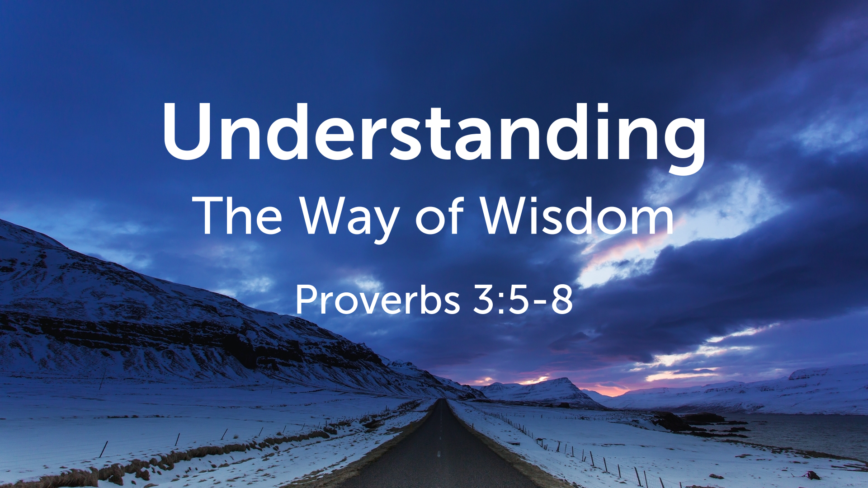
Proverbs 3:5–8 ESV
⁵ Trust in the Lord with all your heart, and do not lean on your own understanding. ⁶ In all your ways acknowledge him, and he will make straight your paths. ⁷ Be not wise in your own eyes; fear the Lord, and turn away from evil. ⁸ It will be healing to your flesh and refreshment to your bones.

The source of understanding

Understanding belongs to God
Job 12:13 ESV
¹³ “With God are wisdom and might; he has counsel and understanding.
Psalm 136:5 ESV
⁵ to him who by understanding made the heavens, for his steadfast love endures forever;

Understanding is a gift from God
Proverbs 2:6 ESV
⁶ For the Lord gives wisdom; from his mouth come knowledge and understanding;

Understanding spiritual truth

Understanding truth about God
1 John 5:20 ESV
²⁰ And we know that the Son of God has come and has given us understanding, so that we may know him who is true; and we are in him who is true, in his Son Jesus Christ. He is the true God and eternal life.

Understanding God’s purposes
God has revealed many of His purposes and we still do not understand; Dt 9:6 God’s reason for choosing Israel; 1 Ch 28:19 God’s plans for the temple; Job 34:10–11 the reason for Job’s suffering; Ps 73:16–17 God’s dealings with the wicked; Is 57:1–2 God’s purpose in taking the righteous; Je 9:12–13 the reason for the exile

Understanding God’s word
Psalm 119:73 ESV
⁷³ Your hands have made and fashioned me; give me understanding that I may learn your commandments.
Luke 24:45 ESV
⁴⁵ Then he opened their minds to understand the Scriptures,

Understanding Jesus Christ’s teaching
Mt 13:11; Mt 16:12; Mt 17:13; Mk 4:33; Mk 8:17; Jn 2:22

Understanding God’s salvation
Ephesians 1:18 ESV
¹⁸ having the eyes of your hearts enlightened, that you may know what is the hope to which he has called you, what are the riches of his glorious inheritance in the saints,

Human understanding is limited
Proverbs 3:5 ESV
⁵ Trust in the Lord with all your heart, and do not lean on your own understanding.
1 Corinthians 13:12 ESV
¹² For now we see in a mirror dimly, but then face to face. Now I know in part; then I shall know fully, even as I have been fully known.

Gaining understanding

Through faith
Hebrews 11:3 ESV
³ By faith we understand that the universe was created by the word of God, so that what is seen was not made out of things that are visible.

Through God’s Spirit
1 Corinthians 2:12 ESV
¹² Now we have received not the spirit of the world, but the Spirit who is from God, that we might understand the things freely given us by God.

Through God’s word
Psalm 119:130 ESV
¹³⁰ The unfolding of your words gives light; it imparts understanding to the simple.

Through wise teaching
Psalm 49:3 ESV
³ My mouth shall speak wisdom; the meditation of my heart shall be understanding.

Lack of understanding of spiritual truth

Not knowing God
Isaiah 1:3 ESV
³ The ox knows its owner, and the donkey its master’s crib, but Israel does not know, my people do not understand.”

Lack of understanding due to hardened hearts
Job 17:4; Is 44:18; Is 48:8; Je 5:21; Eze 12:2; Mt 13:13–15; Mk 6:52; Jn 12:40; Ac 28:26–27; Eph 4:18

Not understanding God’s purposes
Luke 12:56 ESV
⁵⁶ You hypocrites! You know how to interpret the appearance of earth and sky, but why do you not know how to interpret the present time?
1 Corinthians 2:8 ESV
⁸ None of the rulers of this age understood this, for if they had, they would not have crucified the Lord of glory.

Not understanding Jesus Christ’s teaching
Matthew 13:19 ESV
¹⁹ When anyone hears the word of the kingdom and does not understand it, the evil one comes and snatches away what has been sown in his heart. This is what was sown along the path.

The results of understanding

Seeking God
Psalm 14:2 ESV
² The Lord looks down from heaven on the children of man, to see if there are any who understand, who seek after God.

Obedience
Psalm 119:34 ESV
³⁴ Give me understanding, that I may keep your law and observe it with my whole heart.

Taking the right path
Proverbs 2:9 ESV
⁹ Then you will understand righteousness and justice and equity, every good path;

Life
Psalm 119:144 ESV
¹⁴⁴ Your testimonies are righteous forever; give me understanding that I may live.
Proverbs 16:22 ESV
²² Good sense is a fountain of life to him who has it, but the instruction of fools is folly.

Sensible living
Job 28:28 avoidance of evil; Pr 11:12 slowness to criticise; Pr 12:11 conscientious labour; Pr 13:15 winning favour; Pr 17:27 showing restraint and an even temper; Jas 3:13 good deeds and humility

The results of a lack of understanding

Foolish behavior
Pr 6:32 committing adultery; Pr 7:7 being easily seduced; Pr 17:18 making rash commitments; Pr 18:1–2 selfishness and self-importance; Pr 24:30–31 idleness leading to ruin; Ho 4:11 Drunkenness clouds understanding.

Death
Proverbs 10:21 ESV
²¹ The lips of the righteous feed many, but fools die for lack of sense.
Proverbs 21:16 ESV
¹⁶ One who wanders from the way of good sense will rest in the assembly of the dead.

Understand God’s Plan of Salvation
Hear God’s Word; Believe that Word; Repent from Misunderstanding; Confess Jesus as God’s Son and Savior; Be Baptized for the remission of Sin and to be added to the Lord’s body; Remain Faithful all the days of your Life.
Romans 10:17 ESV
¹⁷ So faith comes from hearing, and hearing through the word of Christ.
Hebrews 11:6 ESV
⁶ And without faith it is impossible to please him, for whoever would draw near to God must believe that he exists and that he rewards those who seek him.
Acts 17:30 ESV
³⁰ The times of ignorance God overlooked, but now he commands all people everywhere to repent,
Matthew 10:32–33 ESV
³² So everyone who acknowledges me before men, I also will acknowledge before my Father who is in heaven, ³³ but whoever denies me before men, I also will deny before my Father who is in heaven.
1 Peter 3:21 ESV
²¹ Baptism, which corresponds to this, now saves you, not as a removal of dirt from the body but as an appeal to God for a good conscience, through the resurrection of Jesus Christ,
Revelation 2:10 ESV
¹⁰ Do not fear what you are about to suffer. Behold, the devil is about to throw some of you into prison, that you may be tested, and for ten days you will have tribulation. Be faithful unto death, and I will give you the crown of life.

