Synopsis
Jesus Christ, falsely accused of blasphemy towards God and treason towards Rome, humbly endured his trial as a fulfilment of the purposes of God.

- The preliminary hearing before Annas (1st-trial)
John 18:12–14 (NIV) — 12 Then the detachment of soldiers with its commander and the Jewish officials arrested Jesus. They bound him 13 and brought him first to Annas, who was the father-in-law of Caiaphas, the high priest that year. 14 Caiaphas was the one who had advised the Jewish leaders that it would be good if one man died for the people.
John 18:19–23 (NIV) — 19 Meanwhile, the high priest questioned Jesus about his disciples and his teaching. 20 “I have spoken openly to the world,” Jesus replied. “I always taught in synagogues or at the temple, where all the Jews come together. I said nothing in secret. 21 Why question me? Ask those who heard me. Surely they know what I said.” 22 When Jesus said this, one of the officials nearby slapped him in the face. “Is this the way you answer the high priest?” he demanded. 23 “If I said something wrong,” Jesus replied, “testify as to what is wrong. But if I spoke the truth, why did you strike me?”
- Procedure Violations
Jews Had Important Procedures to Prevent Injustice
Amos 5:24 (NIV)
24 But let justice roll on like a river, righteousness like a never-failing stream!
Micah 6:8 (NIV)
8 He has shown you, O mortal, what is good. And what does the Lord require of you? To act justly and to love mercy and to walk humbly with your God.
Witnesses testified falsely
Deuteronomy 19:15–20 (NIV)
15 One witness is not enough to convict anyone accused of any crime or offense they may have committed. A matter must be established by the testimony of two or three witnesses.
16 If a malicious witness takes the stand to accuse someone of a crime, 17 the two people involved in the dispute must stand in the presence of the Lord before the priests and the judges who are in office at the time. 18 The judges must make a thorough investigation, and if the witness proves to be a liar, giving false testimony against a fellow Israelite, 19 then do to the false witness as that witness intended to do to the other party. You must purge the evil from among you. 20 The rest of the people will hear of this and be afraid, and never again will such an evil thing be done among you.
Matthew 26:59 (NIV)
59 The chief priests and the whole Sanhedrin were looking for false evidence against Jesus so that they could put him to death.
Witnesses for accused testify first
John 18:21–23 (NIV)
²¹ Why question me? Ask those who heard me. Surely they know what I said.”
²² When Jesus said this, one of the officials nearby slapped him in the face. “Is this the way you answer the high priest?” he demanded.
²³ “If I said something wrong,” Jesus replied, “testify as to what is wrong. But if I spoke the truth, why did you strike me?”
Trails should be In public - first two trials held in houses
1. No trials at night - can't start before the morning sacrifice or after the evening sacrifice
2. No trials on a feast day or day before
Sanhedrin could not originate charges
Must start in lower court and then be brought to Sanhedrin for decision
- Jesus Christ’s trial centres upon his Messianic claims
Jesus declares himself to be the Christ
Matthew 26:63–64 (NIV) — 63 But Jesus remained silent. The high priest said to him, “I charge you under oath by the living God: Tell us if you are the Messiah, the Son of God.” 64 “You have said so,” Jesus replied. “But I say to all of you: From now on you will see the Son of Man sitting at the right hand of the Mighty One and coming on the clouds of heaven.”
Jesus is mocked as the Christ
Matthew 26:67–68 (NIV) — 67 Then they spit in his face and struck him with their fists. Others slapped him 68 and said, “Prophesy to us, Messiah. Who hit you?”
- Jesus Christ’s response to his trial
Acts 8:32–35 (NIV) — 32 This is the passage of Scripture the eunuch was reading: “He was led like a sheep to the slaughter, and as a lamb before its shearer is silent, so he did not open his mouth. 33 In his humiliation he was deprived of justice. Who can speak of his descendants? For his life was taken from the earth.” 34 The eunuch asked Philip, “Tell me, please, who is the prophet talking about, himself or someone else?” 35 Then Philip began with that very passage of Scripture and told him the good news about Jesus.
1 Peter 2:23 (NIV) — 23 When they hurled their insults at him, he did not retaliate; when he suffered, he made no threats. Instead, he entrusted himself to him who judges justly.
- Jesus Christ’s trial confirms he is God’s servant
Isaiah 53:10 (NIV) — 10 Yet it was the Lord’s will to crush him and cause him to suffer, and though the Lord makes his life an offering for sin, he will see his offspring and prolong his days, and the will of the Lord will prosper in his hand.
Acts 2:23 (NIV) — 23 This man was handed over to you by God’s deliberate plan and foreknowledge; and you, with the help of wicked men, put him to death by nailing him to the cross.

Hear - Romans 10:17 (NIV)
¹⁷ Consequently, faith comes from hearing the message, and the message is heard through the word about Christ.
Believe - Hebrews 11:6 (NIV)
⁶ And without faith it is impossible to please God, because anyone who comes to him must believe that he exists and that he rewards those who earnestly seek him.
Repent - Acts 17:30 (NIV)
³⁰ In the past God overlooked such ignorance, but now he commands all people everywhere to repent.
Confess - 1 Timothy 6:12 (NIV)
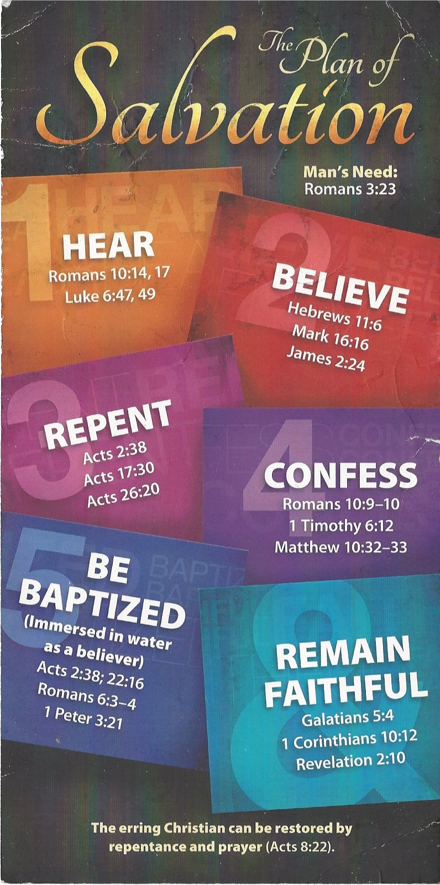
¹² Fight the good fight of the faith. Take hold of the eternal life to which you were called when you made your good confession in the presence of many witnesses.

Be Baptized - Acts 22:16 (NIV)
¹⁶ And now what are you waiting for? Get up, be baptized and wash your sins away, calling on his name.’
Remain Steadfast - Revelation 2:10 (NIV)
¹⁰ Do not be afraid of what you are about to suffer. I tell you, the devil will put some of you in prison to test you, and you will suffer persecution for ten days. Be faithful, even to the point of death, and I will give you life as your victor’s crown.

