They Spoke the Word of the Lord
Barry G. Johnson, Sr. / www.barrygjohnsonsr.com
"What Does "Believe on the Lord Jesus Christ, and You Will be Saved" mean?" / Belief; Believe; Word; Salvation; Faith / Acts 16:30–34
It is the Word of God which must proceed the salvation of God.
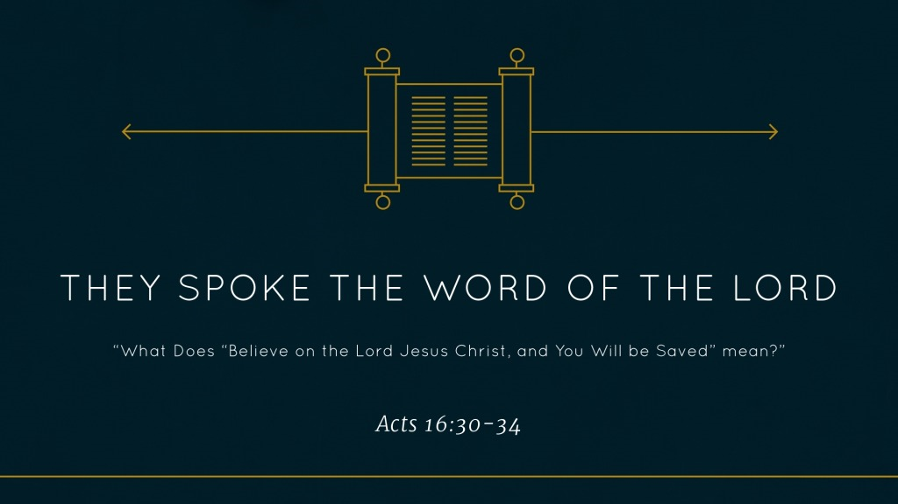
Acts 16:30–34 ESV
³⁰ Then he brought them out and said, “Sirs, what must I do to be saved?” ³¹ And they said, “Believe in the Lord Jesus, and you will be saved, you and your household.” ³² And they spoke the word of the Lord to him and to all who were in his house. ³³ And he took them the same hour of the night and washed their wounds; and he was baptized at once, he and all his family. ³⁴ Then he brought them up into his house and set food before them. And he rejoiced along with his entire household that he had believed in God.

What Must I Do to Be Saved?
John 16:8 ESV
⁸ And when he comes, he will convict the world concerning sin and righteousness and judgment:
Acts 16:17 ESV
¹⁷ She followed Paul and us, crying out, “These men are servants of the Most High God, who proclaim to you the way of salvation.”

Believe in the Lord Jesus and You will Be Saved

Believe in Your Mind only
James 2:14–17 ESV
¹⁴ What good is it, my brothers, if someone says he has faith but does not have works? Can that faith save him? ¹⁵ If a brother or sister is poorly clothed and lacking in daily food, ¹⁶ and one of you says to them, “Go in peace, be warmed and filled,” without giving them the things needed for the body, what good is that? ¹⁷ So also faith by itself, if it does not have works, is dead.
James 2:19–20 ESV
¹⁹ You believe that God is one; you do well. Even the demons believe—and shudder! ²⁰ Do you want to be shown, you foolish person, that faith apart from works is useless?

Believe with Your Actions
James 2:18 ESV
¹⁸ But someone will say, “You have faith and I have works.” Show me your faith apart from your works, and I will show you my faith by my works.
James 2:21–26 ESV
²¹ Was not Abraham our father justified by works when he offered up his son Isaac on the altar? ²² You see that faith was active along with his works, and faith was completed by his works; ²³ and the Scripture was fulfilled that says, “Abraham believed God, and it was counted to him as righteousness”—and he was called a friend of God. ²⁴ You see that a person is justified by works and not by faith alone. ²⁵ And in the same way was not also Rahab the prostitute justified by works when she received the messengers and sent them out by another way? ²⁶ For as the body apart from the spirit is dead, so also faith apart from works is dead.

Baptized at Once
1. The Jews on Pentecost (Acts 2)
2. The Samaritans (Acts 8)
3. Simon (Acts 8)
4. The Ethiopian Treasurer (Acts 8)
5. Saul (Acts 9; 22; 26)
6. Cornelius (Acts 10)
7. Lydia (Acts 16)
8. The Jailor (Acts 16)
9. Some Athenians (Acts 17)
10. The Corinthians (Acts 18)
11. The Ephesians (Acts 19)

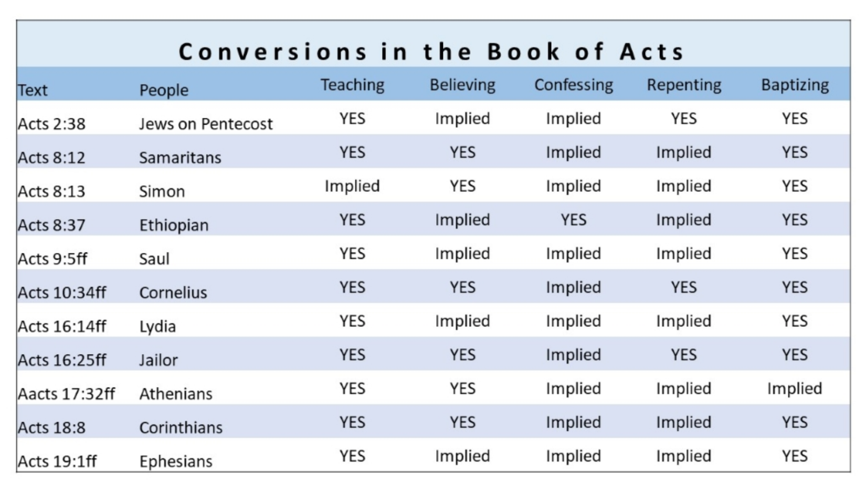

God’s Plan of Salvation

Romans 10:17 ESV
¹⁷ So faith comes from hearing, and hearing through the word of Christ.
Hebrews 11:6 ESV
⁶ And without faith it is impossible to please him, for whoever would draw near to God must believe that he exists and that he rewards those who seek him.
Luke 13:3 ESV
³ No, I tell you; but unless you repent, you will all likewise perish.
1 Timothy 6:12–13 ESV
¹² Fight the good fight of the faith. Take hold of the eternal life to which you were called and about which you made the good confession in the presence of many witnesses. ¹³ I charge you in the presence of God, who gives life to all things, and of Christ Jesus, who in his testimony before Pontius Pilate made the good confession,
Acts 2:37–38 ESV
³⁷ Now when they heard this they were cut to the heart, and said to Peter and the rest of the apostles, “Brothers, what shall we do?” ³⁸ And Peter said to them, “Repent and be baptized every one of you in the name of Jesus Christ for the forgiveness of your sins, and you will receive the gift of the Holy Spirit.
Revelation 2:10 ESV
¹⁰ Do not fear what you are about to suffer. Behold, the devil is about to throw some of you into prison, that you may be tested, and for ten days you will have tribulation. Be faithful unto death, and I will give you the crown of life.

