Barry G. Johnson, Sr. / www.bgjsr22.com
Christianity is Reality: All Have Sinned / Sin; Righteousness / Romans 3:21–23
All human beings’ sin and are guilty in the sight of God on account of a fallen nature, which can be traced back to Adam. Acts of sin thus arise from a sinful human heart. The basis of cleansing and cancelling sin is the atoning death of Jesus Christ.
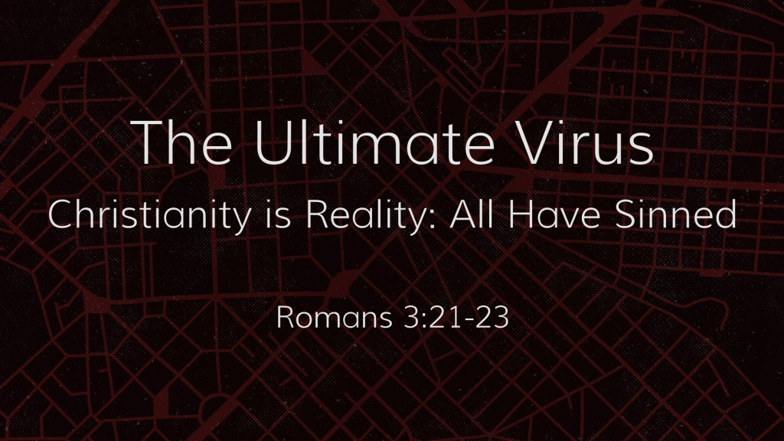

The Virus from the Beginning
Romans 5:19 ESV
¹⁹ For as by the one man’s disobedience the many were made sinners, so by the one man’s obedience the many will be made righteous.
See also Ge 3:1–24; Ro 5:12; 1 Co 15:22

The Universe is Subject to the Virus
Galatians 3:22 ESV
²² But the Scripture imprisoned everything under sin, so that the promise by faith in Jesus Christ might be given to those who believe.
See also Ro 5:21; Ro 11:32

The Virus is Inherent in Human Nature

Sinfulness from birth
Psalm 51:5 ESV
⁵ Behold, I was brought forth in iniquity,
and in sin did my mother conceive me.
See also Job 25:4; Ps 58:3

The sinful heart
Genesis 6:5 ESV
⁵ The Lord saw that the wickedness of man was great in the earth, and that every intention of the thoughts of his heart was only evil continually.
See also Ge 8:21; Ec 9:3; Je 17:9; Mt 15:19

The sinful nature
Ephesians 2:3 ESV
³ among whom we all once lived in the passions of our flesh, carrying out the desires of the body and the mind, and were by nature children of wrath, like the rest of mankind.
See also Ro 8:6–8; Ga 5:19–21

The universality of sin

No-one is righteous
Romans 3:9–19 ESV
⁹ What then? Are we Jews any better off? No, not at all. For we have already charged that all, both Jews and Greeks, are under sin, ¹⁰ as it is written:
“None is righteous, no, not one;
¹¹ no one understands;
no one seeks for God.
¹² All have turned aside; together they have become worthless;
no one does good,
not even one.”
¹³ “Their throat is an open grave;
they use their tongues to deceive.”
“The venom of asps is under their lips.”
¹⁴ “Their mouth is full of curses and bitterness.”
¹⁵ “Their feet are swift to shed blood;
¹⁶ in their paths are ruin and misery,
¹⁷ and the way of peace they have not known.”
¹⁸ “There is no fear of God before their eyes.”
¹⁹ Now we know that whatever the law says it speaks to those who are under the law, so that every mouth may be stopped, and the whole world may be held accountable to God.
See also Ps 5:9; Ps 10:7; Ps 14:1–3; Ps 36:1; Ps 140:3; Is 59:7–8

All have sinned
Romans 3:23 ESV
²³ for all have sinned and fall short of the glory of God,
See also Ge 6:11–12; 1 Ki 8:46; Ec 7:20; Is 53:6; Ro 1:18–32; Jas 3:2

Everyone is sinful in God’s sight
1 John 1:8 ESV
⁸ If we say we have no sin, we deceive ourselves, and the truth is not in us.
See also Ps 130:3; Ps 143:2; Pr 20:9; Is 64:6–7; Mt 19:17; 1 Jn 1:10

Jesus has not Contracted the Virus
Hebrews 4:15 ESV
¹⁵ For we do not have a high priest who is unable to sympathize with our weaknesses, but one who in every respect has been tempted as we are, yet without sin.
1 Peter 2:22 ESV
²² He committed no sin, neither was deceit found in his mouth.
See also Is 53:9; Lk 23:47; 2 Co 5:21; Heb 7:26; 1 Jn 3:5

How to Cure the Virus

Hear God’s Word - Romans 10:17

Believe God’s Word - Hebrews 11:6

Repent of your Sins - Luke 13:3

Confess Jesus as the Son of God - 1 John 4:3

Be Baptized for the Remission of Sin - Acts 16:22

Remain Steadfast for Life - 1 Corinthians 15:58

