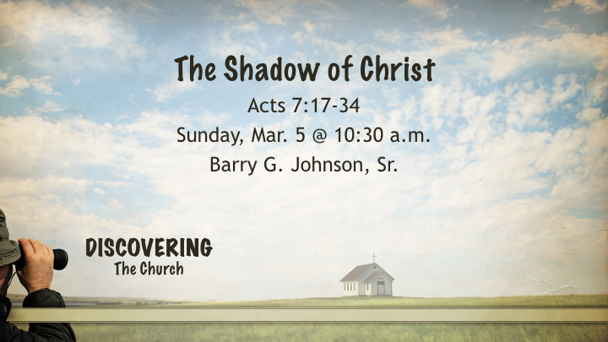
Thesis/ Central Idea:

Stephen spoke to the shadow of Christ in Moses that the people would come to believe in Jesus.

Outline Objectives:

- Moses as the forerunner of Jesus the Christ
- Moses shared characteristics of Jesus the Christ
- Shadow Institutions through Moses
- Jesus Christ is superior to Moses

Sermon Outline:

- Moses as the forerunner of Jesus the Christ
- As Teacher
Exodus 18:20 (ESV) — 20 and you shall warn them about the statutes and the laws, and make them know the way in which they must walk and what they must do.
Matthew 23:10 (ESV) — 10 Neither be called instructors, for you have one instructor, the Christ.
- As intercessor
Psalm 106:23 (ESV) — 23 Therefore he said he would destroy them— had not Moses, his chosen one, stood in the breach before him, to turn away his wrath from destroying them.
Hebrews 7:25 (ESV) — 25 Consequently, he is able to save to the uttermost those who draw near to God through him, since he always lives to make intercession for them.
- As servant of the Lord
Joshua 1:1–2 (ESV) — 1 After the death of Moses the servant of the Lord, the Lord said to Joshua the son of Nun, Moses’ assistant, 2 “Moses my servant is dead. Now therefore arise, go over this Jordan, you and all this people, into the land that I am giving to them, to the people of Israel.
Acts 3:13 (ESV) — 13 The God of Abraham, the God of Isaac, and the God of Jacob, the God of our fathers, glorified his servant Jesus, whom you delivered over and denied in the presence of Pilate, when he had decided to release him.
- As prophet
Numbers 12:6–8 (ESV) — 6 And he said, “Hear my words: If there is a prophet among you, I the Lord make myself known to him in a vision; I speak with him in a dream. 7 Not so with my servant Moses. He is faithful in all my house. 8 With him I speak mouth to mouth, clearly, and not in riddles, and he beholds the form of the Lord. Why then were you not afraid to speak against my servant Moses?”
Acts 3:22 (ESV) — 22 Moses said, ‘The Lord God will raise up for you a prophet like me from your brothers. You shall listen to him in whatever he tells you.
- As deliverer
Exodus 3:10 (ESV) — 10 Come, I will send you to Pharaoh that you may bring my people, the children of Israel, out of Egypt.”
Galatians 5:1 (ESV) — 1 For freedom Christ has set us free; stand firm therefore, and do not submit again to a yoke of slavery.
- As judge
Exodus 18:13 (ESV) — 13 The next day Moses sat to judge the people, and the people stood around Moses from morning till evening.
- As writer
Exodus 24:4 (ESV) — 4 And Moses wrote down all the words of the Lord. He rose early in the morning and built an altar at the foot of the mountain, and twelve pillars, according to the twelve tribes of Israel.
Luke 24:27 (ESV) — 27 And beginning with Moses and all the Prophets, he interpreted to them in all the Scriptures the things concerning himself.
John 1:45 (ESV) — 45 Philip found Nathanael and said to him, “We have found him of whom Moses in the Law and also the prophets wrote, Jesus of Nazareth, the son of Joseph.”
John 5:46 (ESV) — 46 For if you believed Moses, you would believe me; for he wrote of me.
- As shepherd
Psalm 77:20 (ESV) — 20 You led your people like a flock by the hand of Moses and Aaron.
John 10:11 (ESV) — 11 I am the good shepherd. The good shepherd lays down his life for the sheep.
- As the friend of God
Exodus 33:11 (ESV) — 11 Thus the Lord used to speak to Moses face to face, as a man speaks to his friend. When Moses turned again into the camp, his assistant Joshua the son of Nun, a young man, would not depart from the tent.
Matthew 17:5 (ESV) — 5 He was still speaking when, behold, a bright cloud overshadowed them, and a voice from the cloud said, “This is my beloved Son, with whom I am well pleased; listen to him.”
John 5:20 (ESV) — 20 For the Father loves the Son and shows him all that he himself is doing. And greater works than these will he show him, so that you may marvel.
- As the mediator of the law and the covenant
Exodus 19:5–6 (ESV) — 5 Now therefore, if you will indeed obey my voice and keep my covenant, you shall be my treasured possession among all peoples, for all the earth is mine; 6 and you shall be to me a kingdom of priests and a holy nation.’ These are the words that you shall speak to the people of Israel.”
Galatians 3:19 (ESV) — 19 Why then the law? It was added because of transgressions, until the offspring should come to whom the promise had been made, and it was put in place through angels by an intermediary.
Hebrews 9:15 (ESV) — 15 Therefore he is the mediator of a new covenant, so that those who are called may receive the promised eternal inheritance, since a death has occurred that redeems them from the transgressions committed under the first covenant.
Hebrews 12:24 (ESV) — 24 and to Jesus, the mediator of a new covenant, and to the sprinkled blood that speaks a better word than the blood of Abel.
- Moses shared characteristics of Jesus the Christ
- He understood that the law meant life
Deuteronomy 32:46–47 (ESV) — 46 he said to them, “Take to heart all the words by which I am warning you today, that you may command them to your children, that they may be careful to do all the words of this law. 47 For it is no empty word for you, but your very life, and by this word you shall live long in the land that you are going over the Jordan to possess.”
Matthew 19:17 (ESV) — 17 And he said to him, “Why do you ask me about what is good? There is only one who is good. If you would enter life, keep the commandments.”
- He was passionate in his defense of the Lord’s holiness
Exodus 32:19 (ESV) — 19 And as soon as he came near the camp and saw the calf and the dancing, Moses’ anger burned hot, and he threw the tablets out of his hands and broke them at the foot of the mountain.
Luke 19:45–46 (ESV) — 45 And he entered the temple and began to drive out those who sold, 46 saying to them, “It is written, ‘My house shall be a house of prayer,’ but you have made it a den of robbers.”
- He worked miracles that brought glory to God
Exodus 14:15–18 (ESV) — 15 The Lord said to Moses, “Why do you cry to me? Tell the people of Israel to go forward. 16 Lift up your staff, and stretch out your hand over the sea and divide it, that the people of Israel may go through the sea on dry ground. 17 And I will harden the hearts of the Egyptians so that they shall go in after them, and I will get glory over Pharaoh and all his host, his chariots, and his horsemen. 18 And the Egyptians shall know that I am the Lord, when I have gotten glory over Pharaoh, his chariots, and his horsemen.”
John 2:11 (ESV) — 11 This, the first of his signs, Jesus did at Cana in Galilee, and manifested his glory. And his disciples believed in him.
- Shadow Institutions through Moses
- He inaugurates the ritual slaughter of the Passover lamb
Exodus 12:21 (ESV) — 21 Then Moses called all the elders of Israel and said to them, “Go and select lambs for yourselves according to your clans, and kill the Passover lamb.
John 1:29 (ESV) — 29 The next day he saw Jesus coming toward him, and said, “Behold, the Lamb of God, who takes away the sin of the world!
- He sprinkles the people with the blood of the covenant
Exodus 24:8 (ESV) — 8 And Moses took the blood and threw it on the people and said, “Behold the blood of the covenant that the Lord has made with you in accordance with all these words.”
Leviticus 17:11 (ESV) — 11 For the life of the flesh is in the blood, and I have given it for you on the altar to make atonement for your souls, for it is the blood that makes atonement by the life.
Matthew 26:28 (ESV) — 28 for this is my blood of the covenant, which is poured out for many for the forgiveness of sins.
Hebrews 9:13–14 (ESV) — 13 For if the blood of goats and bulls, and the sprinkling of defiled persons with the ashes of a heifer, sanctify for the purification of the flesh, 14 how much more will the blood of Christ, who through the eternal Spirit offered himself without blemish to God, purify our conscience from dead works to serve the living God.
- He orders the atonement sacrifice
Numbers 16:46 (ESV) — 46 And Moses said to Aaron, “Take your censer, and put fire on it from off the altar and lay incense on it and carry it quickly to the congregation and make atonement for them, for wrath has gone out from the Lord; the plague has begun.”
Romans 3:25 (ESV) — 25 whom God put forward as a propitiation by his blood, to be received by faith. This was to show God’s righteousness, because in his divine forbearance he had passed over former sins.
- Moses enters the glory of the Lord
Exodus 24:17–18 (ESV) — 17 Now the appearance of the glory of the Lord was like a devouring fire on the top of the mountain in the sight of the people of Israel. 18 Moses entered the cloud and went up on the mountain. And Moses was on the mountain forty days and forty nights.
Exodus 34:29 (ESV) — 29 When Moses came down from Mount Sinai, with the two tablets of the testimony in his hand as he came down from the mountain, Moses did not know that the skin of his face shone because he had been talking with God.
Matthew 17:2 (ESV) — 2 And he was transfigured before them, and his face shone like the sun, and his clothes became white as light.
2 Corinthians 3:7 (ESV) — 7 Now if the ministry of death, carved in letters on stone, came with such glory that the Israelites could not gaze at Moses’ face because of its glory, which was being brought to an end,
- Jesus Christ is superior to Moses
Hebrews 3:3 (ESV) — 3 For Jesus has been counted worthy of more glory than Moses—as much more glory as the builder of a house has more honor than the house itself.
Hebrews 3:5–6 (ESV) — 5 Now Moses was faithful in all God’s house as a servant, to testify to the things that were to be spoken later, 6 but Christ is faithful over God’s house as a son. And we are his house, if indeed we hold fast our confidence and our boasting in our hope.

Hear - Romans 10:17 (NIV)
¹⁷ Consequently, faith comes from hearing the message, and the message is heard through the word about Christ.
Believe - Hebrews 11:6 (NIV)
⁶ And without faith it is impossible to please God, because anyone who comes to him must believe that he exists and that he rewards those who earnestly seek him.
Repent - Acts 17:30 (NIV)
³⁰ In the past God overlooked such ignorance, but now he commands all people everywhere to repent.
Confess - 1 Timothy 6:12 (NIV)
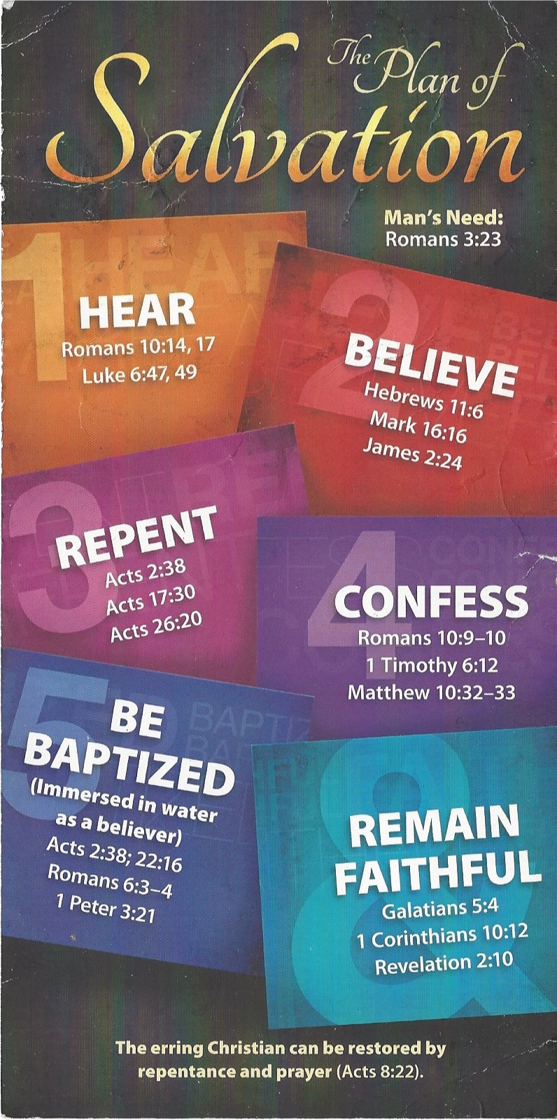
¹² Fight the good fight of the faith. Take hold of the eternal life to which you were called when you made your good confession in the presence of many witnesses.

Be Baptized - Acts 22:16 (NIV)
¹⁶ And now what are you waiting for? Get up, be baptized and wash your sins away, calling on his name.’
Remain Steadfast - Revelation 2:10 (NIV)
¹⁰ Do not be afraid of what you are about to suffer. I tell you, the devil will put some of you in prison to test you, and you will suffer persecution for ten days. Be faithful, even to the point of death, and I will give you life as your victor’s crown.
Coming in March
Wed. Mar. 1, 2017 | (2) The Deliverance through Joseph (7:9–16) | T. Padgett
Sun. Mar. 5, 2017 | (3) The Deliverance through Moses (7:17–34) | B. Johnson
Sun. Mar. 5, 2017 eve | (4) The Apostasy of Israel (7:35–50) | C. Banks
Wed. Mar. 8, 2017 | (5) The Rejection of the Messiah (7:51–53) | T. Padgett
Sun. Mar. 12, 2017 | 4. Stephen’s Martyrdom (7:54–8:1a) | B. Johnson
Sun. Mar. 12, 2017 eve | 5. Persecution and Dispersal of the Hellenists (8:1b-3) | M. Hollins
 | 6. The Witness of Philip (8:4–40)
 | (1) The Mission in Samaria (8:4–25)
Wed. Mar. 15, 2017 | Philip’s Witness to the Samaritans (8:4–8) | D. Drozd
Sun. Mar. 19, 2017 | Philip and Simon (8:9–13) | T. Padgett
Sun. Mar. 19, 2017 eve | Peter and John and the Samaritans (8:14–17) | B. Johnson
Wed. Mar. 22, 2017 | Peter and Simon (8:18–24) | T. Padgett
 | Conclusion (8:25)
 | (2) The Witness to the Ethiopian Treasurer (8:26–40)
Sun. Mar. 26, 2017 | The Preparation (8:26–29) | B. Johnson
Sun. Mar. 26, 2017 eve | The Witness (8:30–35) | T. Padgett
Wed. Mar. 29, 2017 | The Commitment (8:36–40) | D. Drozd

