Central Idea
The obedient submission of Jesus to his Father, seen in his willingness to become human for humanity’s sake, his freedom from self-interest and his willingness to serve others.

- Jesus willingness to become human
Philippians 2:6–7 (ESV) — 6 who, though he was in the form of God, did not count equality with God a thing to be grasped, 7 but emptied himself, by taking the form of a servant, being born in the likeness of men.
- Jesus humility predicted in OT
Matthew 12:19–20 (ESV) — 19 He will not quarrel or cry aloud, nor will anyone hear his voice in the streets; 20 a bruised reed he will not break, and a smoldering wick he will not quench, until he brings justice to victory;
- The suffering servant:
Acts 8:32–33 (ESV) — 32 Now the passage of the Scripture that he was reading was this: “Like a sheep he was led to the slaughter and like a lamb before its shearer is silent, so he opens not his mouth. 33 In his humiliation justice was denied him. Who can describe his generation? For his life is taken away from the earth.”
- The coming king:
Matthew 21:5 (ESV) — 5 “Say to the daughter of Zion, ‘Behold, your king is coming to you, humble, and mounted on a donkey, on a colt, the foal of a beast of burden.’ ”
- The shepherd struck:
Matthew 26:31 (ESV) — 31 Then Jesus said to them, “You will all fall away because of me this night. For it is written, ‘I will strike the shepherd, and the sheep of the flock will be scattered.’
- Jesus servant attitude
Mark 10:45 (ESV) — 45 For even the Son of Man came not to be served but to serve, and to give his life as a ransom for many.”

- Jesus teaching humility
Mark 9:33–37 (ESV) — 33 And they came to Capernaum. And when he was in the house he asked them, “What were you discussing on the way?” 34 But they kept silent, for on the way they had argued with one another about who was the greatest. 35 And he sat down and called the twelve. And he said to them, “If anyone would be first, he must be last of all and servant of all.” 36 And he took a child and put him in the midst of them, and taking him in his arms, he said to them, 37 “Whoever receives one such child in my name receives me, and whoever receives me, receives not me but him who sent me.”
- Jesus humility modeled for others
John 13:12–17 (ESV) — 12 When he had washed their feet and put on his outer garments and resumed his place, he said to them, “Do you understand what I have done to you? 13 You call me Teacher and Lord, and you are right, for so I am. 14 If I then, your Lord and Teacher, have washed your feet, you also ought to wash one another’s feet. 15 For I have given you an example, that you also should do just as I have done to you. 16 Truly, truly, I say to you, a servant is not greater than his master, nor is a messenger greater than the one who sent him. 17 If you know these things, blessed are you if you do them.
- The poverty of Jesus
Luke 2:7 (ESV) — 7 And she gave birth to her firstborn son and wrapped him in swaddling cloths and laid him in a manger, because there was no place for them in the inn.
- Jesus obedience to his parents
Luke 2:51 (ESV) — 51 And he went down with them and came to Nazareth and was submissive to them. And his mother treasured up all these things in her heart.
- Jesus obedience to His heavenly Father
John 5:30 (ESV) — 30 “I can do nothing on my own. As I hear, I judge, and my judgment is just, because I seek not my own will but the will of him who sent me.
- Jesus dependence on His heavenly Father
John 5:19 (ESV) — 19 So Jesus said to them, “Truly, truly, I say to you, the Son can do nothing of his own accord, but only what he sees the Father doing. For whatever the Father does, that the Son does likewise.
- Jesus submission to baptism
Matthew 3:13–15 (ESV) — 13 Then Jesus came from Galilee to the Jordan to John, to be baptized by him. 14 John would have prevented him, saying, “I need to be baptized by you, and do you come to me?” 15 But Jesus answered him, “Let it be so now, for thus it is fitting for us to fulfill all righteousness.” Then he consented.
- Jesus humble acceptance of bad treatment
1 Peter 2:23 (ESV) — 23 When he was reviled, he did not revile in return; when he suffered, he did not threaten, but continued entrusting himself to him who judges justly.
- Jesus acceptance of the cross
Philippians 2:8 (ESV) — 8 And being found in human form, he humbled himself by becoming obedient to the point of death, even death on a cross.
- Jesus humility with other people
- Children:
Matthew 19:13–15 (ESV) — 13 Then children were brought to him that he might lay his hands on them and pray. The disciples rebuked the people, 14 but Jesus said, “Let the little children come to me and do not hinder them, for to such belongs the kingdom of heaven.” 15 And he laid his hands on them and went away.
- Beggars:
Matthew 20:29–34 (ESV) — 29 And as they went out of Jericho, a great crowd followed him. 30 And behold, there were two blind men sitting by the roadside, and when they heard that Jesus was passing by, they cried out, “Lord, have mercy on us, Son of David!” 31 The crowd rebuked them, telling them to be silent, but they cried out all the more, “Lord, have mercy on us, Son of David!” 32 And stopping, Jesus called them and said, “What do you want me to do for you?” 33 They said to him, “Lord, let our eyes be opened.” 34 And Jesus in pity touched their eyes, and immediately they recovered their sight and followed him.

Hear - Romans 10:17 (NIV)
¹⁷ Consequently, faith comes from hearing the message, and the message is heard through the word about Christ.
Believe - Hebrews 11:6 (NIV)
⁶ And without faith it is impossible to please God, because anyone who comes to him must believe that he exists and that he rewards those who earnestly seek him.
Repent - Acts 17:30 (NIV)
³⁰ In the past God overlooked such ignorance, but now he commands all people everywhere to repent.
Confess - Romans 10:9–10 (NIV)
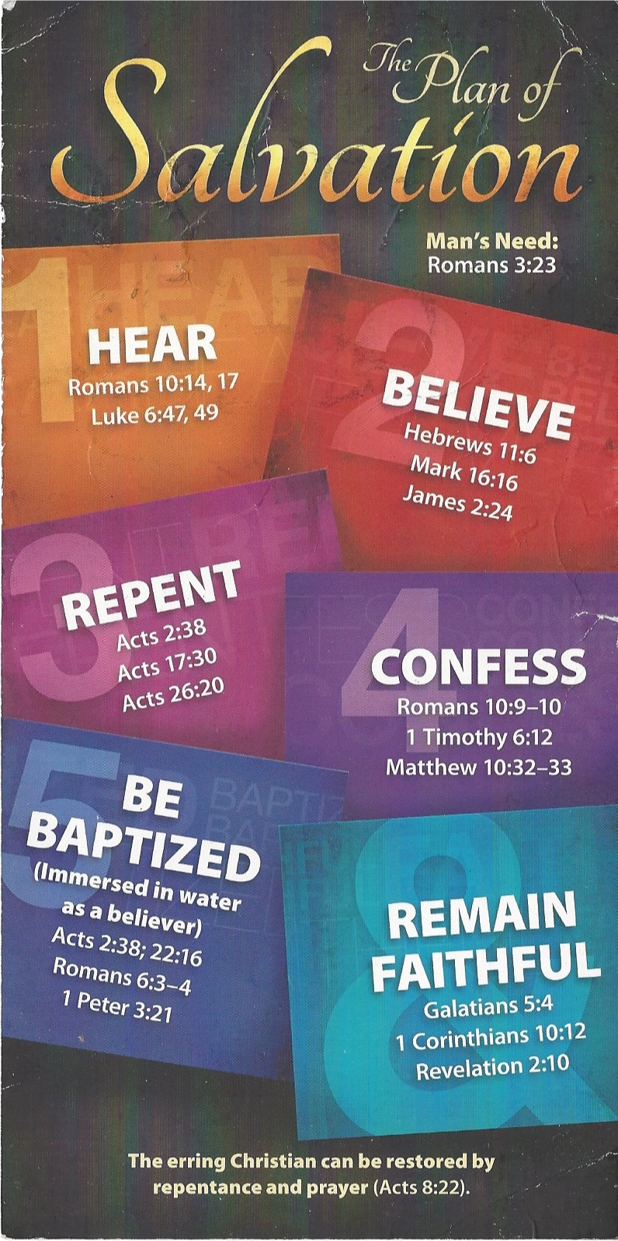
⁹ If you declare with your mouth, “Jesus is Lord,” and believe in your heart that God raised him from the dead, you will be saved. ¹⁰ For it is with your heart that you believe and are justified, and it is with your mouth that you profess your faith and are saved.
Be Baptized - Romans 6:3–4 (NIV)
³ Or don’t you know that all of us who were baptized into Christ Jesus were baptized into his death? ⁴ We were therefore buried with him through baptism into death in order that, just as Christ was raised from the dead through the glory of the Father, we too may live a new life.
Remain Faithful - Revelation 2:10 (NIV)
¹⁰ Do not be afraid of what you are about to suffer. I tell you, the devil will put some of you in prison to test you, and you will suffer persecution for ten days. Be faithful, even to the point of death, and I will give you life as your victor’s crown.

