Thesis:
The Empty Tomb of Jesus confirms His claims, frees mankind and establishes a new covenant with our creator.

I. Confirmation Of Jesus
A. Not a Liar, not a Lunatic
Mark 8:31 ESV
And he began to teach them that the Son of Man must suffer many things and be rejected by the elders and the chief priests and the scribes and be killed, and after three days rise again.
Matthew 16:21–24 ESV
From that time Jesus began to show his disciples that he must go to Jerusalem and suffer many things from the elders and chief priests and scribes, and be killed, and on the third day be raised. And Peter took him aside and began to rebuke him, saying, “Far be it from you, Lord! This shall never happen to you.” But he turned and said to Peter, “Get behind me, Satan! You are a hindrance to me. For you are not setting your mind on the things of God, but on the things of man.”
Then Jesus told his disciples, “If anyone would come after me, let him deny himself and take up his cross and follow me.
B. He is Lord
John 9:35–39 ESV
Jesus heard that they had cast him out, and having found him he said, “Do you believe in the Son of Man?” He answered, “And who is he, sir, that I may believe in him?” Jesus said to him, “You have seen him, and it is he who is speaking to you.” He said, “Lord, I believe,” and he worshiped him. Jesus said, “For judgment I came into this world, that those who do not see may see, and those who see may become blind.”
John 11:39 ESV
Jesus said, “Take away the stone.” Martha, the sister of the dead man, said to him, “Lord, by this time there will be an odor, for he has been dead four days.”
1 Thessalonians 4:16 ESV
For the Lord himself will descend from heaven with a cry of command, with the voice of an archangel, and with the sound of the trumpet of God. And the dead in Christ will rise first.
II. After the Sabbath
Matthew 28:1 ESV
Now after the Sabbath, toward the dawn of the first day of the week, Mary Magdalene and the other Mary went to see the tomb.
A. The Old is Dismissed
Colossians 2:13–14 ESV
And you, who were dead in your trespasses and the uncircumcision of your flesh, God made alive together with him, having forgiven us all our trespasses, by canceling the record of debt that stood against us with its legal demands. This he set aside, nailing it to the cross.
Ephesians 2:15 ESV
by abolishing the law of commandments expressed in ordinances, that he might create in himself one new man in place of the two, so making peace,
B. The New is Ushered In
1 Corinthians 11:25 ESV
In the same way also he took the cup, after supper, saying, “This cup is the new covenant in my blood. Do this, as often as you drink it, in remembrance of me.”
1 Peter 2:24 ESV
He himself bore our sins in his body on the tree, that we might die to sin and live to righteousness. By his wounds you have been healed.
III. Rolling back the Stone
Matthew 28:4 ESV
And for fear of him the guards trembled and became like dead men.
A. The Grave had Dominion
Job 38:17 ESV
Have the gates of death been revealed to you,
or have you seen the gates of deep darkness?
Isaiah 38:10 ESV
I said, In the middle of my days
I must depart;
I am consigned to the gates of Sheol
for the rest of my years.
B. We are released from the Grave
Psalm 9:13 ESV
Be gracious to me, O LORD!
See my affliction from those who hate me,
O you who lift me up from the gates of death,
Matthew 16:18 ESV
And I tell you, you are Peter, and on this rock I will build my church, and the gates of hell shall not prevail against it.

Hear - Romans 10:17 (NIV)
¹⁷ Consequently, faith comes from hearing the message, and the message is heard through the word about Christ.
Believe - Hebrews 11:6 (NIV)
⁶ And without faith it is impossible to please God, because anyone who comes to him must believe that he exists and that he rewards those who earnestly seek him.
Repent - Acts 17:30 (NIV)
³⁰ In the past God overlooked such ignorance, but now he commands all people everywhere to repent.
Confess - 1 Timothy 6:12 (NIV)
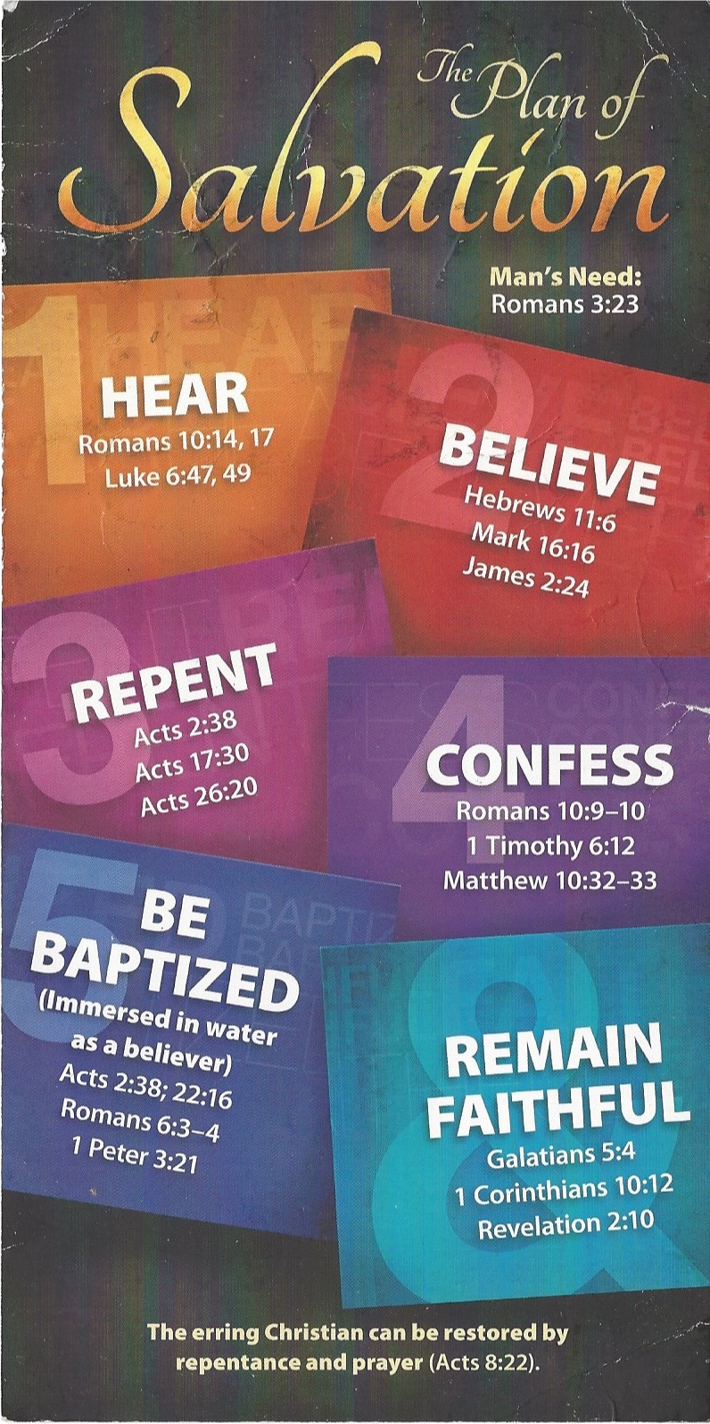
¹² Fight the good fight of the faith. Take hold of the eternal life to which you were called when you made your good confession in the presence of many witnesses.

Be Baptized - Acts 22:16 (NIV)
¹⁶ And now what are you waiting for? Get up, be baptized and wash your sins away, calling on his name.’
Remain Steadfast - Revelation 2:10 (NIV)
¹⁰ Do not be afraid of what you are about to suffer. I tell you, the devil will put some of you in prison to test you, and you will suffer persecution for ten days. Be faithful, even to the point of death, and I will give you life as your victor’s crown.

