Barry G. Johnson, Sr. / General
Discovering the Church / Conversion; Lydia becomes a believer; A Person Pure in Heart / Acts 16:11–15
The Lord opens the heart of Lydia and she and her household are baptized and added to the Church.
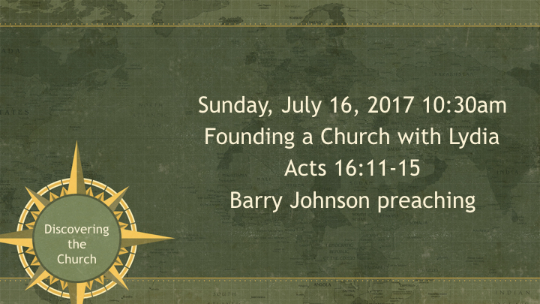
Acts 16:11–15 (ESV)
¹¹ So, setting sail from Troas, we made a direct voyage to Samothrace, and the following day to Neapolis, ¹² and from there to Philippi, which is a leading city of the district of Macedonia and a Roman colony. We remained in this city some days. ¹³ And on the Sabbath day we went outside the gate to the riverside, where we supposed there was a place of prayer, and we sat down and spoke to the women who had come together. ¹⁴ One who heard us was a woman named Lydia, from the city of Thyatira, a seller of purple goods, who was a worshiper of God. The Lord opened her heart to pay attention to what was said by Paul. ¹⁵ And after she was baptized, and her household as well, she urged us, saying, “If you have judged me to be faithful to the Lord, come to my house and stay.” And she prevailed upon us.

I. One Who Heard Us
Romans 10:14–18 ESV
¹⁴ How then will they call on him in whom they have not believed? And how are they to believe in him of whom they have never heard? And how are they to hear without someone preaching? ¹⁵ And how are they to preach unless they are sent? As it is written, “How beautiful are the feet of those who preach the good news!” ¹⁶ But they have not all obeyed the gospel. For Isaiah says, “Lord, who has believed what he has heard from us?” ¹⁷ So faith comes from hearing, and hearing through the word of Christ. ¹⁸ But I ask, have they not heard? Indeed they have, for “Their voice has gone out to all the earth, and their words to the ends of the world.”
Galatians 3:1–9 ESV
¹ O foolish Galatians! Who has bewitched you? It was before your eyes that Jesus Christ was publicly portrayed as crucified. ² Let me ask you only this: Did you receive the Spirit by works of the law or by hearing with faith? ³ Are you so foolish? Having begun by the Spirit, are you now being perfected by the flesh? ⁴ Did you suffer so many things in vain—if indeed it was in vain? ⁵ Does he who supplies the Spirit to you and works miracles among you do so by works of the law, or by hearing with faith— ⁶ just as Abraham “believed God, and it was counted to him as righteousness”? ⁷ Know then that it is those of faith who are the sons of Abraham. ⁸ And the Scripture, foreseeing that God would justify the Gentiles by faith, preached the gospel beforehand to Abraham, saying, “In you shall all the nations be blessed.” ⁹ So then, those who are of faith are blessed along with Abraham, the man of faith.

II. A Worshipper of God
John 4:23–24 ESV
²³ But the hour is coming, and is now here, when the true worshipers will worship the Father in spirit and truth, for the Father is seeking such people to worship him. ²⁴ God is spirit, and those who worship him must worship in spirit and truth.”
Mark 7:6–9 ESV
⁶ And he said to them, “Well did Isaiah prophesy of you hypocrites, as it is written, “ ‘This people honors me with their lips, but their heart is far from me; ⁷ in vain do they worship me, teaching as doctrines the commandments of men.’ ⁸ You leave the commandment of God and hold to the tradition of men.” ⁹ And he said to them, “You have a fine way of rejecting the commandment of God in order to establish your tradition!

III. The Lord Opened Her Heart
Matthew 16:13–17 ESV
¹³ Now when Jesus came into the district of Caesarea Philippi, he asked his disciples, “Who do people say that the Son of Man is?” ¹⁴ And they said, “Some say John the Baptist, others say Elijah, and others Jeremiah or one of the prophets.” ¹⁵ He said to them, “But who do you say that I am?” ¹⁶ Simon Peter replied, “You are the Christ, the Son of the living God.” ¹⁷ And Jesus answered him, “Blessed are you, Simon Bar-Jonah! For flesh and blood has not revealed this to you, but my Father who is in heaven.
Proverbs 15:11 ESV
¹¹ Sheol and Abaddon lie open before the Lord; how much more the hearts of the children of man!
Revelation 3:10 ESV
¹⁰ Because you have kept my word about patient endurance, I will keep you from the hour of trial that is coming on the whole world, to try those who dwell on the earth.

Invitation God’s Plan of Salvation
