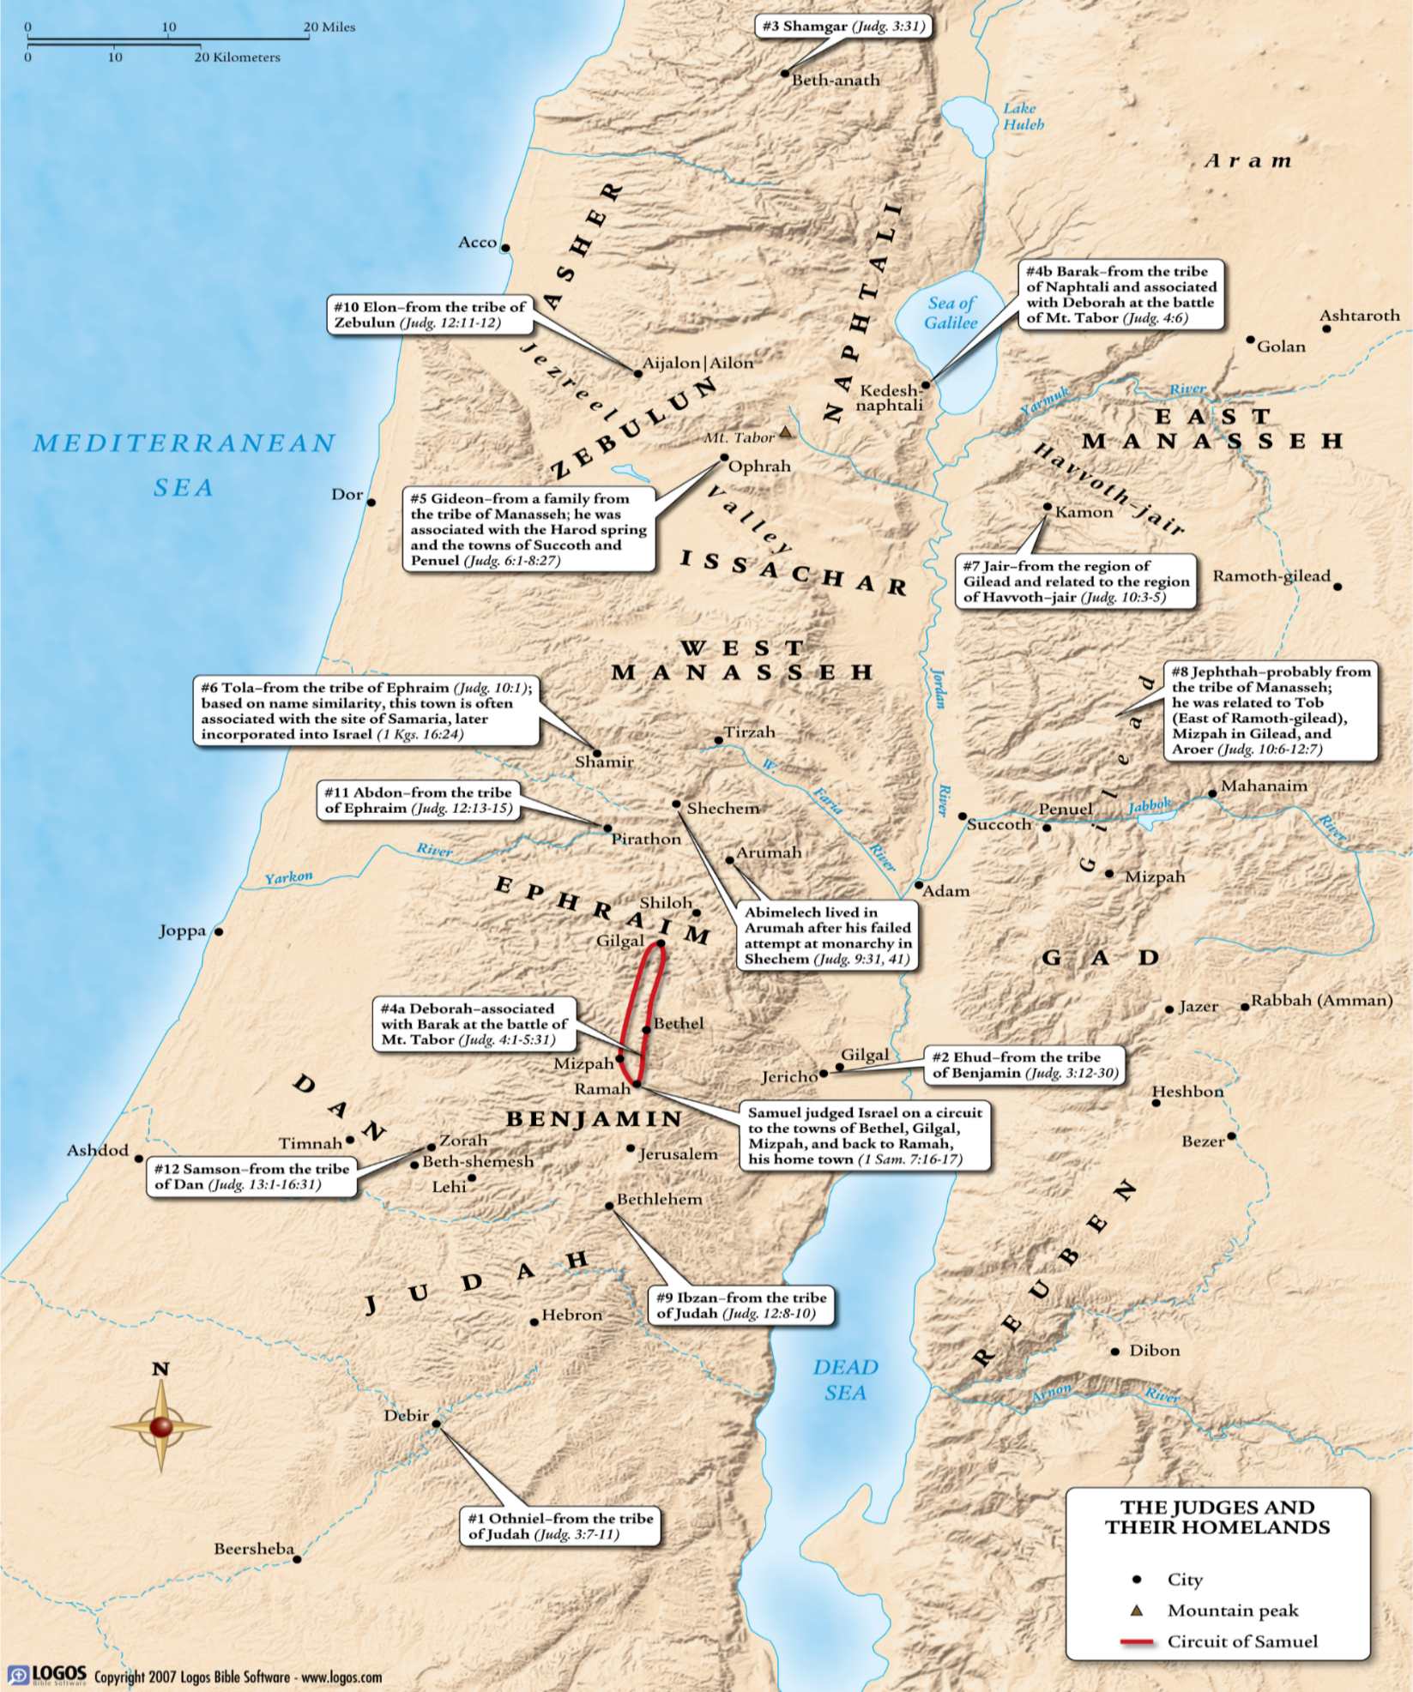
Barry G. Johnson, Sr. / www.barrygjohnsonsr.com
Judges: A Modern-Day Spiral / Judges 20:1–3
God’s people are often their own worst enemy. It is not the enemies outside who threaten the soul but the Canaanite within.
Judges 20:1–3 ESV
¹ Then all the people of Israel came out, from Dan to Beersheba, including the land of Gilead, and the congregation assembled as one man to the Lord at Mizpah. ² And the chiefs of all the people, of all the tribes of Israel, presented themselves in the assembly of the people of God, 400,000 men on foot that drew the sword. ³ (Now the people of Benjamin heard that the people of Israel had gone up to Mizpah.) And the people of Israel said, “Tell us, how did this evil happen?”

The Moral Degeneration of Israel (19:1-21:25)

Beginning of the outrage at Gibeah (19:1-9)
Judges 19:1–2 ESV
¹ In those days, when there was no king in Israel, a certain Levite was sojourning in the remote parts of the hill country of Ephraim, who took to himself a concubine from Bethlehem in Judah. ² And his concubine was unfaithful to him, and she went away from him to her father’s house at Bethlehem in Judah, and was there some four months.

Nature of the outrage at Gibeah (19:10-30)
Judges 19:15 ESV
¹⁵ and they turned aside there, to go in and spend the night at Gibeah. And he went in and sat down in the open square of the city, for no one took them into his house to spend the night.
Judges 19:16–17 ESV
¹⁶ And behold, an old man was coming from his work in the field at evening. The man was from the hill country of Ephraim, and he was sojourning in Gibeah. The men of the place were Benjaminites. ¹⁷ And he lifted up his eyes and saw the traveler in the open square of the city. And the old man said, “Where are you going? And where do you come from?”
Judges 19:22–23 ESV
²² As they were making their hearts merry, behold, the men of the city, worthless fellows, surrounded the house, beating on the door. And they said to the old man, the master of the house, “Bring out the man who came into your house, that we may know him.” ²³ And the man, the master of the house, went out to them and said to them, “No, my brothers, do not act so wickedly; since this man has come into my house, do not do this vile thing.
Judges 19:24 ESV
²⁴ Behold, here are my virgin daughter and his concubine. Let me bring them out now. Violate them and do with them what seems good to you, but against this man do not do this outrageous thing.”
Judges 19:25–26 ESV
²⁵ But the men would not listen to him. So the man seized his concubine and made her go out to them. And they knew her and abused her all night until the morning. And as the dawn began to break, they let her go. ²⁶ And as morning appeared, the woman came and fell down at the door of the man’s house where her master was, until it was light.

The Canaanization of Israel comes to a fitting conclusion
2 Corinthians 5:18–19 ESV
¹⁸ All this is from God, who through Christ reconciled us to himself and gave us the ministry of reconciliation; ¹⁹ that is, in Christ God was reconciling the world to himself, not counting their trespasses against them, and entrusting to us the message of reconciliation.

Civil War threatens the survival of a people
Judges 21:1–2 ESV

Judges is named after an interesting collection of individuals who led Israel after Joshua’s death until the rise of the monarchy under Samuel (up to about 1050 b.c.). In this time of national decline, despite their promise to keep the covenant (Josh. 24:16–18) the people turned from the Lord and began to worship other gods. “Everyone did what was right in his own eyes” (17:6; 21:25). A pattern repeats throughout the book: 1) the people abandoned the Lord; 2) God punished them by raising up a foreign power to oppress them; 3) the people cried out to God for deliverance; and 4) God raised up a deliverer, or judge, for them. The author of the book is unknown, although some Jewish tradition ascribes it to Samuel.
¹ Now the men of Israel had sworn at Mizpah, “No one of us shall give his daughter in marriage to Benjamin.” ² And the people came to Bethel and sat there till evening before God, and they lifted up their voices and wept bitterly.
Judges 21:5–8 ESV
⁵ And the people of Israel said, “Which of all the tribes of Israel did not come up in the assembly to the Lord?” For they had taken a great oath concerning him who did not come up to the Lord to Mizpah, saying, “He shall surely be put to death.” ⁶ And the people of Israel had compassion for Benjamin their brother and said, “One tribe is cut off from Israel this day. ⁷ What shall we do for wives for those who are left, since we have sworn by the Lord that we will not give them any of our daughters for wives?”
⁸ And they said, “What one is there of the tribes of Israel that did not come up to the Lord to Mizpah?” And behold, no one had come to the camp from Jabesh-gilead, to the assembly.
Judges 21:10–14 ESV
¹⁰ So the congregation sent 12,000 of their bravest men there and commanded them, “Go and strike the inhabitants of Jabesh-gilead with the edge of the sword; also the women and the little ones. ¹¹ This is what you shall do: every male and every woman that has lain with a male you shall devote to destruction.” ¹² And they found among the inhabitants of Jabesh-gilead 400 young virgins who had not known a man by lying with him, and they brought them to the camp at Shiloh, which is in the land of Canaan.
¹³ Then the whole congregation sent word to the people of Benjamin who were at the rock of Rimmon and proclaimed peace to them. ¹⁴ And Benjamin returned at that time. And they gave them the women whom they had saved alive of the women of Jabesh-gilead, but they were not enough for them.
Judges 21:25 ESV
²⁵ In those days there was no king in Israel. Everyone did what was right in his own eyes.

What Must I Do to be Saved?

Hear
Romans 10:17 ESV
¹⁷ So faith comes from hearing, and hearing through the word of Christ.

Believe
1 Corinthians 1:21 ESV
²¹ For since, in the wisdom of God, the world did not know God through wisdom, it pleased God through the folly of what we preach to save those who believe.

Confess
Romans 10:9–10 ESV
⁹ because, if you confess with your mouth that Jesus is Lord and believe in your heart that God raised him from the dead, you will be saved. ¹⁰ For with the heart one believes and is justified, and with the mouth one confesses and is saved.

Repent
Luke 13:3 ESV
³ No, I tell you; but unless you repent, you will all likewise perish.

Be Baptized
Acts 2:41 ESV
⁴¹ So those who received his word were baptized, and there were added that day about three thousand souls.

Remain Faithful
Revelation 2:10 ESV
¹⁰ Do not fear what you are about to suffer. Behold, the devil is about to throw some of you into prison, that you may be tested, and for ten days you will have tribulation. Be faithful unto death, and I will give you the crown of life.

My Decision Today
- I would like to be baptized today
- I would like to renew my life to Christ
- I would like to learn more about Jesus and the Bible
What are my next steps?
- Come forward to be baptized
- Request a Bible Study to learn more
- Attend Bible Class to grow and mature
- Find a place to serve others

