Barry G. Johnson, Sr. / www.bgjsr22.com
Christianity is Reality: There is a Heaven / Heaven; Eternity; Examination; Life; Eternal Life; Time / Matthew 25:31–34
Heaven is the place where those who overcome in life, will experience eternity.
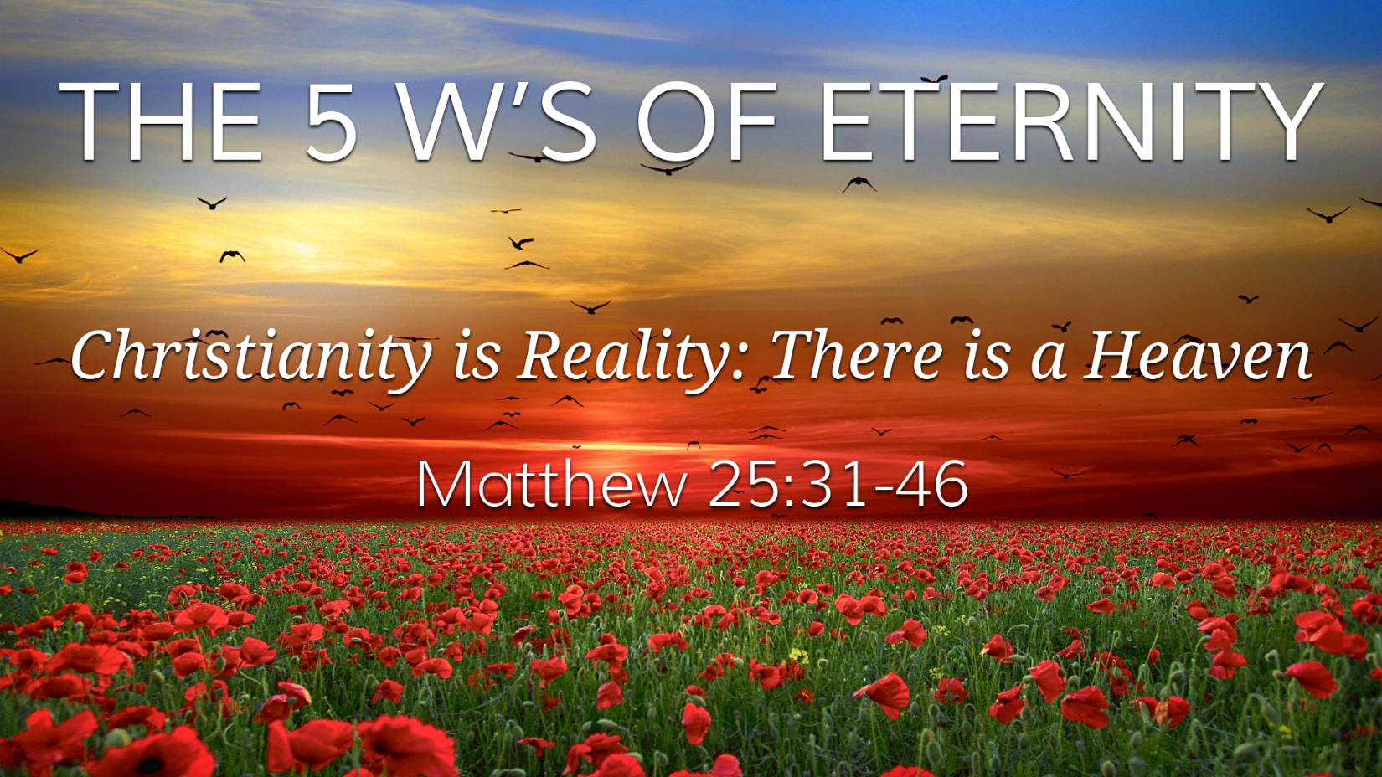
Matthew 25:31–34 ESV
³¹ “When the Son of Man comes in his glory, and all the angels with him, then he will sit on his glorious throne. ³² Before him will be gathered all the nations, and he will separate people one from another as a shepherd separates the sheep from the goats. ³³ And he will place the sheep on his right, but the goats on the left. ³⁴ Then the King will say to those on his right, ‘Come, you who are blessed by my Father, inherit the kingdom prepared for you from the foundation of the world.

What is Eternity?
Hebrews 1:1–2 ESV
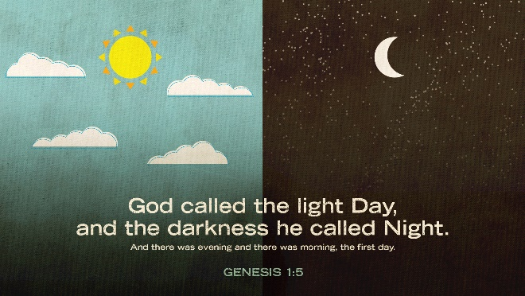
¹ Long ago, at many times and in many ways, God spoke to our fathers by the prophets, ² but in these last days he has spoken to us by his Son, whom he appointed the heir of all things, through whom also he created the world.

When is Eternity?
2 Peter 3:8 ESV
⁸ But do not overlook this one fact, beloved, that with the Lord one day is as a thousand years, and a thousand years as one day.
Ecclesiastes 3:11 ESV
¹¹ He has made everything beautiful in its time. Also, he has put eternity into man’s heart, yet so that he cannot find out what God has done from the beginning to the end.

Who is in Eternity?
Romans 16:26 ESV
²⁶ but has now been disclosed and through the prophetic writings has been made known to all nations, according to the command of the eternal God, to bring about the obedience of faith—
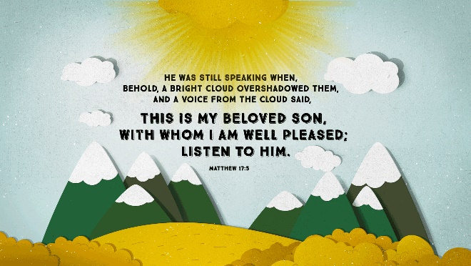
Psalm 90:2 ESV
² Before the mountains were brought forth,
or ever you had formed the earth and the world,
from everlasting to everlasting you are God.
John 8:58 ESV
⁵⁸ Jesus said to them, “Truly, truly, I say to you, before Abraham was, I am.”
Hebrews 9:14 ESV
¹⁴ how much more will the blood of Christ, who through the eternal Spirit offered himself without blemish to God, purify our conscience from dead works to serve the living God.
Matthew 17:1–4 ESV
¹ And after six days Jesus took with him Peter and James, and John his brother, and led them up a high mountain by themselves. ² And he was transfigured before them, and his face shone like the sun, and his clothes became white as light. ³ And behold, there appeared to them Moses and Elijah, talking with him. ⁴ And Peter said to Jesus, “Lord, it is good that we are here. If you wish, I will make three tents here, one for you and one for Moses and one for Elijah.”
Matthew 17:6–9 ESV
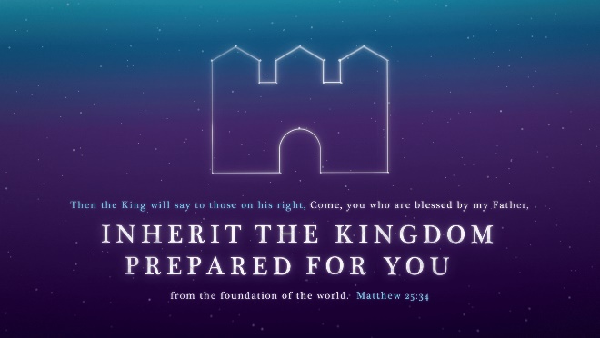
⁶ When the disciples heard this, they fell on their faces and were terrified. ⁷ But Jesus came and touched them, saying, “Rise, and have no fear.” ⁸ And when they lifted up their eyes, they saw no one but Jesus only.
⁹ And as they were coming down the mountain, Jesus commanded them, “Tell no one the vision, until the Son of Man is raised from the dead.”

Why is Eternity?
Luke 23:43 ESV
⁴³ And he said to him, “Truly, I say to you, today you will be with me in paradise.”
John 14:2–3 ESV
² In my Father’s house are many rooms. If it were not so, would I have told you that I go to prepare a place for you? ³ And if I go and prepare a place for you, I will come again and will take you to myself, that where I am you may be also.

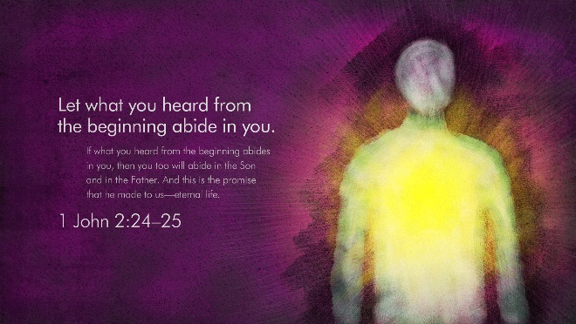
Where is Eternity?
Matthew 25:46 ESV
⁴⁶ And these will go away into eternal punishment, but the righteous into eternal life.”

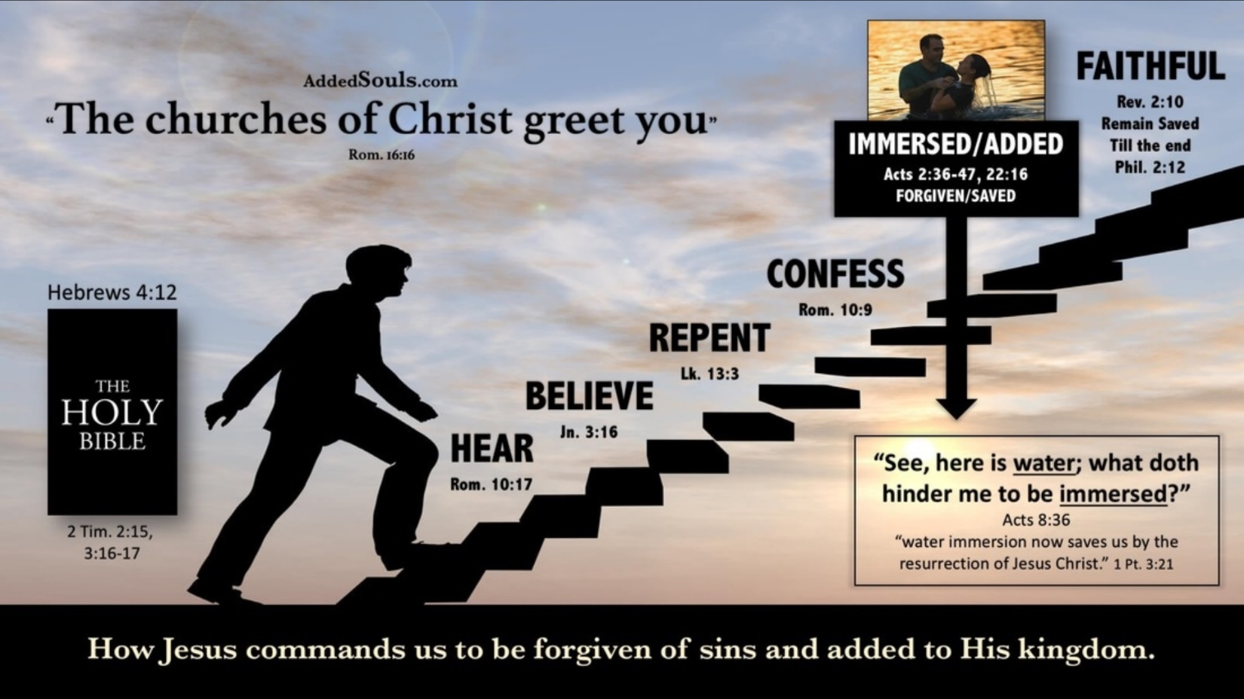
God’s Invitation to Heaven

