Assurance and life of faith (from Logos Sermon Starter)
Synopsis
The completeness of conviction and confidence expressed in the life of the believer. It derives from a reliance upon God and his promises alone, and results in boldness and steadfastness in service and in the face of difficulties.
- Assurance and Faith
Deuteronomy 9:3 (NIV) — 3 But be assured today that the Lord your God is the one who goes across ahead of you like a devouring fire. He will destroy them; he will subdue them before you. And you will drive them out and annihilate them quickly, as the Lord has promised you.
Hebrews 10:22 (NIV) — 22 let us draw near to God with a sincere heart and with the full assurance that faith brings, having our hearts sprinkled to cleanse us from a guilty conscience and having our bodies washed with pure water.
- Assurance and Hope
Hebrews 6:11 (NIV) — 11 We want each of you to show this same diligence to the very end, so that what you hope for may be fully realized.
- Assurance expressed by Believers
- Assurance in Adversity
Hebrews 13:6 (NIV) — 6 So we say with confidence, “The Lord is my helper; I will not be afraid. What can mere mortals do to me?”
- Assurance of God’s Promises
Joshua 23:14 (NIV) — 14 “Now I am about to go the way of all the earth. You know with all your heart and soul that not one of all the good promises the Lord your God gave you has failed. Every promise has been fulfilled; not one has failed.
- Assurance in Ministry
Romans 1:16 (NIV) — 16 For I am not ashamed of the gospel, because it is the power of God that brings salvation to everyone who believes: first to the Jew, then to the Gentile.
1 Timothy 3:13 (NIV) — 13 Those who have served well gain an excellent standing and great assurance in their faith in Christ Jesus.
- Assurance in Prayer
1 John 5:14 (NIV) — 14 This is the confidence we have in approaching God: that if we ask anything according to his will, he hears us.
- Assurance of God’s Will
Romans 14:5 (NIV) — 5 One person considers one day more sacred than another; another considers every day alike. Each of them should be fully convinced in their own mind.
- Assurance may be Strengthened
- Examples of Believers asking for Assurance
Ge 15:8 Abraham; Ex 33:16 Moses; Jdg 6:17 Gideon; Lk 1:18 Zechariah
Genesis 15:8 (NIV) — 8 But Abram said, “Sovereign Lord, how can I know that I will gain possession of it?”
Exodus 33:16 (NIV) — 16 How will anyone know that you are pleased with me and with your people unless you go with us? What else will distinguish me and your people from all the other people on the face of the earth?”
Judges 6:17 (NIV) — 17 Gideon replied, “If now I have found favor in your eyes, give me a sign that it is really you talking to me.
Luke 1:18 (NIV) — 18 Zechariah asked the angel, “How can I be sure of this? I am an old man and my wife is well along in years.”
- Assurance through Understanding
Colossians 2:2 (NIV) — 2 My goal is that they may be encouraged in heart and united in love, so that they may have the full riches of complete understanding, in order that they may know the mystery of God, namely, Christ,
- Assurance through Waiting on God
Psalm 46:10 (NIV) — 10 He says, “Be still, and know that I am God; I will be exalted among the nations, I will be exalted in the earth.”
- Assurance Strengthened by Others
2 Ch 32:6–8 by example; 2 Ti 3:14 through teaching; Col 4:12 through prayer; 1 Th 3:2–3 through encouragement amidst trials
2 Chronicles 32:6–8 (NIV) — 6 He appointed military officers over the people and assembled them before him in the square at the city gate and encouraged them with these words: 7 “Be strong and courageous. Do not be afraid or discouraged because of the king of Assyria and the vast army with him, for there is a greater power with us than with him. 8 With him is only the arm of flesh, but with us is the Lord our God to help us and to fight our battles.” And the people gained confidence from what Hezekiah the king of Judah said.
2 Timothy 3:14 (NIV) — 14 But as for you, continue in what you have learned and have become convinced of, because you know those from whom you learned it,
Colossians 4:12 (NIV) — 12 Epaphras, who is one of you and a servant of Christ Jesus, sends greetings. He is always wrestling in prayer for you, that you may stand firm in all the will of God, mature and fully assured.
1 Thessalonians 3:2–3 (NIV) — 2 We sent Timothy, who is our brother and co-worker in God’s service in spreading the gospel of Christ, to strengthen and encourage you in your faith, 3 so that no one would be unsettled by these trials. For you know quite well that we are destined for them.
- False Teaching Weakens Assurance
2 Thessalonians 2:2 (NIV) — 2 not to become easily unsettled or alarmed by the teaching allegedly from us—whether by a prophecy or by word of mouth or by letter—asserting that the day of the Lord has already come.
2 Timothy 2:18 (NIV) — 18 who have departed from the truth. They say that the resurrection has already taken place, and they destroy the faith of some.
- The Delusion of False Assurance
- The Danger of Self-Assurance
Luke 18:9–14 (NIV) — 9 To some who were confident of their own righteousness and looked down on everyone else, Jesus told this parable: 10 “Two men went up to the temple to pray, one a Pharisee and the other a tax collector. 11 The Pharisee stood by himself and prayed: ‘God, I thank you that I am not like other people—robbers, evildoers, adulterers—or even like this tax collector. 12 I fast twice a week and give a tenth of all I get.’ 13 “But the tax collector stood at a distance. He would not even look up to heaven, but beat his breast and said, ‘God, have mercy on me, a sinner.’ 14 “I tell you that this man, rather than the other, went home justified before God. For all those who exalt themselves will be humbled, and those who humble themselves will be exalted.”
2 Corinthians 10:12 (NIV) — 12 We do not dare to classify or compare ourselves with some who commend themselves. When they measure themselves by themselves and compare themselves with themselves, they are not wise.
Philippians 3:3–4 (NIV) — 3 For it is we who are the circumcision, we who serve God by his Spirit, who boast in Christ Jesus, and who put no confidence in the flesh—4 though I myself have reasons for such confidence. If someone else thinks they have reasons to put confidence in the flesh, I have more:
- Such Assurance Proved False by Conduct
1 John 1:6 (NIV) — 6 If we claim to have fellowship with him and yet walk in the darkness, we lie and do not live out the truth.

Invitation
Romans 10:17 (NIV)
¹⁷ Consequently, faith comes from hearing the message, and the message is heard through the word about Christ.
Hebrews 11:6 (NIV)
⁶ And without faith it is impossible to please God, because anyone who comes to him must believe that he exists and that he rewards those who earnestly seek him.
Acts 17:30 (NIV)
³⁰ In the past God overlooked such ignorance, but now he commands all people everywhere to repent.
Matthew 10:32–33 (NIV)
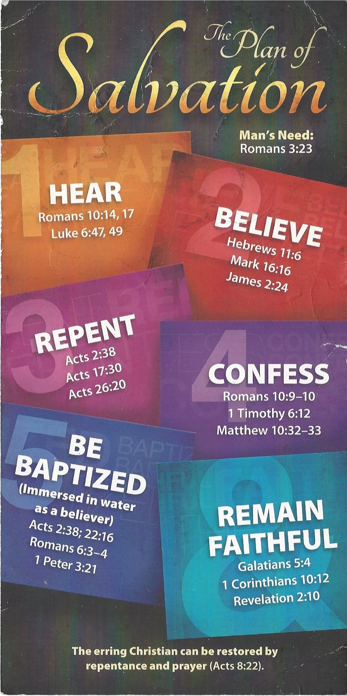
³² “Whoever acknowledges me before others, I will also acknowledge before my Father in heaven. ³³ But whoever disowns me before others, I will disown before my Father in heaven.
Acts 22:16 (NIV)
¹⁶ And now what are you waiting for? Get up, be baptized and wash your sins away, calling on his name.’
Revelation 2:10 (NIV)
¹⁰ Do not be afraid of what you are about to suffer. I tell you, the devil will put some of you in prison to test you, and you will suffer persecution for ten days. Be faithful, even to the point of death, and I will give you life as your victor’s crown.

