Walking Christian
Barry G. Johnson, Sr.
Brookfield church of Christ
Temptation
- Definitions
- Characteristics
- Causes
- Steps to Solution

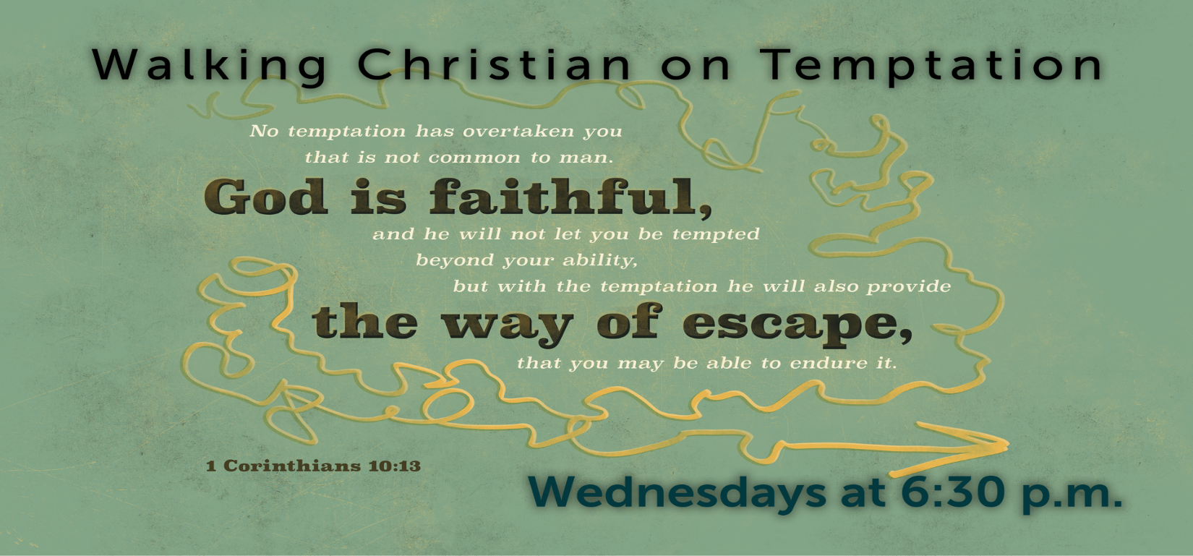
Temptation
Promise of Pleasure—Lured by a Lie
by June Hunt
facilitated by Barry G. Johnson, Sr.
“There is a way that seems right to a man, but in the end it leads to death.”
(Proverbs 14:12)
I. DEFINITIONS
A. What Is Temptation?
• The most common meaning of the word temptation is “an ____________________ to do wrong.”
— The word entice comes from an old Greek hunting and fishing term deleazo, which means “_____________________________________________.”
— No bait will tempt everyone, but everyone is tempted by some type of bait. What will tempt you depends on the desires within your ____________________.
“Each one is tempted when, by his own evil desire, he is dragged away and enticed.” (James 1:14)
• The Old Testament Hebrew word nasah means “an attempt to prove the ____________________ of something.”
— Nasah is most often translated in the Bible as “_______________________________________________________.”
— God permits us to be _________________________________ in order to reveal our strengths and our weaknesses.
Biblical Example:
“Some time later God tested Abraham. He said to him, ‘Abraham!’ ‘Here I am,’ he replied. Then God said, ‘Take your son, your only son, Isaac, whom you love, and go to the region of Moriah. Sacrifice him there as a burnt offering.’ ”
(Genesis 22:1–2)
• The New Testament Greek word peirasmos means “a temptation to sin” or “______________________________________________________________________.”
— This same Greek word is also translated “____________________” or “____________________.”
— When you are tempted, you are in a trying situation that reveals your ____________________ and tests your commitment.
— When you are tested by temptation, you are being ______________________________.
“In this you greatly rejoice, though now for a little while you may have had to suffer grief in all kinds of trials. These have come so that your faith—of greater worth than gold, which perishes even though refined by fire—may be proved genuine and may result in praise, glory and honor when Jesus Christ is revealed.” (1 Peter 1:6–7)
Temptation was experienced by Jesus.
Therefore, He is fully able to help you in your temptation.
“Because he himself suffered when he was tempted, he is able to help those who are being tempted.”
(Hebrews 2:18)
B. What Are Some Twisted Truths about Temptation?
Twisted Truth #1:
“Temptation is sinful.”
Truth:
________________________________. Jesus was tempted in every way, yet He did not sin.
“For we do not have a high priest who is unable to sympathize with our weaknesses, but we have one who has been tempted in every way, just as we are—yet was without sin.” (Hebrews 4:15)
Twisted Truth #2:
“God is tempting me!”
Truth:
____________________________________________________, but it is allowed by God.
“When tempted, no one should say, ‘God is tempting me.’ For God cannot be tempted by evil, nor does he tempt anyone.” (James 1:13)
Twisted Truth #3:
“The devil made me do it!”
Truth:
Temptation is Satan’s attempt to lure you into sin, but he can be ____________________.
“Submit yourselves, then, to God. Resist the devil, and he will flee from you.” (James 4:7)
Twisted Truth #4:
“Somebody else made me do it.”
Truth:
No one can make you kill, steal, lie, cheat or commit any immoral act. You have a ____________________ as to whether you give in to temptation or not.
“My son, if sinners entice you, do not give in to them.” (Proverbs 1:10).
Twisted Truth #5:
“She is so saintly, she is above temptation.”
Truth:
Everyone is tempted, just in different areas. In fact, the mature Christian is often subject to ____________________ temptation.
“So, if you think you are standing firm, be careful that you don’t fall!” (1 Corinthians 10:12)
Twisted Truth #6:
“A thought can’t be sinful.”
Truth:
An initial impure thought is not sinful, though it is a temptation. However, continuing with an unholy thought can make you ____________________ to sin.
“Repent of this wickedness and pray to the Lord. Perhaps he will forgive you for having such a thought in your heart. For I see that you are full of bitterness and captive to sin.” (Acts 8:22–23)
Twisted Truth #7:
“Just pull yourself up by your bootstraps.”
Truth:
Temptation is not overcome by your own ____________________. Temptation is defeated by admitting your weaknesses and yielding to Christ’s power within you.
“He said to me, ‘My grace is sufficient for you, for my power is made perfect in weakness.’ Therefore I will boast all the more gladly about my weaknesses, so that Christ’s power may rest on me.” (2 Corinthians 12:9)
Twisted Truth #8:
“God is angry at me when I’m tempted.”
Truth:
God does not disapprove of you because you are tempted. He can use the temptation as a tool to ____________________ your character.
“Consider it pure joy, my brothers, whenever you face trials of many kinds, because you know that the testing of your faith develops perseverance. Perseverance must finish its work so that you may be mature and complete, not lacking anything.” (James 1:2–4)
Twisted Truth #9:
“What’s the use? I’ve already blown it!”
Truth:
Failure is overcome by a change of ____________________: putting the past behind you and focusing on God’s goal for you—____________________. In Philippians 3:13–14, Paul shared how he appropriated this truth in his own life.
“Brothers, I do not consider myself yet to have taken hold of it. But one thing I do: Forgetting what is behind and straining toward what is ahead, I press on toward the goal to win the prize for which God has called me heavenward in Christ Jesus.” (Philippians 3:13–14)
Twisted Truth #10:
“It’s beyond my ability to control.”
Truth:
Temptation may be beyond your control, but it is not beyond ____________________ control.
“For the Lord will be your confidence and will keep your foot from being snared.” (Proverbs 3:26)
C. How Do You Track Temptation?
• Facing Temptation
— Temptation is experienced by ____________________.
— Temptation occurs often in an area where you have been ____________________ ensnared.
— Temptation begins in your ____________________.
— Temptation takes advantage of your ____________________ and ____________________.
— Temptation appears to meet a ____________________ need but does so illegitimately in the wrong way or at the wrong time.
“In the paths of the wicked lie thorns and snares, but he who guards his soul stays far from them.” (Proverbs 22:5)
• Falling into Temptation
— Temptation strikes when your ____________________ is “off guard.”
— Temptation is entered into by allowing your ____________________ to dwell on the tempting thoughts.
— Temptation uses ____________________ to numb your conscience.
— Temptation becomes relentless and ____________________.
— Temptation provides highly unusual ____________________ to enter into sin.
“Watch and pray so that you will not fall into temptation. The spirit is willing, but the body is weak.” (Matthew 26:41)
Biblical Example
David and Bathsheba
2 Samuel 11:1–13
Sin will make you stray further than you thought you’d stray,
Sin will make you stay longer than you thought you’d stay,
Sin will make you pay much more than you thought you’d pay.

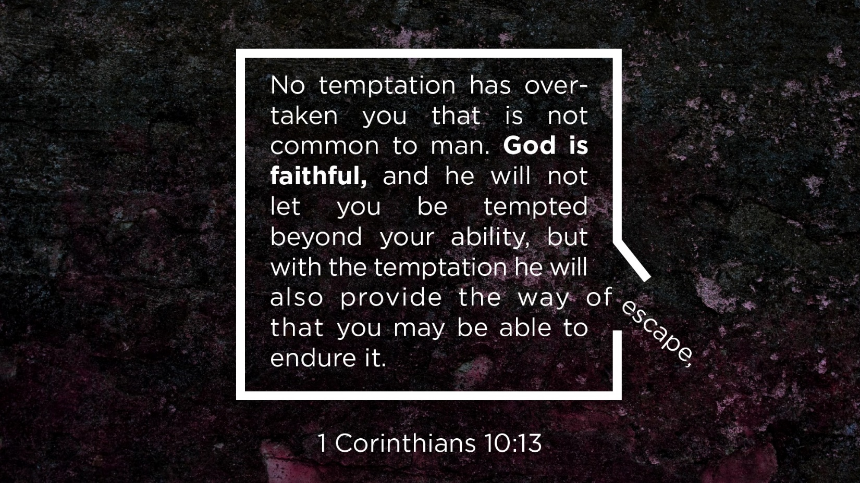
II. CHARACTERISTICS
A. The Taste of Temptation
“When the woman saw that the fruit of the tree was good for food and pleasing to the eye, and also desirable for gaining wisdom, she took some and ate it. She also gave some to her husband, who was with her, and he ate it.”
(Genesis 3:6)
Temptation is …
• ____________________ It appeals to your hopes and desires.
• ____________________ It promises you immense pleasure.
• ____________________ It evades the truth with excuses.
• ____________________ It ensnares your mind and emotions.
• ____________________ It multiplies your appetite for more.
• ____________________ It fails to produce what was promised.
• ____________________ It restricts your relationship with God.
“They promise them freedom, while they themselves are slaves of depravity—for a man is a slave to whatever has mastered him.”
(2 Peter 2:19)
B. Trapped by Temptation
“The righteousness of the upright delivers them, but the unfaithful are trapped by evil desires.”
(Proverbs 11:6)
The Temptation Trap
• Are you ____________________the temptation?
• Are you ____________________about your actions?
• Are you ____________________with hidden guilt?
• Are you ____________________from other interests?
• Are you ____________________eventual exposure?
• Are you ____________________of your salvation?
“My eyes are ever on the Lord, for only he will release my feet from the snare.”
(Psalm 25:15)

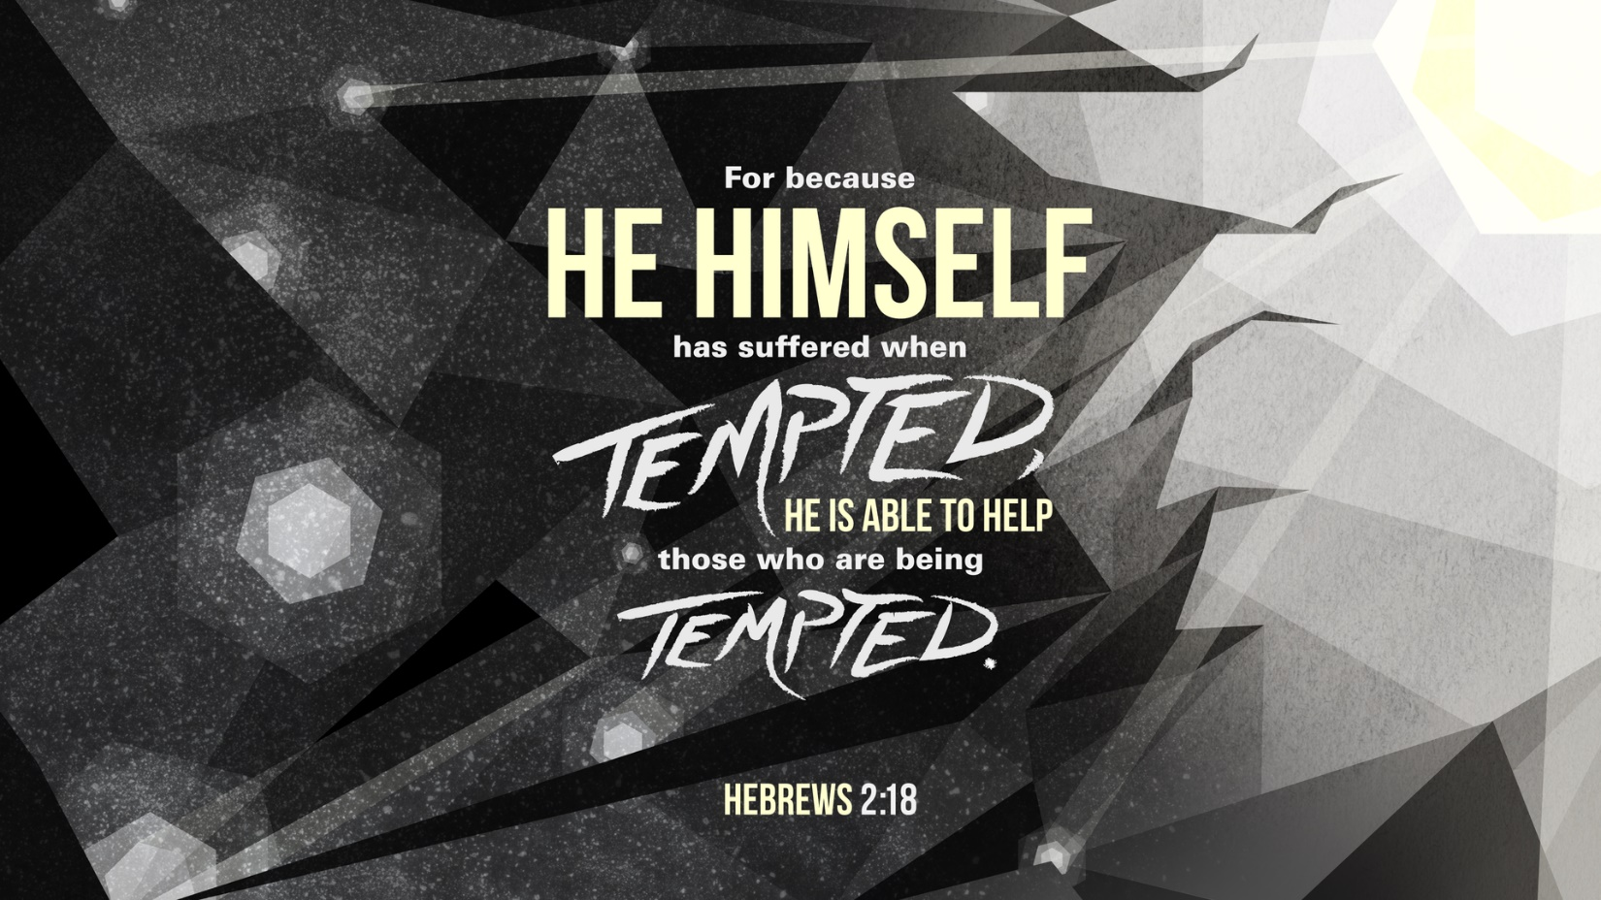
III. CAUSES
A. Causes of Defeat
“Be self-controlled and alert. Your enemy the devil prowls around like a roaring lion looking for someone to devour.”
(1 Peter 5:8)
Satan’s Avenues of Appeal
“You were dead in your transgressions and sins, in which you used to live when you followed the ways of this world and of the ruler of the kingdom of the air, the spirit who is now at work in those who are disobedient. All of us also lived among them at one time, gratifying the cravings of our sinful nature and following its desires and thoughts. Like the rest, we were by nature objects of wrath.”
(Ephesians 2:1–3)
Eve’s Temptation

Genesis 3:1–6
• Satan enticed Eve to disobey God and act _____________________ of His will.
• Satan tempted Eve to act on her physical _____________________ to … taste what is good.
• Satan tempted Eve through her natural desire to … have what is _____________________ to the eye.
• Satan tempted Eve by appealing to her need for _____________________ and her _____________________ desire to … “be like God.”
Jesus’ Temptation
Matthew 4:1–10
• Satan enticed Jesus to act for Himself, independently of His _____________________.
• Satan tempted Jesus to meet His own _____________________ needs … turn the stones into bread.
• Satan tempted Jesus by displaying something unusually _____________________ … “showed him all the kingdoms of the world.”
• Satan tempted Jesus by seeking to get Him to prove His own _____________________ … “if you are the Son of God.”
Your Temptation
1 John 2:16
• Satan entices me to act _____________________ of God and attempt to meet my own needs.
• Satan tempts me to follow my _____________________ desires … “lust of the flesh (KJV).”
• Satan tempts me to go after what is visually _____________________ … “lust of the eyes (KJV).”
• Satan tempts me through my desire for personal _____________________ … “pride of life (KJV).”
“Resist him, standing firm in the faith, because you know that your brothers throughout the world are undergoing the same kind of sufferings.”
(1 Peter 5:9)

B. Root Cause
Wrong Belief:
“This is so tempting that right now I want it more than anything else. Although I know it’s wrong, I feel that I need it.”
Right Belief:
_________________________________________________________________________________________________________________________________________________________________________________________________________________________________________________________________________________
“Cast your cares on the Lord and he will sustain you; he will never let the righteous fall.” (Psalm 55:22)

IV. STEPS TO SOLUTION
A. Key Verse to Memorize
“No temptation has seized you except what is common to man. And God is faithful; he will not let you be tempted beyond what you can bear. But when you are tempted, he will also provide a way out so that you can stand up under it.”
(1 Corinthians 10:13)
B. Key Passage to Read and Reread
Romans chapter 6
See Yourself Dead to Sinful Desires
• Because you are a believer, you are _____________________ to the bondage of sin. | v. 2
• Because you are “_____________________ into Christ,” you picture your old pattern of sin as dead and buried and see your new power over sin. | v. 3
• Because you are “_____________________ with Christ,” your old way of life is buried. | v. 4
• Because you are “_____________________ with Christ,” you have resurrection power over sin. | v. 4
• Because you are “_____________________ with Christ in His death,” you are dead to the power of sin’s desire. | v. 5
• Because you are “united with Christ in His _____________________,” you have supernatural power over sin. | v. 5
• Because your sin nature was “_____________________ with Christ,” your natural bent to sin is crucified. | v. 6
• Because all who have _____________________ are free from sin, you are no longer a slave to sin. | v. 7
• Because you “died with Christ,” you died to sin’s _____________________. | v. 8
• Because you know that death has no mastery over Christ, you are not to be mastered by the _____________________ of death. | v. 9
• Because you know that Christ _____________________ for God, you are to live for God. | v. 10
• Because you count yourself “dead to sin,” you deem yourself _____________________ to your old way of life. | v. 11
• Because you have been “brought from death to life,” your body is an instrument for _____________________ in a way that is right. | v. 13
C. The Freedom Formula
Formula for Self-Control
A New Purpose + A New Priority + A New Plan = Transformed Life
• Choose to _____________________ the character of Christ.
“For those God foreknew he also predestined to be conformed to the likeness of his Son.” (Romans 8:29)
• Choose to _____________________ your old habit for a new habit.
“Do not conform any longer to the pattern of this world, but be transformed by the renewing of your mind.” (Romans 12:2)
• Choose to _____________________ on Christ’s strength, not your own strength.
“I can do everything through him who gives me strength.” (Philippians 4:13)
• Choose to _____________________ God’s Gift of self-control.
“Therefore, prepare your minds for action; be self-controlled; set your hope fully on the grace to be given you when Jesus Christ is revealed.” (1 Peter 1:13)
Illustrations: How to Use the Formula
Hooked on Hunger
• A New Purpose:
________________________________________________________________________________________
• A New Priority:
________________________________________________________________________________________
• A New Plan:
I will rely on Christ’s strength, not mine …
— _____________________________________________________________________________________
— _____________________________________________________________________________________
— _____________________________________________________________________________________
— _____________________________________________________________________________________
— _____________________________________________________________________________________
— _____________________________________________________________________________________
— _____________________________________________________________________________________
— _____________________________________________________________________________________
— _____________________________________________________________________________________
— _____________________________________________________________________________________
“Whether you eat or drink or whatever you do, do it all for the glory of God.” (1 Corinthians 10:31)
Pulled by Pornography
• A New Purpose:
________________________________________________________________________________________
• A New Priority:
________________________________________________________________________________________
• A New Plan:
I will rely on Christ’s strength, not mine …
— _____________________________________________________________________________________
— _____________________________________________________________________________________
— to develop a strategy for Internet use by either getting rid of my computer, using it only under the password supervision of my wife or roommate or by installing accountability software on my computer (for example, www.covenanteyes.com)
— _____________________________________________________________________________________
— _____________________________________________________________________________________
— _____________________________________________________________________________________
— _____________________________________________________________________________________
— _____________________________________________________________________________________
D. Resisting Temptation
“In your struggle against sin, you have not yet resisted to the point of shedding your blood.”
(Hebrews 12:4)
Recognize the source.
• _____________________ that Satan is the author of tempting thoughts.
• _____________________ Satan’s purpose is to destroy your character.
• _____________________ to be snared by Satan.
• _____________________ that Satan is a defeated foe.
“For our struggle is not against flesh and blood, but against the rulers, against the authorities, against the powers of this dark world and against the spiritual forces of evil in the heavenly realms.” (Ephesians 6:12)
Expect to win the war.
• Expect to give your total _____________________.
• Expect many _____________________.
• Expect to win even if you _____________________ some minor battles.
• Expect _____________________ to win the war for you.
“In all these things we are more than conquerors through him who loved us.” (Romans 8:37)
Search your heart.
• Do you know that temptation is _____________________ your unmet need?
• Do you know the unmet needs to which you are _____________________ (the need for love, for significance and for security)?
• Do you know that seeking to meet the need _____________________ is sin?
• Do you know whether you _____________________ want to be delivered from this sin?
• Do you know that you are _____________________ to overcome sin in your own strength?
• Do you know that God will _____________________ your need in His time?
“Humble yourselves, therefore, under God’s mighty hand, that he may lift you up in due time.” (1 Peter 5:6)
Imagine the consequences.
• Think about the loss of your _____________________.
• Think about the _____________________ and _____________________ you would experience.
• Think about the loss of _____________________ and a clear conscience.
• Think about the _____________________ you may cause others.
• Think about the tragic _____________________ suffered by those who yielded to temptation in Scripture:
— Lot’s wife was turned to salt. (Read Genesis 19:1–29.)
— Samson lost his sight and strength. (Read Judges chapter 16.)
— David grieved over his divided family. (Read 2 Samuel 12:9–12.)
“Because of your wrath there is no health in my body; my bones have no soundness because of my sin.” (Psalm 38:3)
Sense God’s presence.
• God is with you every _____________________.
• God knows your _____________________ and _____________________.
• God knows your every _____________________.
• God knows how to help you _____________________ your thoughts.
“Nothing in all creation is hidden from God’s sight. Everything is uncovered and laid bare before the eyes of him to whom we must give account.” (Hebrews 4:13)
Transform your thoughts with truth.
• _____________________ your temptation as a test of loyalty.
• _____________________ the spiritual truth that sin has no power over you.
• _____________________ regular time praying for Christ’s strength.
• _____________________ God’s will and way through reading His Word.
• _____________________ specific Scriptures to memorize that apply to your area of temptation.
— temptation to be _______________________________________________________________________
“When words are many, sin is not absent, but he who holds his tongue is wise.” (Proverbs 10:19)
— temptation to be _______________________________________________________________________
“Do not let any unwholesome talk come out of your mouths, but only what is helpful for building others up according to their needs, that it may benefit those who listen.” (Ephesians 4:29)
— temptation to be _______________________________________________________________________
“Do not swerve to the right or the left; keep your foot from evil.” (Proverbs 4:27)
— temptation to be _______________________________________________________________________
“Can a man walk on hot coals without his feet being scorched? So is he who sleeps with another man’s wife; no one who touches her will go unpunished.” (Proverbs 6:28–29)
— temptation to be _______________________________________________________________________
“A gossip betrays a confidence, but a trustworthy man keeps a secret.” (Proverbs 11:13)
— temptation to be _______________________________________________________________________
“I made a covenant with my eyes not to look lustfully at a girl.” (Job 31:1)
— temptation to be _______________________________________________________________________
“Do not judge, or you too will be judged.” (Matthew 7:1)
— temptation to be _______________________________________________________________________
“What causes fights and quarrels among you? Don’t they come from your desires that battle within you?” (James 4: 1)
— temptation to be _______________________________________________________________________
“Everyone should be quick to listen, slow to speak and slow to become angry, for man’s anger does not bring about the righteous life that God desires.” (James 1:19–20)
“The weapons we fight with are not the weapons of the world. On the contrary, they have divine power to demolish strongholds. We demolish arguments and every pretension that sets itself up against the knowledge of God, and we take captive every thought to make it obedient to Christ.”
(2 Corinthians 10:4–5)
E. The Road Back Home
“So he got up and went to his father. But while he was still a long way off, his father saw him and was filled with compassion for him; he ran to his son, threw his arms around him and kissed him.”
(Luke 15:20)
The Road Back Home
Isaiah chapter 30
Isaiah chapter 30 pictures God’s relationship with His Hebrew children. They had been rebellious, deceitful and disobedient. “These are rebellious people, deceitful children, children unwilling to listen to the Lord’s instruction” (Isaiah 30:9). In spite of their rebellion, God reveals His compassion and His provision for their way back home. (Read Isaiah 30:15–26.)
• R_____________________
“This is what the Sovereign Lord, the Holy One of Israel, says: ‘In repentance and rest is your salvation, in quietness and trust is your strength, but you would have none of it.’ ” (Isaiah 30:15)
Repentance involves _____________________ grief over your sin—not just _____________________ for the consequences.
Repentance also requires total _____________________ before God, acknowledging your _____________________ and turning from temptation.
• R_____________________
“The Lord longs to be gracious to you; he rises to show you compassion. For the Lord is a God of justice. Blessed are all who wait for him!” (Isaiah 30:18)
Accept God’s _____________________ toward you as He offers His forgiveness.
Rest in His _____________________.
Don’t run ahead of the Lord … just _____________________ to know His will.
• R_____________________
“O people of Zion, who live in Jerusalem, you will weep no more. How gracious he will be when you cry for help! As soon as he hears, he will answer you.” (Isaiah 30:19)
Cry out for help! As soon as God hears you, He will answer you. Although you have _____________________, your pain will be eased as you allow His grace to _____________________ your heart.
• R_____________________
“Whether you turn to the right or to the left, your ears will hear a voice behind you, saying, ‘This is the way; walk in it.’ ” (Isaiah 30:21)
Once you return to God, you must learn His path for your life. As you pray and spend time in His Word, you will hear His voice telling you the way you must go. This way includes making _____________________ and accepting _____________________.
• R_____________________
“Then you will defile your idols overlaid with silver and your images covered with gold; you will throw them away like a menstrual cloth and say to them, ‘Away with you!’ ” (Isaiah 30:22)
As you yield yourself to God’s power, sin’s power will lose its hold on you. You will no longer be mastered by your desire to sin nor will you be in _____________________ to that which has controlled your mind, will and emotions.
• R_____________________
“He will also send you rain for the seed you sow in the ground, and the food that comes from the land will be rich and plentiful. In that day your cattle will graze in broad meadows. The oxen and donkeys that work the soil will eat fodder and mash, spread out with fork and shovel.… Streams of water will flow on every high mountain and every lofty hill. The moon will shine like the sun, and the sunlight will be seven times brighter, like the light of seven full days, when the Lord binds up the bruises of his people and heals the wounds he inflicted.” (Isaiah 30:23–26)
God will always bring blessing to the _____________________ heart that returns home. Your life will be richer, and the sun will shine brighter as you walk in communion with the Father of Compassion.

Sin is a declaration of independence from God. But when we choose sin, we find ourselves in slavery to sin. We abolish slavery when we believe God’s Word that the Christian is “dead to sin”—sin’s power. Abolish slavery with a declaration of independence from sin and experience your freedom in Christ.
—June Hunt

Turn from Temptation

When Tempted To …

• Blame God
“When tempted, no one should say, ‘God is tempting me.’ For God cannot be tempted by evil, nor does he tempt anyone.” (James 1:13)
• Complain
“Do everything without complaining or arguing, so that you may become blameless and pure, children of God without fault in a crooked and depraved generation, in which you shine like stars in the universe.” (Philippians 2:14–15)
• Doubt God
“What is impossible with men is possible with God.” (Luke 18:27)
• Give Up
“Therefore, since we are surrounded by such a great cloud of witnesses, let us throw off everything that hinders and the sin that so easily entangles, and let us run with perseverance the race marked out for us.” (Hebrews 12:1)
• Lie
“Truthful lips endure forever, but a lying tongue lasts only a moment.” (Proverbs 12:19)
• Lust
“You have heard that it was said, ‘Do not commit adultery.’ But I tell you that anyone who looks at a woman lustfully has already committed adultery with her in his heart. If your right eye causes you to sin, gouge it out and throw it away. It is better for you to lose one part of your body than for your whole body to be thrown into hell. And if your right hand causes you to sin, cut it off and throw it away. It is better for you to lose one part of your body than for your whole body to go into hell.” (Matthew 5:27–30)
• Quarrel
“Keep reminding them of these things. Warn them before God against quarreling about words; it is of no value, and only ruins those who listen.” (2 Timothy 2:14)
• Worry
“Do not worry about your life, what you will eat or drink; or about your body, what you will wear. Is not life more important than food, and the body more important than clothes? Look at the birds of the air; they do not sow or reap or store away in barns, and yet your heavenly Father feeds them. Are you not much more valuable than they? Who of you by worrying can add a single hour to his life? And why do you worry about clothes? See how the lilies of the field grow. They do not labor or spin. Yet I tell you that not even Solomon in all his splendor was dressed like one of these. If that is how God clothes the grass of the field, which is here today and tomorrow is thrown into the fire, will he not much more clothe you, O you of little faith? So do not worry, saying, ‘What shall we eat?’ or ‘What shall we drink?’ or ‘What shall we wear?’ For the pagans run after all these things, and your heavenly Father knows that you need them. But seek first his kingdom and his righteousness, and all these things will be given to you as well. Therefore do not worry about tomorrow, for tomorrow will worry about itself. Each day has enough trouble of its own.” (Matthew 6:25–34)
• Angry
“My dear brothers, take note of this: Everyone should be quick to listen, slow to speak and slow to become angry, for man’s anger does not bring about the righteous life that God desires.” (James 1:19–20)
• Discouraged
“We are hard pressed on every side, but not crushed; perplexed, but not in despair; persecuted, but not abandoned; struck down, but not destroyed.” (2 Corinthians 4:8–9)
• Disobedient
“This is love for God: to obey his commands. And his commands are not burdensome.” (1 John 5:3)
• Impatient
“Be completely humble and gentle; be patient, bearing with one another in love.” (Ephesians 4:2)
• Self-sufficient
“I am the vine; you are the branches. If a man remains in me and I in him, he will bear much fruit; apart from me you can do nothing.” (John 15:5)
• Unforgiving
“Bear with each other and forgive whatever grievances you may have against one another. Forgive as the Lord forgave you.” (Colossians 3:13)
• Unsubmissive
“Submit to one another out of reverence for Christ.” (Ephesians 5:21)
• Vengeful
“Do not repay anyone evil for evil. Be careful to do what is right in the eyes of everybody. If it is possible, as far as it depends on you, live at peace with everyone. Do not take revenge, my friends, but leave room for God’s wrath, for it is written: ‘It is mine to avenge; I will repay,’ says the Lord. On the contrary: ‘If your enemy is hungry, feed him; if he is thirsty, give him something to drink. In doing this, you will heap burning coals on his head.’ Do not be overcome by evil, but overcome evil with good.” (Romans 12:17–21)
“I have hidden your word in my heart that I might not sin against you.”
(Psalm 119:11)

All Scripture quotations, unless otherwise indicated, are taken from the HOLY BIBLE, NEW INTERNATIONAL VERSION®. NIV®.
Copyright © 1973, 1978, 1984 International Bible Society. Used by permission of Zondervan. All rights reserved.
We acknowledge that mistakes could occur in the writing of any of our resources or an omission may be found in the many Scripture references and citations contained herein. Although the editors have sought to avoid all errors, some may have crept in or been overlooked, for which we take full responsibility. The considerate reader would render us a great service by calling our attention to any such error.
The Biblical Counseling Keys should not be construed as a substitute for one-on-one, Christ-centered counseling when needed.
To order CDs, tapes, resource books and additional Biblical Counseling Keys on Anger, Depression,
Envy & Jealousy, Fear & Phobias, Guilt, Procrastination & Motivation, Self-Worth, Worry, and other related topics,
contact Hope For The Heart P.O. Box 7 Dallas, TX 75221 or call toll-free 1-800-488-HOPE (4673).
Please visit our website for License Agreement and Terms and Conditions.
www.hopefortheheart.org
All rights reserved worldwide. No part of this material may be reproduced in any form without written permission from Hope For The Heart.
© 1991–2008 Hope For The Heart

SELECTED BIBLIOGRAPHY
Arterburn, Stephen F., Fred Stoeker, and Mike Yorkey. Every Man’s Battle: Winning the War on Sexual Temptation One Victory at a Time. Colorado Springs, CO: WaterBrook, 2000.
Austin, Lynn. “Satan’s Tackle Box.” The Christian Reader, July/August 1994, 53–56.
Backus, William, and Marie Chapian. Why Do I Do What I Don’t Want to Do? Minneapolis, MN: Bethany House, 1984.
Baker, Don. Lord, I’ve Got a Problem. Eugene, OR: Harvest House, 1988.
Eisenman, Tom L. Temptations Men Face: Straightforward Talk on Power, Money, Affairs, Perfectionism, Insensitivity. Saltshaker Books. Downers Grove, IL: InterVarsity, 1990.
Gillham, Anabel. The Building Up & Tearing Down of Strongholds. Fort Worth, TX: Lifetime Guarantee Ministries, n.d.
Gothard, Bill. Moral Freedom. n.p.: Campus Teams, Inc., 1968.
Hunt, June. Counseling Through Your Bible Handbook. Eugene, Oregon: Harvest House Publishers, 2007.
Hunt, June. How to Forgive … When You Don’t Feel Like It. Eugene, Oregon: Harvest House Publishers, 2007.
Hunt, June. How to Handle Your Emotions. Eugene, Oregon: Harvest House Publishers, 2008.
Hunt, June. Seeing Yourself Through God’s Eyes. Eugene, Oregon: Harvest House Publishers, 2008
Instititute in Basic Youth Conflicts. “Ten Steps to Conquer Impure Thoughts.” In Training Faithful Men, 1976.
Lee, Richard. The Unfailing Promise. Waco, TX: Word, 1988.
Lutzer, Erwin W. How to Say No to a Stubborn Habit: Even When You Feel LIke Saying Yes. Wheaton, IL: Victor, 1986.
Owen, John. Sin & Temptation: The Challenge to Personal Godliness. abridged ed, ed. James M. Houston. Portland, OR: Multnomah, 1983.
Smith, Hannah Whitall. “Lies in Disguise.” Last Days Magazine, Fall 1988, 7–11.
Stanley, Charles F. Temptation. Nashville: Oliver-Nelson, 1988.

