Barry G. Johnson, Sr. / General
Discovering the Church / Slander; Truth / Acts 24:1–9
False and malicious talk about others. It not only harms those against whom it is directed, but also brings ruin to those who propagate it.
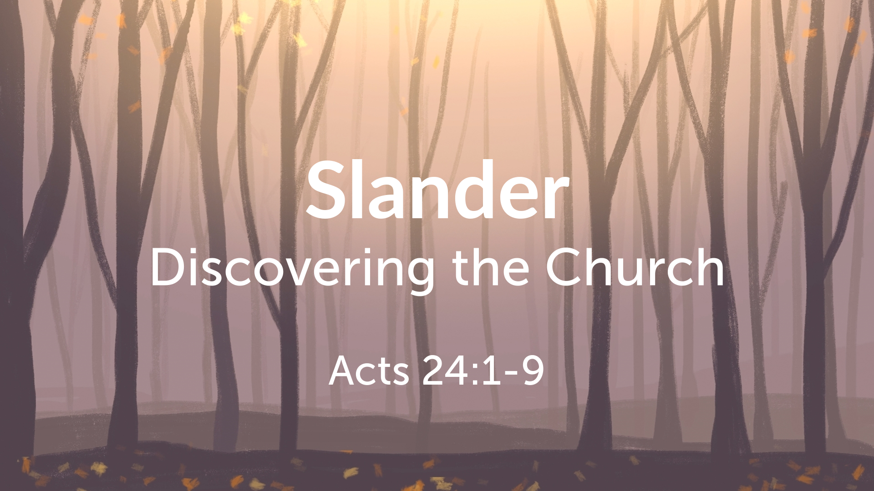
Acts 24:1–9 ESV
¹ And after five days the high priest Ananias came down with some elders and a spokesman, one Tertullus. They laid before the governor their case against Paul. ² And when he had been summoned, Tertullus began to accuse him, saying: “Since through you we enjoy much peace, and since by your foresight, most excellent Felix, reforms are being made for this nation, ³ in every way and everywhere we accept this with all gratitude. ⁴ But, to detain you no further, I beg you in your kindness to hear us briefly. ⁵ For we have found this man a plague, one who stirs up riots among all the Jews throughout the world and is a ringleader of the sect of the Nazarenes. ⁶ He even tried to profane the temple, but we seized him. ⁸ By examining him yourself you will be able to find out from him about everything of which we accuse him.” ⁹ The Jews also joined in the charge, affirming that all these things were so.

Slander condemned

Slander is sinful
Mark 7:21–23 ESV
²¹ For from within, out of the heart of man, come evil thoughts, sexual immorality, theft, murder, adultery, ²² coveting, wickedness, deceit, sensuality, envy, slander, pride, foolishness. ²³ All these evil things come from within, and they defile a person.”

Slander is forbidden
Leviticus 19:16 ESV
¹⁶ You shall not go around as a slanderer among your people, and you shall not stand up against the life of your neighbor: I am the Lord.
Colossians 3:8 ESV
⁸ But now you must put them all away: anger, wrath, malice, slander, and obscene talk from your mouth.

Slander is destructive
Proverbs 16:27 ESV
²⁷ A worthless man plots evil, and his speech is like a scorching fire.

Dealing with slander

Committing one’s cause to God
Psalm 120:1–2 ESV
¹ In my distress I called to the Lord, and he answered me. ² Deliver me, O Lord, from lying lips, from a deceitful tongue.

Maintaining one’s integrity
1 Peter 2:12 ESV
¹² Keep your conduct among the Gentiles honorable, so that when they speak against you as evildoers, they may see your good deeds and glorify God on the day of visitation.

Rejoicing in the Lord
Matthew 5:11–12 ESV
¹¹ “Blessed are you when others revile you and persecute you and utter all kinds of evil against you falsely on my account. ¹² Rejoice and be glad, for your reward is great in heaven, for so they persecuted the prophets who were before you.

Not listening to slander
1 Samuel 24:9 ESV
⁹ And David said to Saul, “Why do you listen to the words of men who say, ‘Behold, David seeks your harm’?
Proverbs 17:4 ESV
⁴ An evildoer listens to wicked lips, and a liar gives ear to a mischievous tongue.

Judgment upon slanderers
Proverbs 21:28 ESV
²⁸ A false witness will perish, but the word of a man who hears will endure.
1 Corinthians 6:9–10 ESV
⁹ Or do you not know that the unrighteous will not inherit the kingdom of God? Do not be deceived: neither the sexually immoral, nor idolaters, nor adulterers, nor men who practice homosexuality, ¹⁰ nor thieves, nor the greedy, nor drunkards, nor revilers, nor swindlers will inherit the kingdom of God.

God’s Plan of Salvation

Hear His truth
Matthew 7:24–27 ESV
²⁴ “Everyone then who hears these words of mine and does them will be like a wise man who built his house on the rock. ²⁵ And the rain fell, and the floods came, and the winds blew and beat on that house, but it did not fall, because it had been founded on the rock. ²⁶ And everyone who hears these words of mine and does not do them will be like a foolish man who built his house on the sand. ²⁷ And the rain fell, and the floods came, and the winds blew and beat against that house, and it fell, and great was the fall of it.”

Believe His Truth
Hebrews 11:6 ESV
⁶ And without faith it is impossible to please him, for whoever would draw near to God must believe that he exists and that he rewards those who seek him.

Repent and Turn to the Truth
Acts 17:30 ESV
³⁰ The times of ignorance God overlooked, but now he commands all people everywhere to repent,

Confess the Truth
1 Timothy 6:12 ESV
¹² Fight the good fight of the faith. Take hold of the eternal life to which you were called and about which you made the good confession in the presence of many witnesses.

Be Baptized according to Truth
Acts 22:16 ESV
¹⁶ And now why do you wait? Rise and be baptized and wash away your sins, calling on his name.’

Remain Steadfast to the Truth
1 Corinthians 10:12 ESV
¹² Therefore let anyone who thinks that he stands take heed lest he fall.

