Barry G. Johnson, Sr. / General
Discovering the Church / Zeal; Sincere; Error / Acts 22:1–5
Paul begins defense of his teaching telling the mob that he was sincere but wrong about those who follow Jesus.
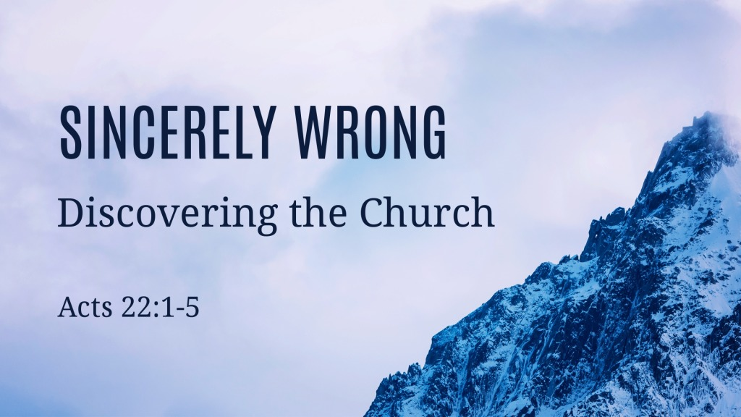
Acts 22:1–5 (ESV)
“Brothers and fathers, hear the defense that I now make before you.”
² And when they heard that he was addressing them in the Hebrew language, they became even more quiet. And he said:
³ “I am a Jew, born in Tarsus in Cilicia, but brought up in this city, educated at the feet of Gamaliel according to the strict manner of the law of our fathers, being zealous for God as all of you are this day. ⁴ I persecuted this Way to the death, binding and delivering to prison both men and women, ⁵ as the high priest and the whole council of elders can bear me witness. From them I received letters to the brothers, and I journeyed toward Damascus to take those also who were there and bring them in bonds to Jerusalem to be punished.

The Person: Paul lets the mob know he used to be just like them.
Acts 13:26 ESV
²⁶ “Brothers, sons of the family of Abraham, and those among you who fear God, to us has been sent the message of this salvation.
Acts 23:1 ESV
¹ And looking intently at the council, Paul said, “Brothers, I have lived my life before God in all good conscience up to this day.”
Romans 10:1–4 ESV
¹ Brothers, my heart’s desire and prayer to God for them is that they may be saved. ² For I bear them witness that they have a zeal for God, but not according to knowledge. ³ For, being ignorant of the righteousness of God, and seeking to establish their own, they did not submit to God’s righteousness. ⁴ For Christ is the end of the law for righteousness to everyone who believes.

The Practice: Paul lets the mob know that he understands the traditions and the old faith of Judaism.
Galatians 1:14 ESV
¹⁴ And I was advancing in Judaism beyond many of my own age among my people, so extremely zealous was I for the traditions of my fathers.
Philippians 3:4–7 ESV
⁴ though I myself have reason for confidence in the flesh also. If anyone else thinks he has reason for confidence in the flesh, I have more: ⁵ circumcised on the eighth day, of the people of Israel, of the tribe of Benjamin, a Hebrew of Hebrews; as to the law, a Pharisee; ⁶ as to zeal, a persecutor of the church; as to righteousness under the law, blameless. ⁷ But whatever gain I had, I counted as loss for the sake of Christ.

The Persecution: Paul tells the mob what his ignorance caused, the persecution of the truth and the church
2 Corinthians 1:12 ESV
¹² For our boast is this, the testimony of our conscience, that we behaved in the world with simplicity and godly sincerity, not by earthly wisdom but by the grace of God, and supremely so toward you.
1 Corinthians 5:8 ESV
⁸ Let us therefore celebrate the festival, not with the old leaven, the leaven of malice and evil, but with the unleavened bread of sincerity and truth.

God’s Plan of Salvation in line with the Truth

Hear the Truth
Romans 10:14 ESV
¹⁴ How then will they call on him in whom they have not believed? And how are they to believe in him of whom they have never heard? And how are they to hear without someone preaching?
Romans 10:17 ESV
¹⁷ So faith comes from hearing, and hearing through the word of Christ.

Believe the Truth
Hebrews 11:6 ESV
⁶ And without faith it is impossible to please him, for whoever would draw near to God must believe that he exists and that he rewards those who seek him.

Repent - turn to the Truth
Acts 26:20 ESV
²⁰ but declared first to those in Damascus, then in Jerusalem and throughout all the region of Judea, and also to the Gentiles, that they should repent and turn to God, performing deeds in keeping with their repentance.

Confess - the Truth of Jesus
Romans 10:9–10 ESV
⁹ because, if you confess with your mouth that Jesus is Lord and believe in your heart that God raised him from the dead, you will be saved. ¹⁰ For with the heart one believes and is justified, and with the mouth one confesses and is saved.

Be Baptized - Truth demands it
Acts 2:38 ESV
³⁸ And Peter said to them, “Repent and be baptized every one of you in the name of Jesus Christ for the forgiveness of your sins, and you will receive the gift of the Holy Spirit.

Remain Faithful to the truth
1 Corinthians 10:12 ESV
¹² Therefore let anyone who thinks that he stands take heed lest he fall.

