Barry G. Johnson, Sr. / www.bgjsr22.com
Christianity is Reality: There is Good and Evil / Self-control; Discipline; Good; Evil; Realism; Restraint / 1 Peter 3:10–12
Self-Control leads to that which is good by the Heart, Habits and Head of mankind.
1 Peter 3:10–12 ESV
¹⁰ For
“Whoever desires to love life
and see good days,
let him keep his tongue from evil
and his lips from speaking deceit;
¹¹ let him turn away from evil and do good;
let him seek peace and pursue it.
¹² For the eyes of the Lord are on the righteous,
and his ears are open to their prayer.
But the face of the Lord is against those who do evil.”

I. Self-Controlled HEART/ EMOTIONS

A. Cleansed Heart
Matthew 5:8 ESV
⁸ “Blessed are the pure in heart, for they shall see God.
Jeremiah 17:9 ESV
⁹ The heart is deceitful above all things,
and desperately sick;
who can understand it?

B. Controlled Heart
Psalm 139:23–24 ESV
²³ Search me, O God, and know my heart!
Try me and know my thoughts!
²⁴ And see if there be any grievous way in me,
and lead me in the way everlasting!

C. Consecrated Heart
Proverbs 4:23 ESV
²³ Keep your heart with all vigilance,
for from it flow the springs of life.
Matthew 15:19 ESV
¹⁹ For out of the heart come evil thoughts, murder, adultery, sexual immorality, theft, false witness, slander.

D. Christ-like heart
Proverbs 3:5 ESV
⁵ Trust in the Lord with all your heart,
and do not lean on your own understanding.
Ezekiel 36:26 ESV
²⁶ And I will give you a new heart, and a new spirit I will put within you. And I will remove the heart of stone from your flesh and give you a heart of flesh.

II. Self-Controlled HABITS/ ACTIONS

A. Daily Habits
Galatians 5:16 ESV
¹⁶ But I say, walk by the Spirit, and you will not gratify the desires of the flesh.

B. Dedicated Habits
Philippians 4:5 ESV
⁵ Let your reasonableness be known to everyone. The Lord is at hand;

C. Divine Habits
Matthew 5:16 ESV
¹⁶ In the same way, let your light shine before others, so that they may see your good works and give glory to your Father who is in heaven.

D. Determined Habits
Daniel 1:8 ESV
⁸ But Daniel resolved that he would not defile himself with the king’s food, or with the wine that he drank. Therefore he asked the chief of the eunuchs to allow him not to defile himself.

III. Self-Controlled HEAD/ MIND

A. Christ-like Mind
Philippians 2:5 ESV
⁵ Have this mind among yourselves, which is yours in Christ Jesus,
John 13:15 ESV
¹⁵ For I have given you an example, that you also should do just as I have done to you.

B. Controlled Mind
Proverbs 16:32 ESV
³² Whoever is slow to anger is better than the mighty,
and he who rules his spirit than he who takes a city.

C. Cleansed Mind
Psalm 51:2 ESV
² Wash me thoroughly from my iniquity,
and cleanse me from my sin!
Proverbs 23:7 ESV
⁷ for he is like one who is inwardly calculating.
“Eat and drink!” he says to you,
but his heart is not with you.

D. Consecrated Mind
Psalm 19:14 ESV
¹⁴ Let the words of my mouth and the meditation of my heart
be acceptable in your sight,
O Lord, my rock and my redeemer.

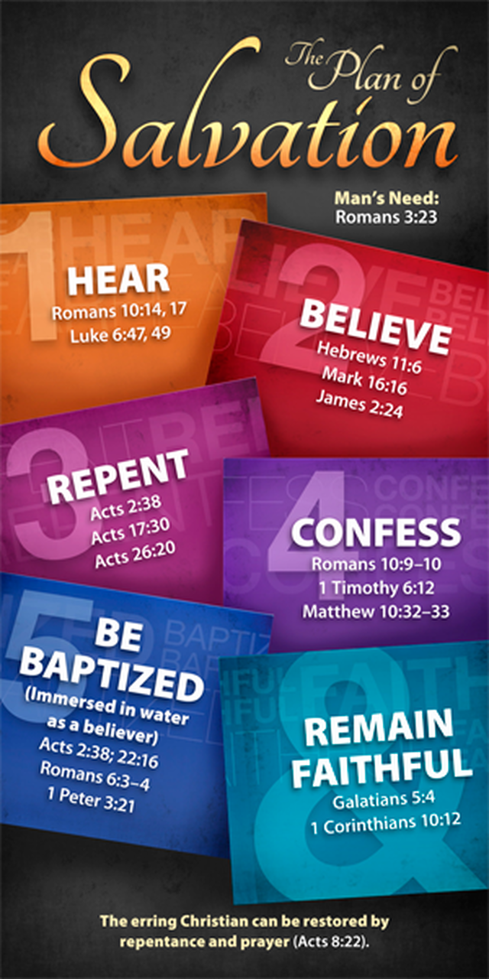
Do You Want to do Good?

