Central Idea:

Jesus prepares His Disciples for His death by telling them to be ready to do the same.

Objectives:

- Self-denial as the basis for discipleship
- Dying to self is a means of knowing freedom from sin
- The importance of sharing in the death of Christ
- The example of Paul
- Self-denial is not the same as self-infliction

Sermon Outline:

- Self-denial as the basis for discipleship
- Self-denial is essential
Mark 8:34–35 (NIV) — 34 Then he called the crowd to him along with his disciples and said: “Whoever wants to be my disciple must deny themselves and take up their cross and follow me. 35 For whoever wants to save their life will lose it, but whoever loses their life for me and for the gospel will save it.
See also 1 Jn 3:16
1 John 3:16 (NIV) — 16 This is how we know what love is: Jesus Christ laid down his life for us. And we ought to lay down our lives for our brothers and sisters.
- The necessity of putting to death sinful human nature and the world’s values
Romans 8:13 (NIV) — 13 For if you live according to the flesh, you will die; but if by the Spirit you put to death the misdeeds of the body, you will live.
Colossians 3:5 (NIV) — 5 Put to death, therefore, whatever belongs to your earthly nature: sexual immorality, impurity, lust, evil desires and greed, which is idolatry.
See also Mt 5:29–30 ; Ga 5:24 ; Ga 6:14 ; 1 Pe 2:11
Matthew 5:29–30 (NIV) — 29 If your right eye causes you to stumble, gouge it out and throw it away. It is better for you to lose one part of your body than for your whole body to be thrown into hell. 30 And if your right hand causes you to stumble, cut it off and throw it away. It is better for you to lose one part of your body than for your whole body to go into hell.
Galatians 5:24 (NIV) — 24 Those who belong to Christ Jesus have crucified the flesh with its passions and desires.
Galatians 6:14 (NIV) — 14 May I never boast except in the cross of our Lord Jesus Christ, through which the world has been crucified to me, and I to the world.
1 Peter 2:11 (NIV) — 11 Dear friends, I urge you, as foreigners and exiles, to abstain from sinful desires, which wage war against your soul.
- Dying to self is a means of knowing freedom from sin
Romans 6:6–7 (NIV) — 6 For we know that our old self was crucified with him so that the body ruled by sin might be done away with, that we should no longer be slaves to sin—7 because anyone who has died has been set free from sin.
See also Eph 4:22–23
Ephesians 4:22–23 (NIV) — 22 You were taught, with regard to your former way of life, to put off your old self, which is being corrupted by its deceitful desires; 23 to be made new in the attitude of your minds;
- The importance of sharing in the death of Christ
Galatians 2:20 (NIV) — 20 I have been crucified with Christ and I no longer live, but Christ lives in me. The life I now live in the body, I live by faith in the Son of God, who loved me and gave himself for me.
See also Ro 6:3 ; Ro 7:4 ; 2 Co 4:11–12 ; Php 3:10 ; Col 2:20 ; 2 Ti 2:11
Romans 6:3 (NIV) — 3 Or don’t you know that all of us who were baptized into Christ Jesus were baptized into his death?
Romans 7:4 (NIV) — 4 So, my brothers and sisters, you also died to the law through the body of Christ, that you might belong to another, to him who was raised from the dead, in order that we might bear fruit for God.
2 Corinthians 4:11–12 (NIV) — 11 For we who are alive are always being given over to death for Jesus’ sake, so that his life may also be revealed in our mortal body. 12 So then, death is at work in us, but life is at work in you.
Philippians 3:10 (NIV) — 10 I want to know Christ—yes, to know the power of his resurrection and participation in his sufferings, becoming like him in his death,
Colossians 2:20 (NIV) — 20 Since you died with Christ to the elemental spiritual forces of this world, why, as though you still belonged to the world, do you submit to its rules:
2 Timothy 2:11 (NIV) — 11 Here is a trustworthy saying: If we died with him, we will also live with him;
- The example of Paul
1 Corinthians 9:27 (NIV) — 27 No, I strike a blow to my body and make it my slave so that after I have preached to others, I myself will not be disqualified for the prize.
See also 2 Co 11:23–33 ; Ga 6:17
2 Corinthians 11:23–33 (NIV) — 23 Are they servants of Christ? (I am out of my mind to talk like this.) I am more. I have worked much harder, been in prison more frequently, been flogged more severely, and been exposed to death again and again. 24 Five times I received from the Jews the forty lashes minus one. 25 Three times I was beaten with rods, once I was pelted with stones, three times I was shipwrecked, I spent a night and a day in the open sea, 26 I have been constantly on the move. I have been in danger from rivers, in danger from bandits, in danger from my fellow Jews, in danger from Gentiles; in danger in the city, in danger in the country, in danger at sea; and in danger from false believers. 27 I have labored and toiled and have often gone without sleep; I have known hunger and thirst and have often gone without food; I have been cold and naked. 28 Besides everything else, I face daily the pressure of my concern for all the churches. 29 Who is weak, and I do not feel weak? Who is led into sin, and I do not inwardly burn? 30 If I must boast, I will boast of the things that show my weakness. 31 The God and Father of the Lord Jesus, who is to be praised forever, knows that I am not lying. 32 In Damascus the governor under King Aretas had the city of the Damascenes guarded in order to arrest me. 33 But I was lowered in a basket from a window in the wall and slipped through his hands.
Galatians 6:17 (NIV) — 17 From now on, let no one cause me trouble, for I bear on my body the marks of Jesus.
- Self-denial is not the same as self-infliction
Colossians 2:23 (NIV) — 23 Such regulations indeed have an appearance of wisdom, with their self-imposed worship, their false humility and their harsh treatment of the body, but they lack any value in restraining sensual indulgence.
See also Php 3:2–3 ; Col 2:20–22 ; 1 Ti 4:1–5
Philippians 3:2–3 (NIV) — 2 Watch out for those dogs, those evildoers, those mutilators of the flesh. 3 For it is we who are the circumcision, we who serve God by his Spirit, who boast in Christ Jesus, and who put no confidence in the flesh—
Colossians 2:20–22 (NIV) — 20 Since you died with Christ to the elemental spiritual forces of this world, why, as though you still belonged to the world, do you submit to its rules: 21 “Do not handle! Do not taste! Do not touch!”? 22 These rules, which have to do with things that are all destined to perish with use, are based on merely human commands and teachings.
1 Timothy 4:1–5 (NIV) — 1 The Spirit clearly says that in later times some will abandon the faith and follow deceiving spirits and things taught by demons. 2 Such teachings come through hypocritical liars, whose consciences have been seared as with a hot iron. 3 They forbid people to marry and order them to abstain from certain foods, which God created to be received with thanksgiving by those who believe and who know the truth. 4 For everything God created is good, and nothing is to be rejected if it is received with thanksgiving, 5 because it is consecrated by the word of God and prayer.

Invitation:

Hear - Romans 10:17 (KJV)
¹⁷ So then faith cometh by hearing, and hearing by the word of God.
Believe - Hebrews 11:6 (KJV)
⁶ But without faith it is impossible to please him: for he that cometh to God must believe that he is, and that he is a rewarder of them that diligently seek him.
Repent - Acts 17:30 (KJV)
³⁰ And the times of this ignorance God winked at; but now commandeth all men every where to repent:
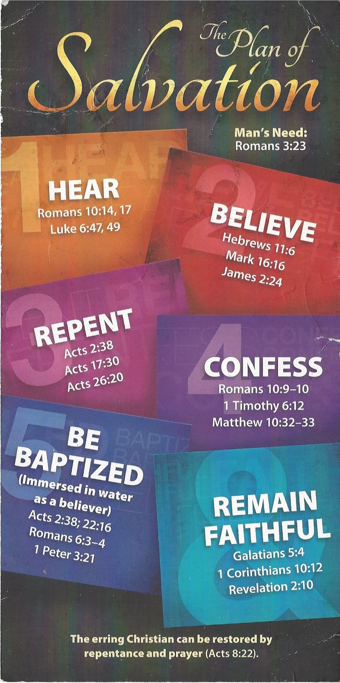
Confess - 1 Timothy 6:12 (KJV)
¹² Fight the good fight of faith, lay hold on eternal life, whereunto thou art also called, and hast professed a good profession before many witnesses.
Be Baptized - Acts 22:16 (KJV)
¹⁶ And now why tarriest thou? arise, and be baptized, and wash away thy sins, calling on the name of the Lord.
Remain Steadfast - 1 Corinthians 10:12 (KJV)
¹² Wherefore let him that thinketh he standeth take heed lest he fall.

