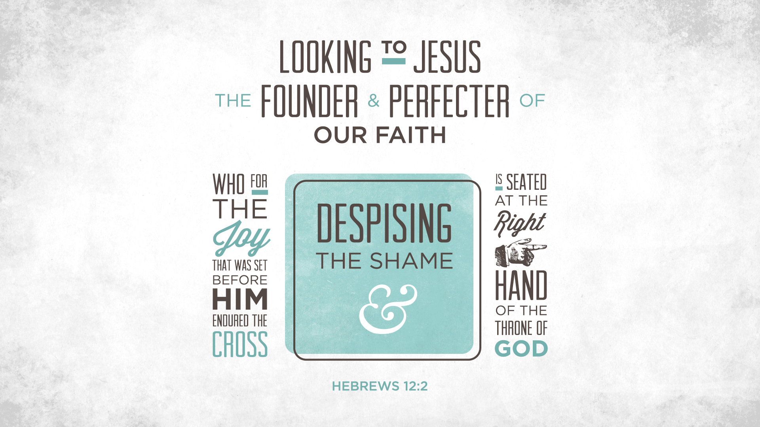
Central Idea:
alternate title: Motivation for evangelism
Evangelism arises from a natural response to the grace of God, a concern for those who have yet to hear the good news and a desire to be faithful to the great commission to bring the good news to the ends of the earth. Evangelism is guided and directed by the Holy Spirit.

Introduction:

Jesus ministry in Galilee continues but with this event and the next which includes the beheading of John the Baptist the period of His popularity comes to an end. Then strangely enough when Jesus feeds the 5000 with a few loaves of bread and fish, the opposition to Jesus begins in earnest.

The Apostles have had ample time to hear and witness the Christ and now it is their turn to go out and preach the Gospel. Of course the Lord compels them, even commands them to go out two by two. He gives them instructions in their evangelistic effort beginning on the job training.

We as disciples of Christ are charged with evangelism also. It is one of the great works of the Church. If you look on the back of our bulletin you will see the 3 pillars that the Lord's Church is built on. Evangelism; Benevolence; and Edification.

This morning we will talk about Evangelism with the title People Reaching People. Are we doing what the Lord clearly commands and expects us to do?

Sermon Outline:

- Motives for evangelism
- Recognizing God’s call
2 Timothy 1:11 (NIV) — 11 And of this gospel I was appointed a herald and an apostle and a teacher.
Isaiah 6:8–9 (NIV) — 8 Then I heard the voice of the Lord saying, “Whom shall I send? And who will go for us?” And I said, “Here am I. Send me!” 9 He said, “Go and tell this people: “ ‘Be ever hearing, but never understanding; be ever seeing, but never perceiving.’
Jonah 1:1–2 (NIV) — 1 The word of the Lord came to Jonah son of Amittai: 2 “Go to the great city of Nineveh and preach against it, because its wickedness has come up before me.”
Acts 22:14–15 (NIV) — 14 “Then he said: ‘The God of our ancestors has chosen you to know his will and to see the Righteous One and to hear words from his mouth. 15 You will be his witness to all people of what you have seen and heard.
2 Corinthians 4:1 (NIV) — 1 Therefore, since through God’s mercy we have this ministry, we do not lose heart.
1 Timothy 2:7 (NIV) — 7 And for this purpose I was appointed a herald and an apostle—I am telling the truth, I am not lying—and a true and faithful teacher of the Gentiles.
- A divine compulsion
1 Corinthians 9:16–17 (NIV) — 16 For when I preach the gospel, I cannot boast, since I am compelled to preach. Woe to me if I do not preach the gospel! 17 If I preach voluntarily, I have a reward; if not voluntarily, I am simply discharging the trust committed to me.
When one is compelled he is not possessed. Possessed as if he does things which are out of his control. To be compelled does not mean that someone or something has taken control of you and it does what it wants. Compelled examples: Luke 14:23; Acts 28:19; Galatians 2:3; 6:12.
Jeremiah 20:9 (NIV) — 9 But if I say, “I will not mention his word or speak anymore in his name,” his word is in my heart like a fire, a fire shut up in my bones. I am weary of holding it in; indeed, I cannot.
Amos 3:8 (NIV) — 8 The lion has roared— who will not fear? The Sovereign Lord has spoken— who can but prophesy?
Acts 4:20 (NIV) — 20 As for us, we cannot help speaking about what we have seen and heard.”
- A God-given responsibility
Ezekiel 3:17–20 (NIV) — 17 “Son of man, I have made you a watchman for the people of Israel; so hear the word I speak and give them warning from me. 18 When I say to a wicked person, ‘You will surely die,’ and you do not warn them or speak out to dissuade them from their evil ways in order to save their life, that wicked person will die for their sin, and I will hold you accountable for their blood. 19 But if you do warn the wicked person and they do not turn from their wickedness or from their evil ways, they will die for their sin; but you will have saved yourself. 20 “Again, when a righteous person turns from their righteousness and does evil, and I put a stumbling block before them, they will die. Since you did not warn them, they will die for their sin. The righteous things that person did will not be remembered, and I will hold you accountable for their blood.
Ezekiel 33:7–9 (NIV) — 7 “Son of man, I have made you a watchman for the people of Israel; so hear the word I speak and give them warning from me. 8 When I say to the wicked, ‘You wicked person, you will surely die,’ and you do not speak out to dissuade them from their ways, that wicked person will die for their sin, and I will hold you accountable for their blood. 9 But if you do warn the wicked person to turn from their ways and they do not do so, they will die for their sin, though you yourself will be saved.
1 Corinthians 3:10–15 (NIV) — 10 By the grace God has given me, I laid a foundation as a wise builder, and someone else is building on it. But each one should build with care. 11 For no one can lay any foundation other than the one already laid, which is Jesus Christ. 12 If anyone builds on this foundation using gold, silver, costly stones, wood, hay or straw, 13 their work will be shown for what it is, because the Day will bring it to light. It will be revealed with fire, and the fire will test the quality of each person’s work. 14 If what has been built survives, the builder will receive a reward. 15 If it is burned up, the builder will suffer loss but yet will be saved—even though only as one escaping through the flames.
2 Corinthians 5:10–11 (NIV) — 10 For we must all appear before the judgment seat of Christ, so that each of us may receive what is due us for the things done while in the body, whether good or bad. 11 Since, then, we know what it is to fear the Lord, we try to persuade others. What we are is plain to God, and I hope it is also plain to your conscience.
- A desire to win the lost
Romans 10:1 (NIV) — 1 Brothers and sisters, my heart’s desire and prayer to God for the Israelites is that they may be saved.
1 Corinthians 9:19–23 (NIV) — 19 Though I am free and belong to no one, I have made myself a slave to everyone, to win as many as possible. 20 To the Jews I became like a Jew, to win the Jews. To those under the law I became like one under the law (though I myself am not under the law), so as to win those under the law. 21 To those not having the law I became like one not having the law (though I am not free from God’s law but am under Christ’s law), so as to win those not having the law. 22 To the weak I became weak, to win the weak. I have become all things to all people so that by all possible means I might save some. 23 I do all this for the sake of the gospel, that I may share in its blessings.
Acts 20:19–20 (NIV) — 19 I served the Lord with great humility and with tears and in the midst of severe testing by the plots of my Jewish opponents. 20 You know that I have not hesitated to preach anything that would be helpful to you but have taught you publicly and from house to house.
Romans 1:14–15 (NIV) — 14 I am obligated both to Greeks and non-Greeks, both to the wise and the foolish. 15 That is why I am so eager to preach the gospel also to you who are in Rome.
Romans 9:1–3 (NIV) — 1 I speak the truth in Christ—I am not lying, my conscience confirms it through the Holy Spirit—2 I have great sorrow and unceasing anguish in my heart. 3 For I could wish that I myself were cursed and cut off from Christ for the sake of my people, those of my own race,
Romans 11:14 (NIV) — 14 in the hope that I may somehow arouse my own people to envy and save some of them.
Romans 15:17–20 (NIV) — 17 Therefore I glory in Christ Jesus in my service to God. 18 I will not venture to speak of anything except what Christ has accomplished through me in leading the Gentiles to obey God by what I have said and done—19 by the power of signs and wonders, through the power of the Spirit of God. So from Jerusalem all the way around to Illyricum, I have fully proclaimed the gospel of Christ. 20 It has always been my ambition to preach the gospel where Christ was not known, so that I would not be building on someone else’s foundation.
2 Corinthians 5:20 (NIV) — 20 We are therefore Christ’s ambassadors, as though God were making his appeal through us. We implore you on Christ’s behalf: Be reconciled to God.
- A recognition of coming judgment
Jude 23 (NIV) — 23 save others by snatching them from the fire; to others show mercy, mixed with fear—hating even the clothing stained by corrupted flesh.
James 5:20 (NIV) — 20 remember this: Whoever turns a sinner from the error of their way will save them from death and cover over a multitude of sins.
2 Peter 3:9 (NIV) — 9 The Lord is not slow in keeping his promise, as some understand slowness. Instead he is patient with you, not wanting anyone to perish, but everyone to come to repentance.
- Responding to God’s grace
2 Corinthians 5:14–15 (NIV) — 14 For Christ’s love compels us, because we are convinced that one died for all, and therefore all died. 15 And he died for all, that those who live should no longer live for themselves but for him who died for them and was raised again.
2 Corinthians 5:18–19 (NIV) — 18 All this is from God, who reconciled us to himself through Christ and gave us the ministry of reconciliation: 19 that God was reconciling the world to himself in Christ, not counting people’s sins against them. And he has committed to us the message of reconciliation.
Ephesians 3:7 (NIV) — 7 I became a servant of this gospel by the gift of God’s grace given me through the working of his power.
1 Timothy 1:12–16 (NIV) — 12 I thank Christ Jesus our Lord, who has given me strength, that he considered me trustworthy, appointing me to his service. 13 Even though I was once a blasphemer and a persecutor and a violent man, I was shown mercy because I acted in ignorance and unbelief. 14 The grace of our Lord was poured out on me abundantly, along with the faith and love that are in Christ Jesus. 15 Here is a trustworthy saying that deserves full acceptance: Christ Jesus came into the world to save sinners—of whom I am the worst. 16 But for that very reason I was shown mercy so that in me, the worst of sinners, Christ Jesus might display his immense patience as an example for those who would believe in him and receive eternal life.
- Confidence in the gospel
Romans 1:16–17 (NIV) — 16 For I am not ashamed of the gospel, because it is the power of God that brings salvation to everyone who believes: first to the Jew, then to the Gentile. 17 For in the gospel the righteousness of God is revealed—a righteousness that is by faith from first to last, just as it is written: “The righteous will live by faith.”
Isaiah 55:10–11 (NIV) — 10 As the rain and the snow come down from heaven, and do not return to it without watering the earth and making it bud and flourish, so that it yields seed for the sower and bread for the eater, 11 so is my word that goes out from my mouth: It will not return to me empty, but will accomplish what I desire and achieve the purpose for which I sent it.
1 Corinthians 1:17–18 (NIV) — 17 For Christ did not send me to baptize, but to preach the gospel—not with wisdom and eloquence, lest the cross of Christ be emptied of its power. 18 For the message of the cross is foolishness to those who are perishing, but to us who are being saved it is the power of God.
2 Corinthians 10:4–5 (NIV) — 4 The weapons we fight with are not the weapons of the world. On the contrary, they have divine power to demolish strongholds. 5 We demolish arguments and every pretension that sets itself up against the knowledge of God, and we take captive every thought to make it obedient to Christ.
2 Timothy 1:8–9 (NIV) — 8 So do not be ashamed of the testimony about our Lord or of me his prisoner. Rather, join with me in suffering for the gospel, by the power of God. 9 He has saved us and called us to a holy life—not because of anything we have done but because of his own purpose and grace. This grace was given us in Christ Jesus before the beginning of time,
- God’s Work in Evangelism
- Divine guidance in evangelism
Acts 8:26–29 (NIV) — 26 Now an angel of the Lord said to Philip, “Go south to the road—the desert road—that goes down from Jerusalem to Gaza.” 27 So he started out, and on his way he met an Ethiopian eunuch, an important official in charge of all the treasury of the Kandake (which means “queen of the Ethiopians”). This man had gone to Jerusalem to worship, 28 and on his way home was sitting in his chariot reading the Book of Isaiah the prophet. 29 The Spirit told Philip, “Go to that chariot and stay near it.”
Acts 16:6–10 (NIV) — 6 Paul and his companions traveled throughout the region of Phrygia and Galatia, having been kept by the Holy Spirit from preaching the word in the province of Asia. 7 When they came to the border of Mysia, they tried to enter Bithynia, but the Spirit of Jesus would not allow them to. 8 So they passed by Mysia and went down to Troas. 9 During the night Paul had a vision of a man of Macedonia standing and begging him, “Come over to Macedonia and help us.” 10 After Paul had seen the vision, we got ready at once to leave for Macedonia, concluding that God had called us to preach the gospel to them.
Acts 5:19–20 (NIV) — 19 But during the night an angel of the Lord opened the doors of the jail and brought them out. 20 “Go, stand in the temple courts,” he said, “and tell the people all about this new life.”
Acts 9:10–11 (NIV) — 10 In Damascus there was a disciple named Ananias. The Lord called to him in a vision, “Ananias!” “Yes, Lord,” he answered. 11 The Lord told him, “Go to the house of Judas on Straight Street and ask for a man from Tarsus named Saul, for he is praying.
Acts 10:19–20 (NIV) — 19 While Peter was still thinking about the vision, the Spirit said to him, “Simon, three men are looking for you. 20 So get up and go downstairs. Do not hesitate to go with them, for I have sent them.”
Acts 11:12 (NIV) — 12 The Spirit told me to have no hesitation about going with them. These six brothers also went with me, and we entered the man’s house.
Acts 13:2 (NIV) — 2 While they were worshiping the Lord and fasting, the Holy Spirit said, “Set apart for me Barnabas and Saul for the work to which I have called them.”
Acts 18:9–11 (NIV) — 9 One night the Lord spoke to Paul in a vision: “Do not be afraid; keep on speaking, do not be silent. 10 For I am with you, and no one is going to attack and harm you, because I have many people in this city.” 11 So Paul stayed in Corinth for a year and a half, teaching them the word of God.
- God opens the door for evangelism
2 Corinthians 2:12 (NIV) — 12 Now when I went to Troas to preach the gospel of Christ and found that the Lord had opened a door for me,
Acts 14:27 (NIV) — 27 On arriving there, they gathered the church together and reported all that God had done through them and how he had opened a door of faith to the Gentiles.
1 Corinthians 16:9 (NIV) — 9 because a great door for effective work has opened to me, and there are many who oppose me.
Colossians 4:3 (NIV) — 3 And pray for us, too, that God may open a door for our message, so that we may proclaim the mystery of Christ, for which I am in chains.
Revelation 3:8 (NIV) — 8 I know your deeds. See, I have placed before you an open door that no one can shut. I know that you have little strength, yet you have kept my word and have not denied my name.
- Areas of ministry assigned by God
Galatians 2:7–9 (NIV) — 7 On the contrary, they recognized that I had been entrusted with the task of preaching the gospel to the uncircumcised, just as Peter had been to the circumcised. 8 For God, who was at work in Peter as an apostle to the circumcised, was also at work in me as an apostle to the Gentiles. 9 James, Cephas and John, those esteemed as pillars, gave me and Barnabas the right hand of fellowship when they recognized the grace given to me. They agreed that we should go to the Gentiles, and they to the circumcised.
Acts 9:15 (NIV) — 15 But the Lord said to Ananias, “Go! This man is my chosen instrument to proclaim my name to the Gentiles and their kings and to the people of Israel.
- The Holy Spirit Empowers Evangelism
Acts 1:8 (NIV) — 8 But you will receive power when the Holy Spirit comes on you; and you will be my witnesses in Jerusalem, and in all Judea and Samaria, and to the ends of the earth.”
Matthew 10:19–20 (NIV) — 19 But when they arrest you, do not worry about what to say or how to say it. At that time you will be given what to say, 20 for it will not be you speaking, but the Spirit of your Father speaking through you.
John 15:26–27 (NIV) — 26 “When the Advocate comes, whom I will send to you from the Father—the Spirit of truth who goes out from the Father—he will testify about me. 27 And you also must testify, for you have been with me from the beginning.
1 Thessalonians 1:5 (NIV) — 5 because our gospel came to you not simply with words but also with power, with the Holy Spirit and deep conviction. You know how we lived among you for your sake.
- Evangelism as a Result of Persecution
Acts 8:4–5 (NIV) — 4 Those who had been scattered preached the word wherever they went. 5 Philip went down to a city in Samaria and proclaimed the Messiah there.
Acts 11:19–21 (NIV) — 19 Now those who had been scattered by the persecution that broke out when Stephen was killed traveled as far as Phoenicia, Cyprus and Antioch, spreading the word only among Jews. 20 Some of them, however, men from Cyprus and Cyrene, went to Antioch and began to speak to Greeks also, telling them the good news about the Lord Jesus. 21 The Lord’s hand was with them, and a great number of people believed and turned to the Lord.
Acts 13:50–51 (NIV) — 50 But the Jewish leaders incited the God-fearing women of high standing and the leading men of the city. They stirred up persecution against Paul and Barnabas, and expelled them from their region. 51 So they shook the dust off their feet as a warning to them and went to Iconium.
Acts 14:6–7 (NIV) — 6 But they found out about it and fled to the Lycaonian cities of Lystra and Derbe and to the surrounding country, 7 where they continued to preach the gospel.
Acts 18:2 (NIV) — 2 There he met a Jew named Aquila, a native of Pontus, who had recently come from Italy with his wife Priscilla, because Claudius had ordered all Jews to leave Rome. Paul went to see them,

Romans 10:17 (KJV 1900)
¹⁷ So then faith cometh by hearing, and hearing by the word of God.
Hebrews 11:6 (KJV 1900)
⁶ But without faith it is impossible to please him: for he that cometh to God must believe that he is, and that he is a rewarder of them that diligently seek him.
Acts 17:30 (KJV 1900)
³⁰ And the times of this ignorance God winked at; but now commandeth all men every where to repent:
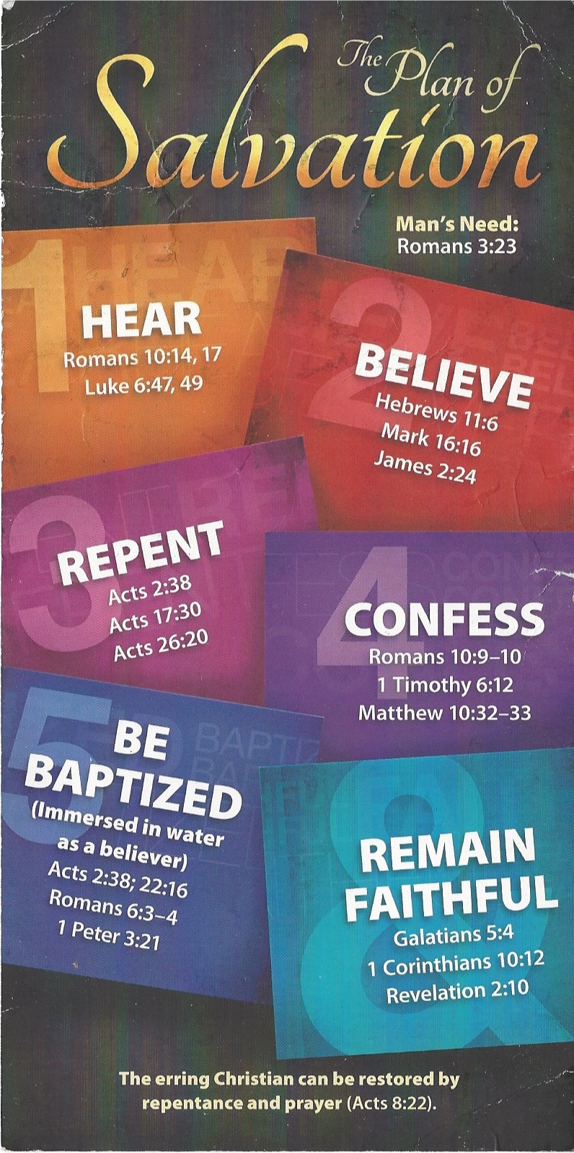
1 Timothy 6:12 (KJV 1900)
¹² Fight the good fight of faith, lay hold on eternal life, whereunto thou art also called, and hast professed a good profession before many witnesses.
Acts 22:16 (KJV 1900)
¹⁶ And now why tarriest thou? arise, and be baptized, and wash away thy sins, calling on the name of the Lord.
1 Corinthians 10:12 (KJV 1900)
¹² Wherefore let him that thinketh he standeth take heed lest he fall.

