Barry G. Johnson, Sr. / www.bgjsr22.com
Christianity is Reality: The Gospel Lives / Gospel; Good News / Galatians 1:11–12
God graciously makes himself known to humanity since people cannot discover him on their own. He achieves this in many ways, but supremely through his Son Jesus Christ.
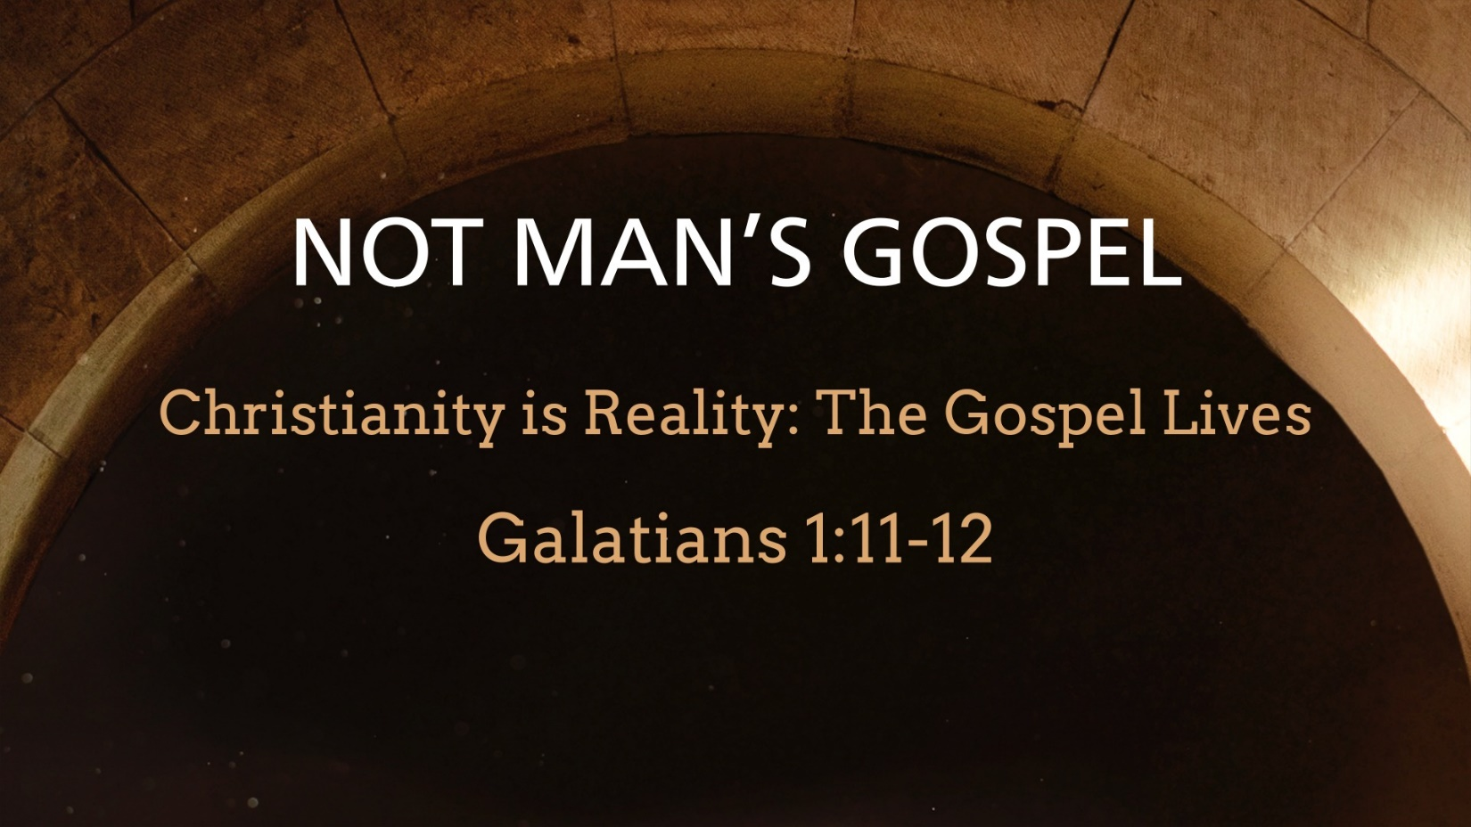
Galatians 1:11–12 ESV
¹¹ For I would have you know, brothers, that the gospel that was preached by me is not man’s gospel. ¹² For I did not receive it from any man, nor was I taught it, but I received it through a revelation of Jesus Christ.

The Necessity of Revelation

God is hidden from human view because of sin
Isaiah 59:2 ESV
² but your iniquities have made a separation
between you and your God,
and your sins have hidden his face from you
so that he does not hear.

People are ignorant of God
Acts 17:23 ESV
²³ For as I passed along and observed the objects of your worship, I found also an altar with this inscription: ‘To the unknown god.’ What therefore you worship as unknown, this I proclaim to you.

People cannot know God unaided
Matthew 11:25–27 ESV
²⁵ At that time Jesus declared, “I thank you, Father, Lord of heaven and earth, that you have hidden these things from the wise and understanding and revealed them to little children; ²⁶ yes, Father, for such was your gracious will. ²⁷ All things have been handed over to me by my Father, and no one knows the Son except the Father, and no one knows the Father except the Son and anyone to whom the Son chooses to reveal him.

The Means by Which God Has Revealed Himself

In the Scriptures
Psalm 119:105 ESV
¹⁰⁵ Your word is a lamp to my feet and a light to my path.

By the Holy Spirit
Ephesians 1:17 ESV
¹⁷ that the God of our Lord Jesus Christ, the Father of glory, may give you the Spirit of wisdom and of revelation in the knowledge of him,

Supremely in Jesus Christ
Hebrews 1:1–2 ESV
¹ Long ago, at many times and in many ways, God spoke to our fathers by the prophets, ² but in these last days he has spoken to us by his Son, whom he appointed the heir of all things, through whom also he created the world.

In the creation
Psalm 19:1 ESV
¹ The heavens declare the glory of God, and the sky above proclaims his handiwork.

Through the prophets
Amos 3:7 ESV
⁷ “For the Lord God does nothing without revealing his secret to his servants the prophets.

In visions and dreams
Daniel 1:17 ESV
¹⁷ As for these four youths, God gave them learning and skill in all literature and wisdom, and Daniel had understanding in all visions and dreams.

In special signs
Hebrews 2:1–4 ESV
¹ Therefore we must pay much closer attention to what we have heard, lest we drift away from it. ² For since the message declared by angels proved to be reliable, and every transgression or disobedience received a just retribution, ³ how shall we escape if we neglect such a great salvation? It was declared at first by the Lord, and it was attested to us by those who heard, ⁴ while God also bore witness by signs and wonders and various miracles and by gifts of the Holy Spirit distributed according to his will.

The Nature of God’s Self-Revelation in Jesus Christ

God reveals Jesus Christ’s true identity
Matthew 16:17 ESV
¹⁷ And Jesus answered him, “Blessed are you, Simon Bar-Jonah! For flesh and blood has not revealed this to you, but my Father who is in heaven.

Jesus Christ is the visible image of God
Colossians 1:15 ESV
¹⁵ He is the image of the invisible God, the firstborn of all creation.

Jesus Christ’s glory is still to be fully revealed
Luke 17:30 ESV
³⁰ so will it be on the day when the Son of Man is revealed.

The mystery of the gospel
Romans 16:25–26 ESV
²⁵ Now to him who is able to strengthen you according to my gospel and the preaching of Jesus Christ, according to the revelation of the mystery that was kept secret for long ages ²⁶ but has now been disclosed and through the prophetic writings has been made known to all nations, according to the command of the eternal God, to bring about the obedience of faith—

God’s Revelation is According to His Own Sovereign Purpose
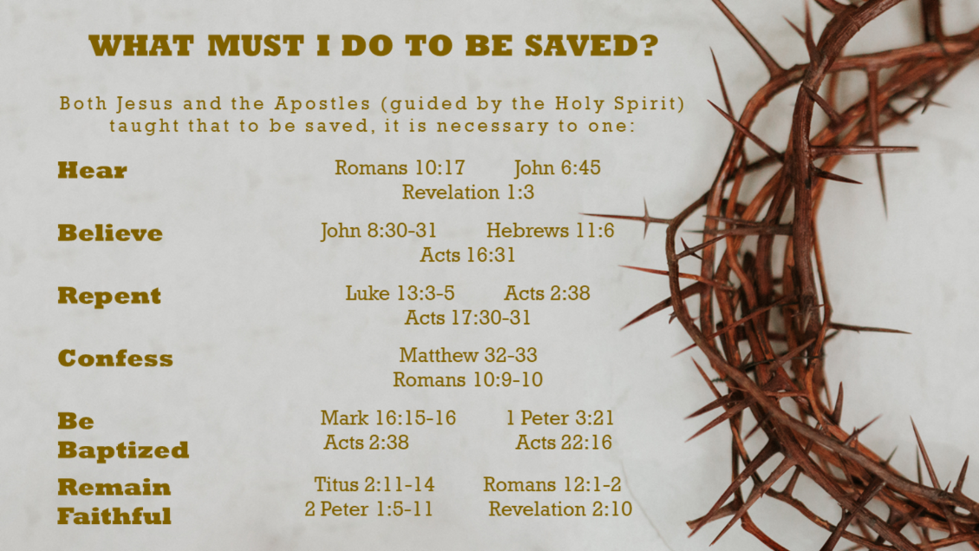
Isaiah 65:1 ESV
¹ I was ready to be sought by those who did not ask for me;
I was ready to be found by those who did not seek me.
I said, “Here I am, here I am,”
to a nation that was not called by my name.

