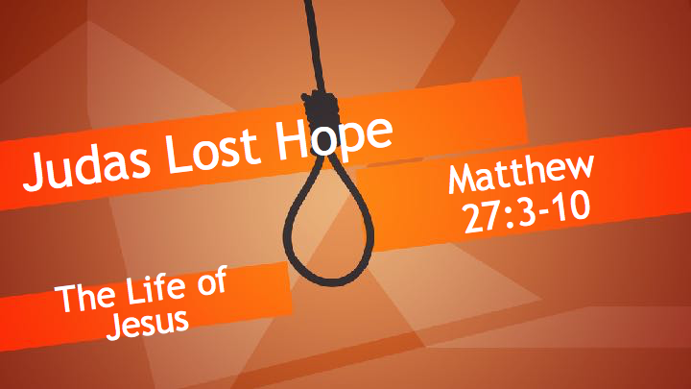
Synopsis
An absence of hope leads to a loss of vision, a sense of despondency and ultimately to despair. This contrasts sharply with the Christian hope.

- Feelings produced by a lack of hope
- Despair
Job 17:13–15 ESV
If I hope for Sheol as my house,
if I make my bed in darkness,
if I say to the pit, ‘You are my father,’
and to the worm, ‘My mother,’ or ‘My sister,’
where then is my hope?
Who will see my hope?
Proverbs 13:12 ESV
Hope deferred makes the heart sick,
but a desire fulfilled is a tree of life.
other references Job 6:11; Job 7:6; Ps 88:15–18; Ec 2:17; Is 19:9; Is 38:18
2 Corinthians 1:8 ESV
For we do not want you to be unaware, brothers, of the affliction we experienced in Asia. For we were so utterly burdened beyond our strength that we despaired of life itself.
- A sense of being abandoned by God
Psalm 22:1–2 ESV
My God, my God, why have you forsaken me?
Why are you so far from saving me, from the words of my groaning?
O my God, I cry by day, but you do not answer,
and by night, but I find no rest.
other references La 3:18; Eze 37:11
- A deep longing for life to end
1 Kings 19:4 ESV
But he himself went a day’s journey into the wilderness and came and sat down under a broom tree. And he asked that he might die, saying, “It is enough; now, O LORD, take away my life, for I am no better than my fathers.”
Job 3:20–21 ESV
“Why is light given to him who is in misery,
and life to the bitter in soul,
who long for death, but it comes not,
and dig for it more than for hidden treasures,
Ecclesiastes 4:1–2 ESV
Again I saw all the oppressions that are done under the sun. And behold, the tears of the oppressed, and they had no one to comfort them! On the side of their oppressors there was power, and there was no one to comfort them. And I thought the dead who are already dead more fortunate than the living who are still alive.
other references Ge 27:46; Nu 11:15; Job 7:13–15; Je 8:3; Jon 4:3; Jon 4:8
Revelation 9:6 ESV
And in those days people will seek death and will not find it. They will long to die, but death will flee from them.
- The outcome of a lack of hope
- The choice of trusting in God or futile self-effort
Romans 4:18 ESV
In hope he believed against hope, that he should become the father of many nations, as he had been told, “So shall your offspring be.”
other references Jon 1:13–14; Je 18:11–12; Ac 27:20
- Suicide
Matthew 27:5 ESV
And throwing down the pieces of silver into the temple, he departed, and he went and hanged himself.
1 Samuel 31:4 ESV
Then Saul said to his armor-bearer, “Draw your sword, and thrust me through with it, lest these uncircumcised come and thrust me through, and mistreat me.” But his armor-bearer would not, for he feared greatly. Therefore Saul took his own sword and fell upon it.
2 Samuel 17:23 ESV
When Ahithophel saw that his counsel was not followed, he saddled his donkey and went off home to his own city. He set his house in order and hanged himself, and he died and was buried in the tomb of his father.
1 Kings 16:18 ESV
And when Zimri saw that the city was taken, he went into the citadel of the king’s house and burned the king’s house over him with fire and died,

