- Genesis - In the beginning / Dream; Interpretation; Joseph (patriarch); Joseph and Aseneth; Joseph (son of Jacob); Famine; Joseph sells grain during the famine; Joseph prepares for famine / Genesis 41:1–57
- Chapter 41’s events propel Joseph from the prison cell to the royal court, from prison clothes to the apparel of rulers, from the lowly station of slave to prisoner to ruler over all Egypt.
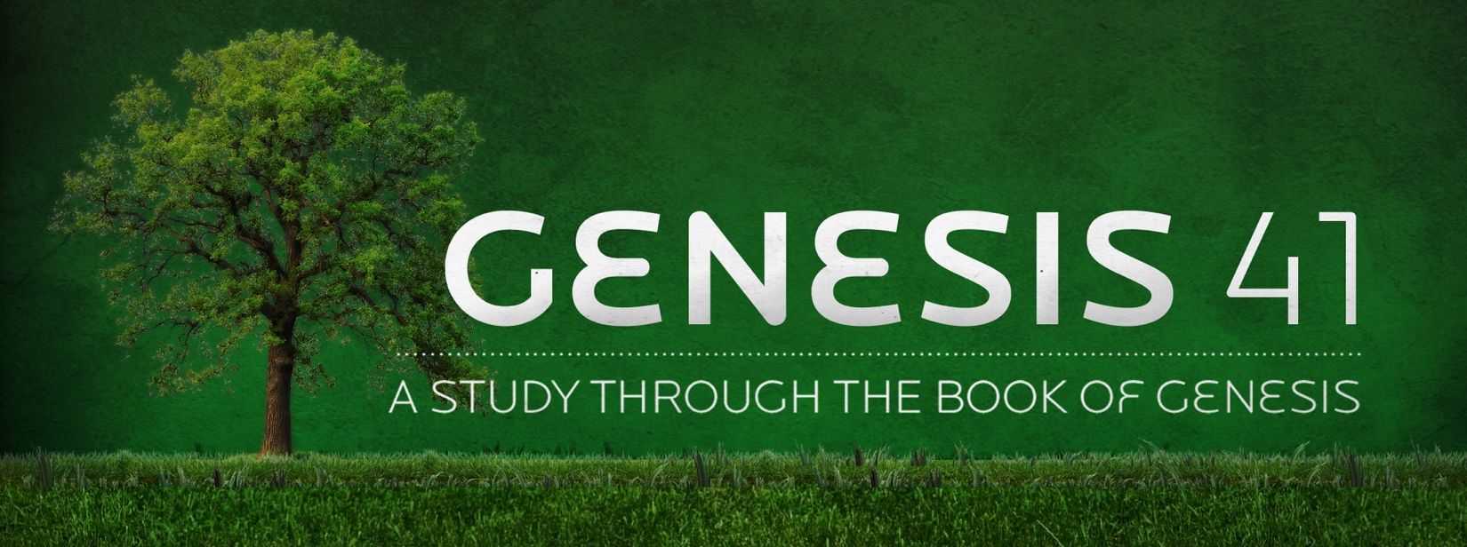

3. JOSEPH’S EXALTATION Ch. 41

1-8) Pharaoh’s two dreams (two years later):
- Who did Pharaoh call on to interpret his dreams?

9-13) The Butler remembers Joseph and tells Pharaoh about him.
- Where did the Butler/Cupbearer meet Joseph?

14-24) Pharaoh hastily calls for Joseph. Pharaoh then tells the dreams to him.
- Who is the real interpreter of Dreams according to Joseph?

25-32) Joseph interprets the dreams. They are actually one dream and interpretation.
- What had God shown Pharaoh?

- Is God limited to giving His revelation only to His chosen people?

- In v32 Joseph says that God will bring it about.

33-36) Joseph advises Pharaoh to find wise officers to prepare for the famine during the good years.
- What type of man does Joseph suggest Pharaoh appoint over the land of Egypt because of the revelation of God?

- What will be the task of the wise and discerning man?

37-45) Pharaoh makes Joseph ruler over Egypt, second only to himself.
- What does Pharaoh recognize about Joseph?

46-49) Joseph gathers food to be saved for the famine.
- How much grain was Joseph able to store in reserves?

50-52) Joseph has two sons:
- What were the names of Joseph’s two sons and what did their names mean?

53-57) The second part of the interpretation comes true; a severe famine comes to the land.
- Who came to Egypt and Joseph to buy grain?

