Jesus before Herod Antipas
Jesus before Herod Antipas
Barry G. Johnson, Sr. / General
The Life of Jesus / Passion; Trial of Jesus; Herod Antipas / Luke 23:6–12
Jesus Christ, falsely accused of blasphemy towards God and treason towards Rome, humbly endured his trial as a fulfilment of the purposes of God.

Luke 23:6–12 ESV
When Pilate heard this, he asked whether the man was a Galilean. And when he learned that he belonged to Herod’s jurisdiction, he sent him over to Herod, who was himself in Jerusalem at that time. When Herod saw Jesus, he was very glad, for he had long desired to see him, because he had heard about him, and he was hoping to see some sign done by him. So he questioned him at some length, but he made no answer. The chief priests and the scribes stood by, vehemently accusing him. And Herod with his soldiers treated him with contempt and mocked him. Then, arraying him in splendid clothing, he sent him back to Pilate. And Herod and Pilate became friends with each other that very day, for before this they had been at enmity with each other.

The preliminary hearing before Annas

The trial before Caiaphas and the Sanhedrin

Jesus Christ is sent to the ruling high priest

False evidence is sought

False accusations are made

Jesus Christ’s trial centers upon his Messianic claims

Jesus declares himself to be the Christ
Matthew 26:63–64 ESV
But Jesus remained silent. And the high priest said to him, “I adjure you by the living God, tell us if you are the Christ, the Son of God.” Jesus said to him, “You have said so. But I tell you, from now on you will see the Son of Man seated at the right hand of Power and coming on the clouds of heaven.”

Jesus Christ is charged with blasphemy

Jesus is mocked as the Christ
Matthew 26:67–68 ESV
Then they spit in his face and struck him. And some slapped him, saying, “Prophesy to us, you Christ! Who is it that struck you?”

The trial before Pilate

The Sanhedrin hand Jesus Christ over to Pilate

Jesus Christ accepts the title of king
John 18:36–37 ESV
Jesus answered, “My kingdom is not of this world. If my kingdom were of this world, my servants would have been fighting, that I might not be delivered over to the Jews. But my kingdom is not from the world.” Then Pilate said to him, “So you are a king?” Jesus answered, “You say that I am a king. For this purpose I was born and for this purpose I have come into the world—to bear witness to the truth. Everyone who is of the truth listens to my voice.”

Pilate decides Jesus Christ is innocent
Luke 23:4 ESV
Then Pilate said to the chief priests and the crowds, “I find no guilt in this man.”

Pilate sends Jesus Christ to Herod
Luke 23:5–8 ESV
But they were urgent, saying, “He stirs up the people, teaching throughout all Judea, from Galilee even to this place.”
When Pilate heard this, he asked whether the man was a Galilean. And when he learned that he belonged to Herod’s jurisdiction, he sent him over to Herod, who was himself in Jerusalem at that time. When Herod saw Jesus, he was very glad, for he had long desired to see him, because he had heard about him, and he was hoping to see some sign done by him.
Herod had been wanting to see Jesus for awhile.
Matthew 14:1 ESV
At that time Herod the tetrarch heard about the fame of Jesus,
Mark 6:14 ESV
King Herod heard of it, for Jesus’ name had become known. Some said, “John the Baptist has been raised from the dead. That is why these miraculous powers are at work in him.”
Luke 9:9 ESV
Herod said, “John I beheaded, but who is this about whom I hear such things?” And he sought to see him.

Herod sends Jesus Christ back to Pilate
Luke 23:11–12 ESV
And Herod with his soldiers treated him with contempt and mocked him. Then, arraying him in splendid clothing, he sent him back to Pilate. And Herod and Pilate became friends with each other that very day, for before this they had been at enmity with each other.
Luke 18:32 ESV
For he will be delivered over to the Gentiles and will be mocked and shamefully treated and spit upon.
Luke 13:1 ESV
There were some present at that very time who told him about the Galileans whose blood Pilate had mingled with their sacrifices.

Jesus Christ’s response to his trial
Isaiah 53:7 ESV
He was oppressed, and he was afflicted,
yet he opened not his mouth;
like a lamb that is led to the slaughter,
and like a sheep that before its shearers is silent,
so he opened not his mouth.

Jesus Christ’s trial confirms he is God’s servant
Acts 4:25–28 ESV
who through the mouth of our father David, your servant, said by the Holy Spirit,
“ ‘Why did the Gentiles rage,
and the peoples plot in vain?
The kings of the earth set themselves,
and the rulers were gathered together,
against the Lord and against his Anointed’—
for truly in this city there were gathered together against your holy servant Jesus, whom you anointed, both Herod and Pontius Pilate, along with the Gentiles and the peoples of Israel, to do whatever your hand and your plan had predestined to take place.
Isaiah 53:10 ESV
Yet it was the will of the LORD to crush him;
he has put him to grief;
when his soul makes an offering for guilt,
he shall see his offspring; he shall prolong his days;
the will of the LORD shall prosper in his hand.
Acts 2:23 ESV
this Jesus, delivered up according to the definite plan and foreknowledge of God, you crucified and killed by the hands of lawless men.

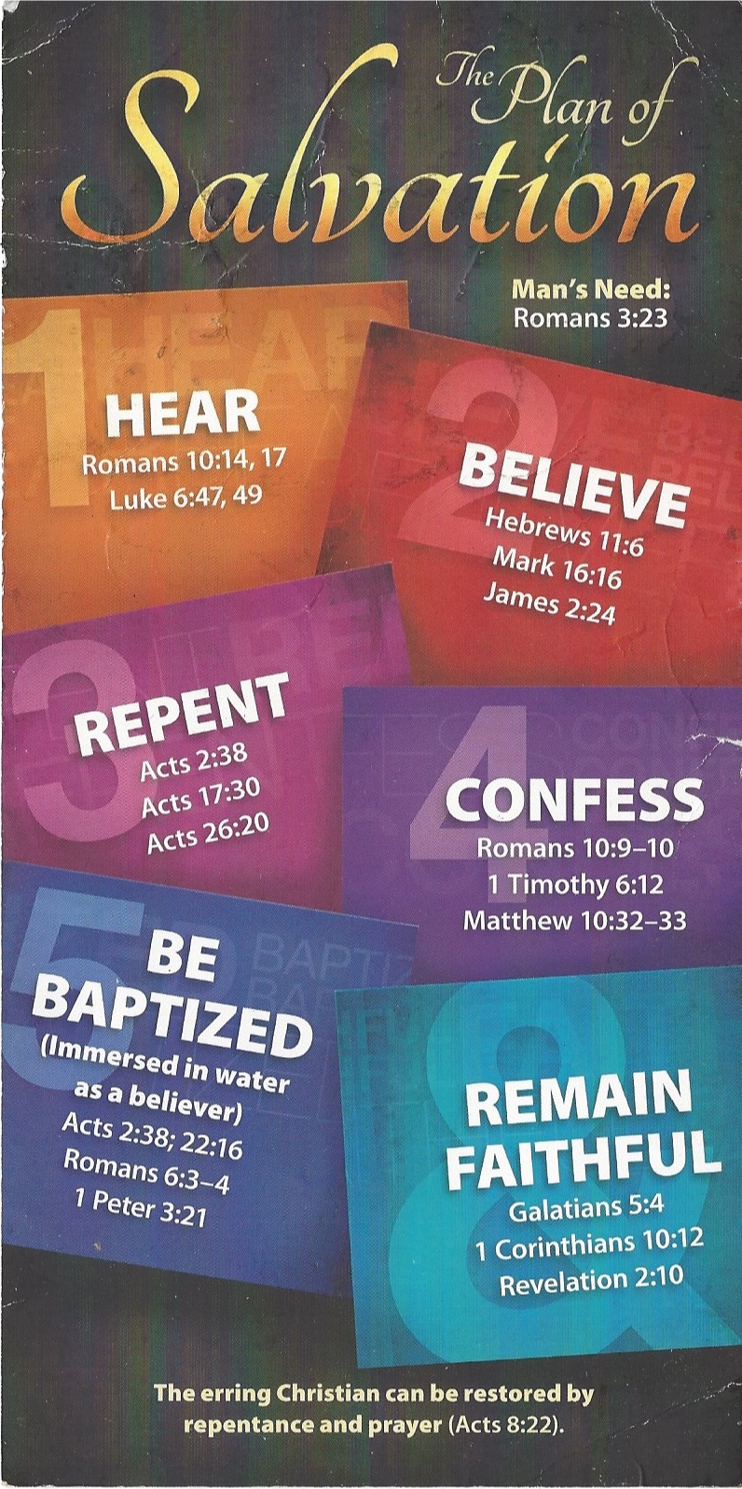
Hear - Romans 10:17 (NIV)
¹⁷ Consequently, faith comes from hearing the message, and the message is heard through the word about Christ.
Believe - Hebrews 11:6 (NIV)
⁶ And without faith it is impossible to please God, because anyone who comes to him must believe that he exists and that he rewards those who earnestly seek him.
Repent - Acts 17:30 (NIV)
³⁰ In the past God overlooked such ignorance, but now he commands all people everywhere to repent.
Confess - 1 Timothy 6:12 (NIV)
¹² Fight the good fight of the faith. Take hold of the eternal life to which you were called when you made your good confession in the presence of many witnesses.

Be Baptized - Acts 22:16 (NIV)
¹⁶ And now what are you waiting for? Get up, be baptized and wash your sins away, calling on his name.’
Remain Steadfast - Revelation 2:10 (NIV)
¹⁰ Do not be afraid of what you are about to suffer. I tell you, the devil will put some of you in prison to test you, and you will suffer persecution for ten days. Be faithful, even to the point of death, and I will give you life as your victor’s crown.

