Barry G. Johnson, Sr. / www.bgjsr22.com
Evangelism 2019 / Fullness of Time; Preparation; Plan; Purpose / Ephesians 1:7–10
We can achieve what God has intended if we align with Him in preparation; purpose and plan.
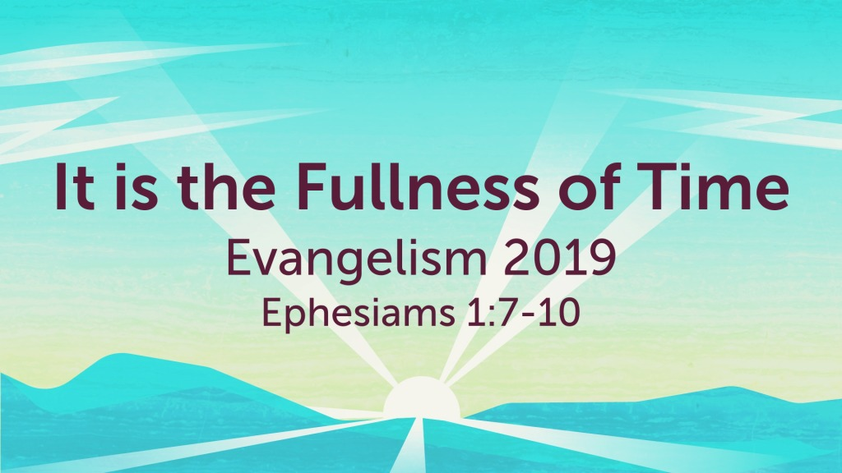
Ephesians 1:7–10 ESV
In him we have redemption through his blood, the forgiveness of our trespasses, according to the riches of his grace, which he lavished upon us, in all wisdom and insight making known to us the mystery of his will, according to his purpose, which he set forth in Christ as a plan for the fullness of time, to unite all things in him, things in heaven and things on earth.

I. Preparation

God is Prepared
Matthew 25:34 ESV
Then the King will say to those on his right, ‘Come, you who are blessed by my Father, inherit the kingdom prepared for you from the foundation of the world.

Hell is Prepared
Matthew 25:41 ESV
“Then he will say to those on his left, ‘Depart from me, you cursed, into the eternal fire prepared for the devil and his angels.

We Must be Prepared
Amos 4:12 ESV
“Therefore thus I will do to you, O Israel;
because I will do this to you,
prepare to meet your God, O Israel!”

II. Purpose
Isaiah 46:10–11 ESV
declaring the end from the beginning
and from ancient times things not yet done,
saying, ‘My counsel shall stand,
and I will accomplish all my purpose,’
calling a bird of prey from the east,
the man of my counsel from a far country.
I have spoken, and I will bring it to pass;
I have purposed, and I will do it.
2 Timothy 1:9 ESV
who saved us and called us to a holy calling, not because of our works but because of his own purpose and grace, which he gave us in Christ Jesus before the ages began,

III. Plan
Isaiah 25:1 ESV
O Lord, you are my God;
I will exalt you; I will praise your name,
for you have done wonderful things,
plans formed of old, faithful and sure.
Acts 2:22–23 ESV
“Men of Israel, hear these words: Jesus of Nazareth, a man attested to you by God with mighty works and wonders and signs that God did through him in your midst, as you yourselves know— this Jesus, delivered up according to the definite plan and foreknowledge of God, you crucified and killed by the hands of lawless men.

God’s Plan of Salvation
