Is Hell for Real?
Barry G. Johnson, Sr. / General
Top Objections to Christianity / Hell; Destruction; Destiny; Morality Play; Will / Luke 12:5
The place of eternal punishment intended for Satan and his angels, but also for human beings who choose to reject God.
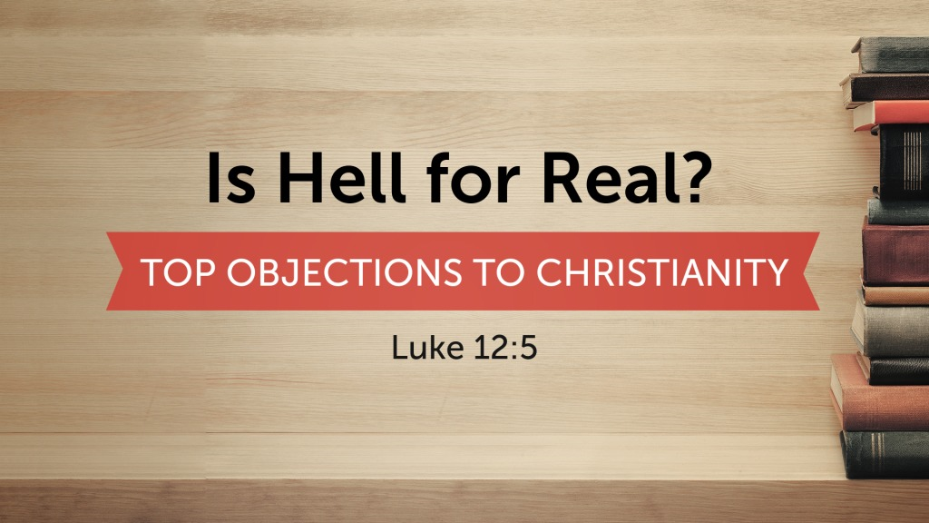
Luke 12:5 ESV
⁵ But I will warn you whom to fear: fear him who, after he has killed, has authority to cast into hell. Yes, I tell you, fear him!
Hebrews 9:27 ESV
²⁷ And just as it is appointed for man to die once, and after that comes judgment,
Romans 6:23 ESV
²³ For the wages of sin is death, but the free gift of God is eternal life in Christ Jesus our Lord.

Hell was originally created for the devil and his angels
Matthew 25:41 ESV
⁴¹ “Then he will say to those on his left, ‘Depart from me, you cursed, into the eternal fire prepared for the devil and his angels.

Hell is a consequence of rejecting God
Matthew 13:40–42 ESV
⁴⁰ Just as the weeds are gathered and burned with fire, so will it be at the end of the age. ⁴¹ The Son of Man will send his angels, and they will gather out of his kingdom all causes of sin and all law-breakers, ⁴² and throw them into the fiery furnace. In that place there will be weeping and gnashing of teeth.

Jesus possesses authority over hell
Matthew 16:18 ESV
¹⁸ And I tell you, you are Peter, and on this rock I will build my church, and the gates of hell shall not prevail against it.
Revelation 1:18 ESV
¹⁸ and the living one. I died, and behold I am alive forevermore, and I have the keys of Death and Hades.
John 5:27 ESV
²⁷ And he has given him authority to execute judgment, because he is the Son of Man.
Acts 10:42 ESV
⁴² And he commanded us to preach to the people and to testify that he is the one appointed by God to be judge of the living and the dead.
Acts 17:31 ESV
³¹ because he has fixed a day on which he will judge the world in righteousness by a man whom he has appointed; and of this he has given assurance to all by raising him from the dead.”

An Invitation to Eternal Life
Hearing - Believing - Confessing - Repenting
Being Baptized - Remain Faithful
Romans 10:17 ESV
¹⁷ So faith comes from hearing, and hearing through the word of Christ.
Romans 10:9 ESV
⁹ because, if you confess with your mouth that Jesus is Lord and believe in your heart that God raised him from the dead, you will be saved.
Luke 13:3 ESV
³ No, I tell you; but unless you repent, you will all likewise perish.
Acts 2:38 ESV
³⁸ And Peter said to them, “Repent and be baptized every one of you in the name of Jesus Christ for the forgiveness of your sins, and you will receive the gift of the Holy Spirit.
Revelation 2:10 ESV
¹⁰ Do not fear what you are about to suffer. Behold, the devil is about to throw some of you into prison, that you may be tested, and for ten days you will have tribulation. Be faithful unto death, and I will give you the crown of life.
starting Wednesday, June 12th at 6:30pm

