Barry G. Johnson, Sr. / www.barrygjohnsonsr.com
Judges: A Downward Spiral / Selfishness / Judges 17:1–6
A self-centred concern for oneself, without due regard to the needs of others. Scripture treats selfishness as an aspect of sin and urges believers to care for others as well as themselves.
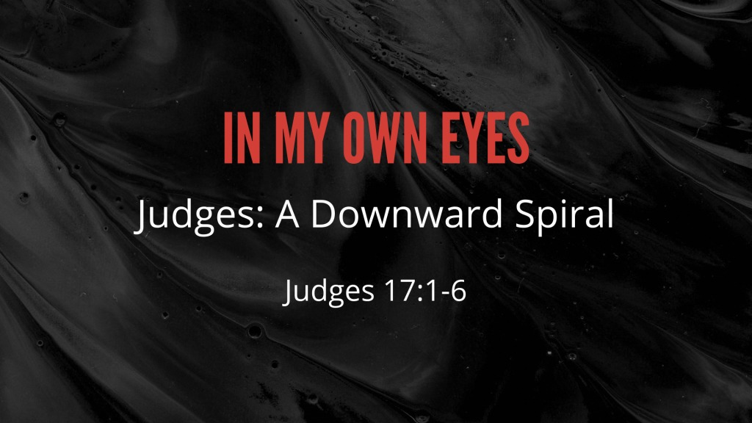
Judges 17:1–6 ESV
¹ There was a man of the hill country of Ephraim, whose name was Micah. ² And he said to his mother, “The 1,100 pieces of silver that were taken from you, about which you uttered a curse, and also spoke it in my ears, behold, the silver is with me; I took it.” And his mother said, “Blessed be my son by the Lord.” ³ And he restored the 1,100 pieces of silver to his mother. And his mother said, “I dedicate the silver to the Lord from my hand for my son, to make a carved image and a metal image. Now therefore I will restore it to you.” ⁴ So when he restored the money to his mother, his mother took 200 pieces of silver and gave it to the silversmith, who made it into a carved image and a metal image. And it was in the house of Micah. ⁵ And the man Micah had a shrine, and he made an ephod and household gods, and ordained one of his sons, who became his priest. ⁶ In those days there was no king in Israel. Everyone did what was right in his own eyes.

Selfishness is a characteristic of the sinner
Romans 8:5 ESV
⁵ For those who live according to the flesh set their minds on the things of the flesh, but those who live according to the Spirit set their minds on the things of the Spirit.
2 Corinthians 5:15 ESV
¹⁵ and he died for all, that those who live might no longer live for themselves but for him who for their sake died and was raised.

Selfishness is a characteristic of sinful society
2 Timothy 3:1–2 ESV
¹ But understand this, that in the last days there will come times of difficulty. ² For people will be lovers of self, lovers of money, proud, arrogant, abusive, disobedient to their parents, ungrateful, unholy,

Expressions of selfishness

Greed
Matthew 23:25 ESV
²⁵ “Woe to you, scribes and Pharisees, hypocrites! For you clean the outside of the cup and the plate, but inside they are full of greed and self-indulgence.

Ambition
Philippians 2:3 ESV
³ Do nothing from selfish ambition or conceit, but in humility count others more significant than yourselves.

Boastfulness
Daniel 4:30 ESV
³⁰ and the king answered and said, “Is not this great Babylon, which I have built by my mighty power as a royal residence and for the glory of my majesty?”

Self-absorption as the result of pain or depression
Job 14:22 ESV
²² He feels only the pain of his own body, and he mourns only for himself.”
1 Kings 19:10 ESV
¹⁰ He said, “I have been very jealous for the Lord, the God of hosts. For the people of Israel have forsaken your covenant, thrown down your altars, and killed your prophets with the sword, and I, even I only, am left, and they seek my life, to take it away.”

Antidotes to selfishness

God’s word
Psalm 119:36 ESV
³⁶ Incline my heart to your testimonies, and not to selfish gain!

The example of Jesus Christ
Romans 15:3 ESV
³ For Christ did not please himself, but as it is written, “The reproaches of those who reproached you fell on me.”

Dying to the old nature
Romans 6:6 ESV
⁶ We know that our old self was crucified with him in order that the body of sin might be brought to nothing, so that we would no longer be enslaved to sin.

Serving one another
1 Peter 4:10 ESV
¹⁰ As each has received a gift, use it to serve one another, as good stewards of God’s varied grace:

Loving one another
John 13:34 ESV
³⁴ A new commandment I give to you, that you love one another: just as I have loved you, you also are to love one another.

God’s Plan of Salvation

Hear
Romans 10:17 ESV
¹⁷ So faith comes from hearing, and hearing through the word of Christ.

Believe and Confess
Romans 10:10 ESV
¹⁰ For with the heart one believes and is justified, and with the mouth one confesses and is saved.

Repent
Luke 13:3 ESV
³ No, I tell you; but unless you repent, you will all likewise perish.

Be Baptized
Acts 2:41 ESV
⁴¹ So those who received his word were baptized, and there were added that day about three thousand souls.

Remain Faithful
1 Corinthians 15:58 ESV
⁵⁸ Therefore, my beloved brothers, be steadfast, immovable, always abounding in the work of the Lord, knowing that in the Lord your labor is not in vain.

My Decision Today
- I would like to be baptized today
- I would like to renew my life to Christ

What are my next steps?
- Come forward to be baptized
- Request a Bible Study to learn more
- Attend Bible Class to grow and mature
- Find a place to serve others

