Herod's Self Destructive Arrogance
Herod's Self Destructive Arrogance
Barry G. Johnson, Sr. / General
Discovering the Church / Arrogant; Arrogance; Humility; A Humble Person / Acts 12:19–24
Through Herod we learn that arrogance is self-destructive and those at enmity with God will receive His justice.
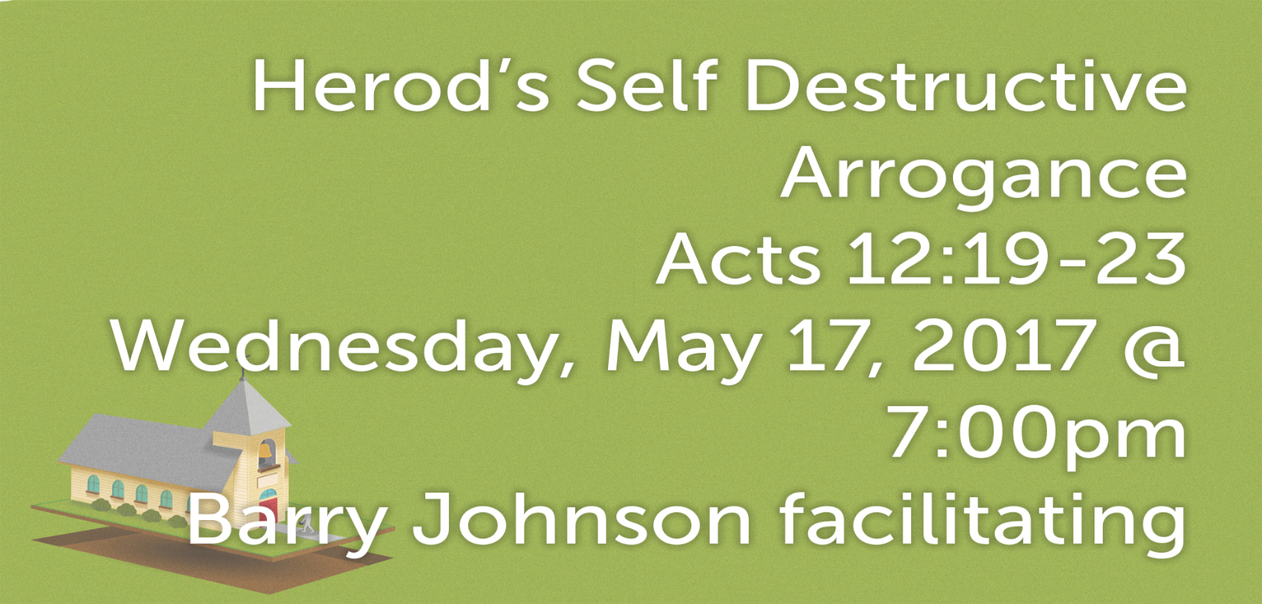
Acts 12:19–23 ESV
¹⁹ And after Herod searched for him and did not find him, he examined the sentries and ordered that they should be put to death. Then he went down from Judea to Caesarea and spent time there.
²⁰ Now Herod was angry with the people of Tyre and Sidon, and they came to him with one accord, and having persuaded Blastus, the king’s chamberlain, they asked for peace, because their country depended on the king’s country for food.
²¹ On an appointed day Herod put on his royal robes, took his seat upon the throne, and delivered an oration to them.
²² And the people were shouting, “The voice of a god, and not of a man!”
²³ Immediately an angel of the Lord struck him down, because he did not give God the glory, and he was eaten by worms and breathed his last.

Examining Peter’s Keepers
Acts 12:19 ESV
¹⁹ And after Herod searched for him and did not find him, he examined the sentries and ordered that they should be put to death. Then he went down from Judea to Caesarea and spent time there.

Herod Upset at Tyre and Sidon
- ref. I Kings 5:11; Ezra 3:7; Ezekiel 27:17; Acts 11:28
Acts 12:20 ESV
²⁰ Now Herod was angry with the people of Tyre and Sidon, and they came to him with one accord, and having persuaded Blastus, the king’s chamberlain, they asked for peace, because their country depended on the king’s country for food.

Herod Adorns Himself
The Works of Josephus: New Updated Edition Chapter 8: What Other Acts Were Done by Agrippa until His Death; and after What Manner He Died
(344) On the second day of which shows he put on a garment made wholly of silver, and of a contexture truly wonderful, and came into the theatre early in the morning; at which time the silver of his garment being illuminated by the fresh reflection of the sun’s rays upon it, shone out after a surprising manner, and was so resplendent as to spread a horror over those that looked intently upon him;
Acts 12:21 ESV
²¹ On an appointed day Herod put on his royal robes, took his seat upon the throne, and delivered an oration to them.
- ref. Luke 21:5; 1 Timothy 2:9-10; 1 Peter 3:3-5; Romans 12:3
Question: How ought we adorn ourselves?
___________________________
- ref. Acts 12:1-5

Herod’s Arrogance
- ref. Isaiah 13:11; Proverbs 16:18-19: Matthew 23:12; James 4:6-7
The Works of Josephus: New Updated Edition Chapter 8: What Other Acts Were Done by Agrippa until His Death; and after What Manner He Died
(345) and presently his flatterers cried out, one from one place, and another from another (though not for his good), that he was a god; and they added, “Be thou merciful to us; for although we have hitherto reverenced thee only as a man, yet shall we henceforth own thee as superior to mortal nature.”
Acts 12:22 ESV
²² And the people were shouting, “The voice of a god, and not of a man!”
Question: What should have Herod’s response been to the crowd?
__________________

Herod is only a man
The Works of Josephus: New Updated Edition Chapter 8: What Other Acts Were Done by Agrippa until His Death; and after What Manner He Died
(346) Upon this the king did neither rebuke them, nor reject their impious flattery. But, as he presently afterwards looked up, he saw an owl sitting on a certain rope over his head, and immediately understood that this bird was the messenger of ill tidings, as it had once been the messenger of good tidings to him; and fell into the deepest sorrow. A severe pain also arose in his belly, and began in a most violent manner.
Acts 12:23 ESV
²³ Immediately an angel of the Lord struck him down, because he did not give God the glory, and he was eaten by worms and breathed his last.
Merriam-Webster’s Collegiate Dictionary (Eleventh Edition) Immediately
im•me•di•ate•ly \ adverb 15th century
1: in direct connection or relation: DIRECTLY (the parties immediately involved in the case) (the house immediately beyond this one)
2: without interval of time: STRAIGHTWAY (I’ll make that call immediately)
Question: Will God always strike down those who oppose Him, like Herod?
__________________________________
- ref. Romans 3:25-26
Are we arrogant or have we humbled ourselves before God?

