Barry G. Johnson, Sr. / General
Discovering the Church / Hear; Salvation; Holy Spirit; Holy Spirit: Gifts / Acts 19:1–12

What you hear and obey determines your destination.
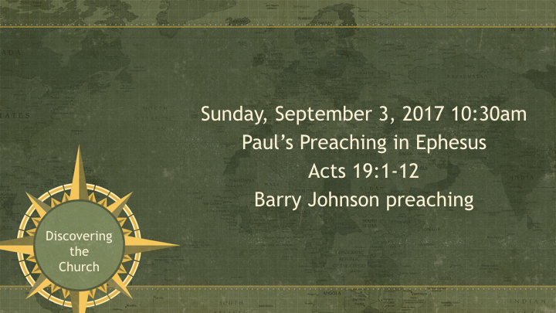
Acts 19:1–12 ESV
¹ And it happened that while Apollos was at Corinth, Paul passed through the inland country and came to Ephesus. There he found some disciples. ² And he said to them, “Did you receive the Holy Spirit when you believed?” And they said, “No, we have not even heard that there is a Holy Spirit.” ³ And he said, “Into what then were you baptized?” They said, “Into John’s baptism.” ⁴ And Paul said, “John baptized with the baptism of repentance, telling the people to believe in the one who was to come after him, that is, Jesus.” ⁵ On hearing this, they were baptized in the name of the Lord Jesus. ⁶ And when Paul had laid his hands on them, the Holy Spirit came on them, and they began speaking in tongues and prophesying. ⁷ There were about twelve men in all.
⁸ And he entered the synagogue and for three months spoke boldly, reasoning and persuading them about the kingdom of God. ⁹ But when some became stubborn and continued in unbelief, speaking evil of the Way before the congregation, he withdrew from them and took the disciples with him, reasoning daily in the hall of Tyrannus. ¹⁰ This continued for two years, so that all the residents of Asia heard the word of the Lord, both Jews and Greeks. ¹¹ And God was doing extraordinary miracles by the hands of Paul, ¹² so that even handkerchiefs or aprons that had touched his skin were carried away to the sick, and their diseases left them and the evil spirits came out of them.

What have you heard?
Acts 19:2 ESV
² And he said to them, “Did you receive the Holy Spirit when you believed?” And they said, “No, we have not even heard that there is a Holy Spirit.”
Acts 2:36–41 ESV
³⁶ Let all the house of Israel therefore know for certain that God has made him both Lord and Christ, this Jesus whom you crucified.” ³⁷ Now when they heard this they were cut to the heart, and said to Peter and the rest of the apostles, “Brothers, what shall we do?” ³⁸ And Peter said to them, “Repent and be baptized every one of you in the name of Jesus Christ for the forgiveness of your sins, and you will receive the gift of the Holy Spirit. ³⁹ For the promise is for you and for your children and for all who are far off, everyone whom the Lord our God calls to himself.” ⁴⁰ And with many other words he bore witness and continued to exhort them, saying, “Save yourselves from this crooked generation.” ⁴¹ So those who received his word were baptized, and there were added that day about three thousand souls.
Matthew 28:18–20 ESV
¹⁸ And Jesus came and said to them, “All authority in heaven and on earth has been given to me. ¹⁹ Go therefore and make disciples of all nations, baptizing them in the name of the Father and of the Son and of the Holy Spirit, ²⁰ teaching them to observe all that I have commanded you. And behold, I am with you always, to the end of the age.”

Where your hearing takes you
Acts 19:3 ESV
³ And he said, “Into what then were you baptized?” They said, “Into John’s baptism.”
Romans 10:17 ESV
¹⁷ So faith comes from hearing, and hearing through the word of Christ.
2 Timothy 4:3 ESV
³ For the time is coming when people will not endure sound teaching, but having itching ears they will accumulate for themselves teachers to suit their own passions,
Matthew 15:7–9 ESV
⁷ You hypocrites! Well did Isaiah prophesy of you, when he said: ⁸ “ ‘This people honors me with their lips, but their heart is far from me; ⁹ in vain do they worship me, teaching as doctrines the commandments of men.’ ”

Believing what you heard
Acts 19:10 ESV
¹⁰ This continued for two years, so that all the residents of Asia heard the word of the Lord, both Jews and Greeks.

Four "essential elements" of Bible baptism

The proper mode: a burial (immersion) - Ro 6:3; Col 2:12
Romans 6:3 ESV
³ Do you not know that all of us who have been baptized into Christ Jesus were baptized into his death?
Colossians 2:12 ESV
¹² having been buried with him in baptism, in which you were also raised with him through faith in the powerful working of God, who raised him from the dead.

The proper authority: in the name of Christ - Ac 19:5
Acts 19:5 ESV
⁵ On hearing this, they were baptized in the name of the Lord Jesus.

The proper purpose: remission of sins - Ac 2:38; 22:16
Acts 2:38 ESV
³⁸ And Peter said to them, “Repent and be baptized every one of you in the name of Jesus Christ for the forgiveness of your sins, and you will receive the gift of the Holy Spirit.
Acts 22:16 ESV
¹⁶ And now why do you wait? Rise and be baptized and wash away your sins, calling on his name.’

The proper subject: penitent believer - Ac 2:38; 8:36; Mk 16:16
Acts 2:38 ESV
³⁸ And Peter said to them, “Repent and be baptized every one of you in the name of Jesus Christ for the forgiveness of your sins, and you will receive the gift of the Holy Spirit.
Acts 8:36 ESV
³⁶ And as they were going along the road they came to some water, and the eunuch said, “See, here is water! What prevents me from being baptized?”
Mark 16:16 ESV
¹⁶ Whoever believes and is baptized will be saved, but whoever does not believe will be condemned.

HEAR
Romans 10:17 (ESV)
¹⁷ So faith comes from hearing, and hearing through the word of Christ.

BELIEVE
Mark 16:16 (ESV)
¹⁶ Whoever believes and is baptized will be saved, but whoever does not believe will be condemned.

REPENT
Acts 17:30 (ESV)
³⁰ The times of ignorance God overlooked, but now he commands all people everywhere to repent,

CONFESS
1 Timothy 6:12 (ESV)
¹² Fight the good fight of the faith. Take hold of the eternal life to which you were called and about which you made the good confession in the presence of many witnesses.

BE BAPTIZED
Romans 6:4 (ESV)
⁴ We were buried therefore with him by baptism into death, in order that, just as Christ was raised from the dead by the glory of the Father, we too might walk in newness of life.

REMAIN FAITHFUL
Revelation 2:10 (ESV)
¹⁰ Do not fear what you are about to suffer. Behold, the devil is about to throw some of you into prison, that you may be tested, and for ten days you will have tribulation. Be faithful unto death, and I will give you the crown of life.

