Barry G. Johnson, Sr. / www.barrygjohnsonsr.com
Romans: The Righteous Shall Live by Faith / Good; Righteous One; Promise; Gift; Love / Romans 2:6–11
All God’s perfect qualities are made freely available to all for the benefit of the whole world.
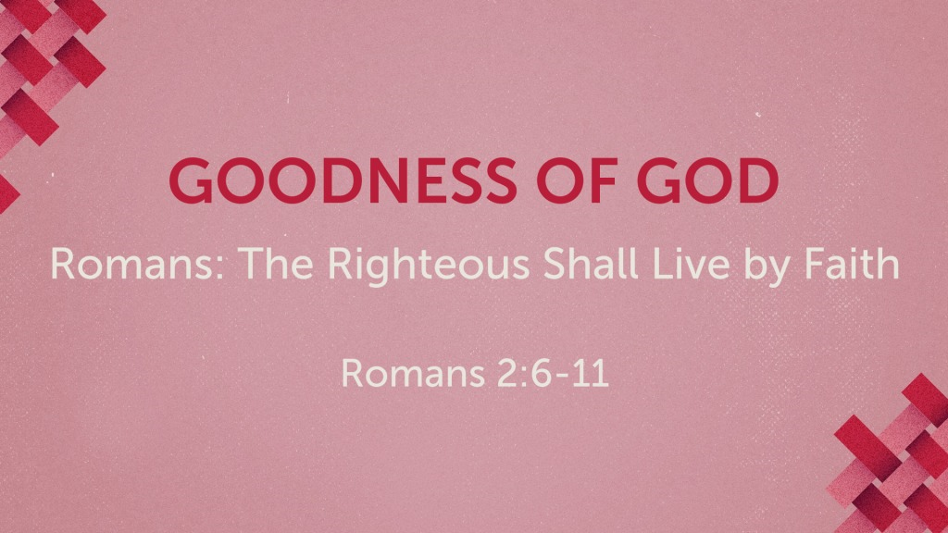

I. God alone is good
Mark 10:18 ESV
¹⁸ And Jesus said to him, “Why do you call me good? No one is good except God alone.

II. God demonstrates his goodness

A. In his actions
Psalm 119:68 ESV
⁶⁸ You are good and do good; teach me your statutes.
See also 2 Ch 30:18; Ne 9:20; Ps 73:1; Ps 143:10; Ac 10:38; Ro 2:4

B. In his work of creation
1 Timothy 4:4 ESV
⁴ For everything created by God is good, and nothing is to be rejected if it is received with thanksgiving,
See also Ge 1:4; Ge 1:31; Ps 145:9

C. In his love
Psalm 86:5 ESV
⁵ For you, O Lord, are good and forgiving, abounding in steadfast love to all who call upon you.
See also 1 Ch 16:34; Ps 25:7–8; Ps 69:16; Ps 100:5

D. In his gifts
James 1:17 ESV
¹⁷ Every good gift and every perfect gift is from above, coming down from the Father of lights, with whom there is no variation or shadow due to change.
See also Nu 13:27; Dt 8:7; Dt 26:11; Heb 9:11

E. In his promises
Joshua 23:14–15 ESV
¹⁴ “And now I am about to go the way of all the earth, and you know in your hearts and souls, all of you, that not one word has failed of all the good things that the Lord your God promised concerning you. All have come to pass for you; not one of them has failed.
¹⁵ But just as all the good things that the Lord your God promised concerning you have been fulfilled for you, so the Lord will bring upon you all the evil things, until he has destroyed you from off this good land that the Lord your God has given you,
See also 2 Sa 7:28; 1 Ki 8:56; Je 29:10

F. In his commands
Psalm 119:39 ESV
³⁹ Turn away the reproach that I dread, for your rules are good.
See also Ps 19:7; Ro 7:12; Ro 7:16; Ro 12:2

III. God’s goodness is to be experienced

A. God is good to those who trust him
Psalm 34:8 ESV
⁸ Oh, taste and see that the Lord is good! Blessed is the man who takes refuge in him!
Nahum 1:7 ESV
⁷ The Lord is good, a stronghold in the day of trouble; he knows those who take refuge in him.
See also Ex 33:19; 2 Ch 7:10; Job 42:11; Ps 31:19–20; Ps 84:11; Ps 86:17; La 3:25; Am 5:14–15; 1 Pe 2:3

B. God’s people can rely on his goodness
Jeremiah 32:40 ESV
⁴⁰ I will make with them an everlasting covenant, that I will not turn away from doing good to them. And I will put the fear of me in their hearts, that they may not turn from me.
See also Ps 23:6; Ps 27:13; Mt 7:11; Php 1:6

IV. God works positively for good in unfavorable circumstances
Genesis 50:20 ESV
²⁰ As for you, you meant evil against me, but God meant it for good, to bring it about that many people should be kept alive, as they are today.
See also Ac 2:23–24; Ro 8:28; 2 Co 4:17; Heb 12:10

V. God’s goodness is to be praised
Psalm 135:3 ESV
³ Praise the Lord, for the Lord is good; sing to his name, for it is pleasant!
See also Dt 8:10; 2 Ch 5:13; 2 Ch 7:3; Ps 86:5; Ps 136:1; Ps 145:7

God’s Goodness seen in His Plan of Salvation
HEAR - BELIEVE - REPENT - CONFESS - BE BAPTIZED - REMAIN FAITHFUL
Romans 10:17 ESV
¹⁷ So faith comes from hearing, and hearing through the word of Christ.
Hebrews 11:6 ESV
⁶ And without faith it is impossible to please him, for whoever would draw near to God must believe that he exists and that he rewards those who seek him.
Romans 2:4 ESV
⁴ Or do you presume on the riches of his kindness and forbearance and patience, not knowing that God’s kindness is meant to lead you to repentance?
1 Timothy 6:12 ESV
¹² Fight the good fight of the faith. Take hold of the eternal life to which you were called and about which you made the good confession in the presence of many witnesses.
Ephesians 4:4–6 ESV
⁴ There is one body and one Spirit—just as you were called to the one hope that belongs to your call— ⁵ one Lord, one faith, one baptism, ⁶ one God and Father of all, who is over all and through all and in all.
1 Corinthians 15:58 ESV
⁵⁸ Therefore, my beloved brothers, be steadfast, immovable, always abounding in the work of the Lord, knowing that in the Lord your labor is not in vain.
Spiritual Exercise and Plan of Action
1. What does it mean, God is good?
2. Name 6 ways God demonstrates His goodness.
3. How have you experienced God’s goodness?
4. Can you name an example of how God worked positively for you in unfavorable conditions?
5. How will you praise God’s goodness moving forward?

