Synopsis
God’s purpose is to bring together and reconcile to himself the whole of creation. This desire for unity is a reflection of the unity within the Godhead; it is expressed in marriage, and demonstrated in the fellowship of the church. God’s Goal of Unity is one in Christ.

Objectives:
- The Godhead is a Reflection of Unity
- Sin Brings Alienation (disunity)
- God’s Purpose in Unity
- How Unity Should be Expressed

- The Godhead is a Reflection of Unity
Deuteronomy 6:4 (NIV) — 4 Hear, O Israel: The Lord our God, the Lord is one.
John 17:22 (NIV) — 22 I have given them the glory that you gave me, that they may be one as we are one—
there is more, check out Mk 12:29; Mk 12:32; Jn 1:1; Jn 17:11; Ga 3:20; 1 Jn 5:7
- Sin Brings Alienation (disunity)
- Alienation from God
Genesis 3:8 (NIV) — 8 Then the man and his wife heard the sound of the Lord God as he was walking in the garden in the cool of the day, and they hid from the Lord God among the trees of the garden.
Genesis 3:23–24 (NIV) — 23 So the Lord God banished him from the Garden of Eden to work the ground from which he had been taken. 24 After he drove the man out, he placed on the east side of the Garden of Eden cherubim and a flaming sword flashing back and forth to guard the way to the tree of life.
Isaiah 59:2 (NIV) — 2 But your iniquities have separated you from your God; your sins have hidden his face from you, so that he will not hear.
Ezekiel 28:16 (NIV) — 16 Through your widespread trade you were filled with violence, and you sinned. So I drove you in disgrace from the mount of God, and I expelled you, guardian cherub, from among the fiery stones.
James 4:4 (NIV) — 4 You adulterous people, don’t you know that friendship with the world means enmity against God? Therefore, anyone who chooses to be a friend of the world becomes an enemy of God.
- Alienation from one another
Genesis 4:7–9 (NIV) — 7 If you do what is right, will you not be accepted? But if you do not do what is right, sin is crouching at your door; it desires to have you, but you must rule over it.” 8 Now Cain said to his brother Abel, “Let’s go out to the field.” While they were in the field, Cain attacked his brother Abel and killed him. 9 Then the Lord said to Cain, “Where is your brother Abel?” “I don’t know,” he replied. “Am I my brother’s keeper?”
Genesis 4:23–24 (NIV) — 23 Lamech said to his wives, “Adah and Zillah, listen to me; wives of Lamech, hear my words. I have killed a man for wounding me, a young man for injuring me. 24 If Cain is avenged seven times, then Lamech seventy-seven times.”
Genesis 6:11 (NIV) — 11 Now the earth was corrupt in God’s sight and was full of violence.
James 4:1–2 (NIV) — 1 What causes fights and quarrels among you? Don’t they come from your desires that battle within you? 2 You desire but do not have, so you kill. You covet but you cannot get what you want, so you quarrel and fight. You do not have because you do not ask God.
Jude 19 (NIV) — 19 These are the people who divide you, who follow mere natural instincts and do not have the Spirit.
- God’s Purpose in Unity
- To bring together all peoples
Psalm 133:1 (NIV) — 1 How good and pleasant it is when God’s people live together in unity!
Ephesians 1:9–10 (NIV) — 9 he made known to us the mystery of his will according to his good pleasure, which he purposed in Christ, 10 to be put into effect when the times reach their fulfillment—to bring unity to all things in heaven and on earth under Christ.
- To unite all peoples under his rule
Zechariah 14:9 (NIV) — 9 The Lord will be king over the whole earth. On that day there will be one Lord, and his name the only name.
there is more, check out Ge 49:10; Ps 72:8–11; Is 2:2–4; Jn 10:16; Php 2:9–11; Re 11:15
- To unite all peoples in worship
Isaiah 19:23–25 (NIV) — 23 In that day there will be a highway from Egypt to Assyria. The Assyrians will go to Egypt and the Egyptians to Assyria. The Egyptians and Assyrians will worship together. 24 In that day Israel will be the third, along with Egypt and Assyria, a blessing on the earth. 25 The Lord Almighty will bless them, saying, “Blessed be Egypt my people, Assyria my handiwork, and Israel my inheritance.”
there is more, check out Ps 86:9; Is 56:6–8; Zec 8:20–23; Zec 14:16; Mk 11:17; Re 15:4
- To bring reconciliation between Jew and Gentile
Ephesians 2:11–19 (NIV) — 11 Therefore, remember that formerly you who are Gentiles by birth and called “uncircumcised” by those who call themselves “the circumcision” (which is done in the body by human hands)—12 remember that at that time you were separate from Christ, excluded from citizenship in Israel and foreigners to the covenants of the promise, without hope and without God in the world. 13 But now in Christ Jesus you who once were far away have been brought near by the blood of Christ. 14 For he himself is our peace, who has made the two groups one and has destroyed the barrier, the dividing wall of hostility, 15 by setting aside in his flesh the law with its commands and regulations. His purpose was to create in himself one new humanity out of the two, thus making peace, 16 and in one body to reconcile both of them to God through the cross, by which he put to death their hostility. 17 He came and preached peace to you who were far away and peace to those who were near. 18 For through him we both have access to the Father by one Spirit. 19 Consequently, you are no longer foreigners and strangers, but fellow citizens with God’s people and also members of his household,
there is more, check out Is 14:1; Ro 10:12; Ga 3:28; Col 3:11
- To bring reconciliation among his people
Jeremiah 50:4 (NIV) — 4 “In those days, at that time,” declares the Lord, “the people of Israel and the people of Judah together will go in tears to seek the Lord their God.
there is more, check out Is 11:10–13; Eze 37:21–24; Mic 2:12; Mt 5:24; Php 4:2
- To reconcile humanity to himself
Colossians 1:19–22 (NIV) — 19 For God was pleased to have all his fullness dwell in him, 20 and through him to reconcile to himself all things, whether things on earth or things in heaven, by making peace through his blood, shed on the cross. 21 Once you were alienated from God and were enemies in your minds because of your evil behavior. 22 But now he has reconciled you by Christ’s physical body through death to present you holy in his sight, without blemish and free from accusation—
there is more, check out Ro 5:10–11; 2 Co 5:18–19; Heb 10:19–20
- How Unity Should be Expressed
- Unity between husband and wife
Genesis 2:24 (NIV) — 24 That is why a man leaves his father and mother and is united to his wife, and they become one flesh.
there is more, check out Mal 2:15; Mt 19:5–6; 1 Co 6:16; 1 Co 7:4; 1 Co 7:10–11
- Marriage as an expression of unity between God and his people
Jeremiah 2:2 (NIV) — 2 “Go and proclaim in the hearing of Jerusalem: “This is what the Lord says: “ ‘I remember the devotion of your youth, how as a bride you loved me and followed me through the wilderness, through a land not sown.
Ephesians 5:31–32 (NIV) — 31 “For this reason a man will leave his father and mother and be united to his wife, and the two will become one flesh.” 32 This is a profound mystery—but I am talking about Christ and the church.
there is more, check out Is 54:5; Je 31:32; Ho 2:16; Jn 3:29; Re 19:7; Re 21:2; Re 21:9
- Unity within the church
John 17:21 (NIV) — 21 that all of them may be one, Father, just as you are in me and I am in you. May they also be in us so that the world may believe that you have sent me.
there is more, check out Ac 2:1; Ac 4:32; 1 Co 1:10; 1 Co 10:17; 1 Co 12:12; Eph 4:13

Hear - Romans 10:17 (NIV)
¹⁷ Consequently, faith comes from hearing the message, and the message is heard through the word about Christ.
Believe - Hebrews 11:6 (NIV)
⁶ And without faith it is impossible to please God, because anyone who comes to him must believe that he exists and that he rewards those who earnestly seek him.
Repent - Acts 17:30 (NIV)
³⁰ In the past God overlooked such ignorance, but now he commands all people everywhere to repent.
Confess - 1 Timothy 6:12 (NIV)
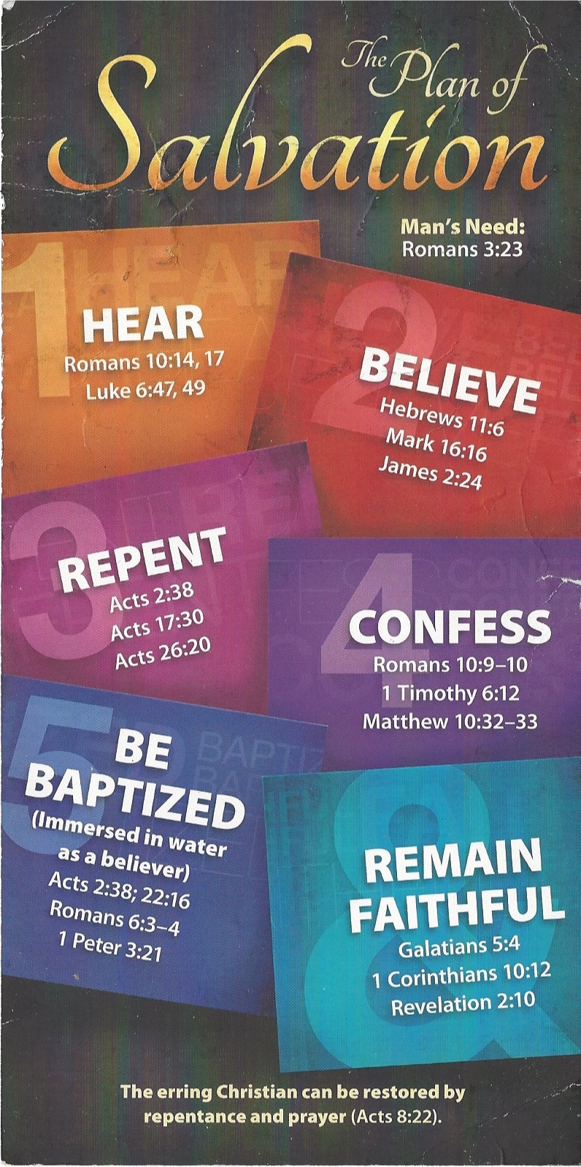
¹² Fight the good fight of the faith. Take hold of the eternal life to which you were called when you made your good confession in the presence of many witnesses.

Be Baptized - Acts 22:16 (NIV)
¹⁶ And now what are you waiting for? Get up, be baptized and wash your sins away, calling on his name.’
Remain Steadfast - Revelation 2:10 (NIV)
¹⁰ Do not be afraid of what you are about to suffer. I tell you, the devil will put some of you in prison to test you, and you will suffer persecution for ten days. Be faithful, even to the point of death, and I will give you life as your victor’s crown.

