God's Deliverance
God's Deliverance
Barry G. Johnson, Sr. / General
Discovering the Church / Deliverance; Deliverer; Salvation; Obedience / Acts 12:6–19
God frequently rescues people from danger, suffering and sin, often through human agency.
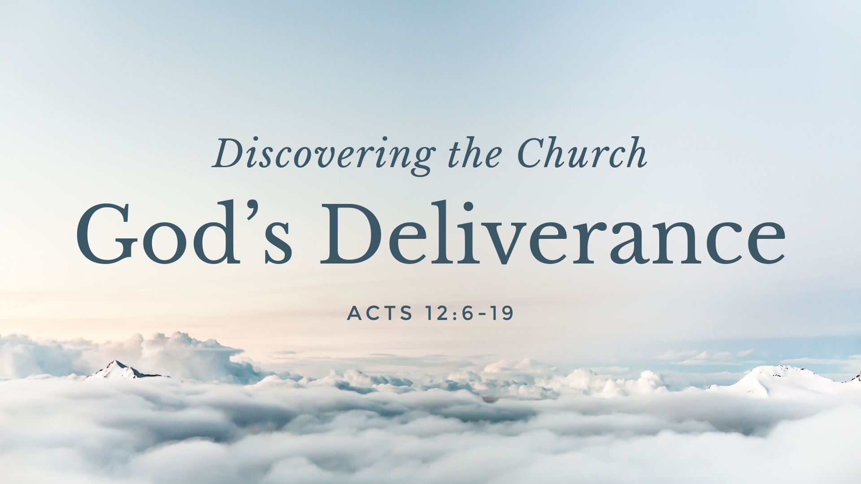

I. God is the Source of Deliverance

A. Deliverance comes from God
Psalm 3:8 ESV
⁸ Salvation belongs to the Lord; your blessing be on your people! Selah

B. There is no deliverance by other gods
2 Kings 18:33 ESV
³³ Has any of the gods of the nations ever delivered his land out of the hand of the king of Assyria?

C. There is no escape from God
Isaiah 43:13 ESV
¹³ Also henceforth I am he; there is none who can deliver from my hand; I work, and who can turn it back?”

II. Different kinds of deliverance

A. From danger
1 Samuel 17:37 ESV
³⁷ And David said, “The Lord who delivered me from the paw of the lion and from the paw of the bear will deliver me from the hand of this Philistine.” And Saul said to David, “Go, and the Lord be with you!”

B. From illness
Psalm 103:3 ESV
³ who forgives all your iniquity, who heals all your diseases,

C. From trouble
Psalm 54:7 ESV
⁷ For he has delivered me from every trouble, and my eye has looked in triumph on my enemies.

D. From slavery
Exodus 20:2 ESV
² “I am the Lord your God, who brought you out of the land of Egypt, out of the house of slavery.

E. From enemies
Luke 1:74 ESV
⁷⁴ that we, being delivered from the hand of our enemies, might serve him without fear,

F. From Satan
Luke 22:31–32 ESV
³¹ “Simon, Simon, behold, Satan demanded to have you, that he might sift you like wheat,
³² but I have prayed for you that your faith may not fail. And when you have turned again, strengthen your brothers.”

G. From the fear of death
Hebrews 2:14–15 ESV
¹⁴ Since therefore the children share in flesh and blood, he himself likewise partook of the same things, that through death he might destroy the one who has the power of death, that is, the devil,
¹⁵ and deliver all those who through fear of death were subject to lifelong slavery.

H. From all fears
Psalm 34:4 ESV
⁴ I sought the Lord, and he answered me and delivered me from all my fears.

I. From sin
Galatians 1:4 ESV
⁴ who gave himself for our sins to deliver us from the present evil age, according to the will of our God and Father,

J. From the coming wrath
1 Thessalonians 5:9 ESV
⁹ For God has not destined us for wrath, but to obtain salvation through our Lord Jesus Christ,

III. Deliverance for God’s people

A. God promises deliverance
Jeremiah 15:11 ESV
¹¹ The Lord said, “Have I not set you free for their good? Have I not pleaded for you before the enemy in the time of trouble and in the time of distress?

B. God’s people are to pray for deliverance
Matthew 6:13 ESV
¹³ And lead us not into temptation, but deliver us from evil.

IV. The proper response to deliverance

A. Praise
Luke 5:25 ESV
²⁵ And immediately he rose up before them and picked up what he had been lying on and went home, glorifying God.
Acts 3:8 ESV
⁸ And leaping up, he stood and began to walk, and entered the temple with them, walking and leaping and praising God.

B. Delight
1 Samuel 2:1 ESV
¹ And Hannah prayed and said, “My heart exults in the Lord; my horn is exalted in the Lord. My mouth derides my enemies, because I rejoice in your salvation.

C. Thanksgiving
Romans 7:24–25 ESV
²⁴ Wretched man that I am! Who will deliver me from this body of death?
²⁵ Thanks be to God through Jesus Christ our Lord! So then, I myself serve the law of God with my mind, but with my flesh I serve the law of sin.

D. Trust
Psalm 40:1–3 ESV
¹ I waited patiently for the Lord; he inclined to me and heard my cry.
² He drew me up from the pit of destruction, out of the miry bog, and set my feet upon a rock, making my steps secure.
³ He put a new song in my mouth, a song of praise to our God. Many will see and fear, and put their trust in the Lord.

E. Obedience
John 5:14 ESV
¹⁴ Afterward Jesus found him in the temple and said to him, “See, you are well! Sin no more, that nothing worse may happen to you.”
John 8:10–11 ESV
¹⁰ Jesus stood up and said to her, “Woman, where are they? Has no one condemned you?”
¹¹ She said, “No one, Lord.” And Jesus said, “Neither do I condemn you; go, and from now on sin no more.”

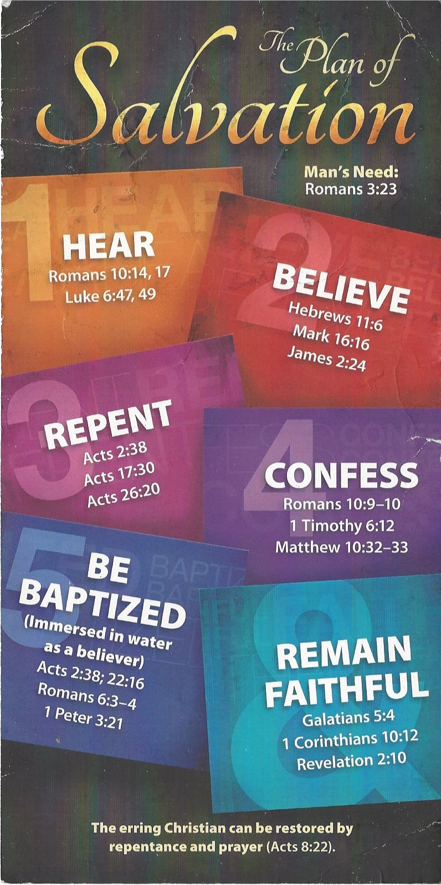
Hear - Romans 10:17 (NIV)
¹⁷ Consequently, faith comes from hearing the message, and the message is heard through the word about Christ.
Believe - Hebrews 11:6 (NIV)
⁶ And without faith it is impossible to please God, because anyone who comes to him must believe that he exists and that he rewards those who earnestly seek him.
Repent - Acts 17:30 (NIV)
³⁰ In the past God overlooked such ignorance, but now he commands all people everywhere to repent.
Confess - 1 Timothy 6:12 (NIV)
¹² Fight the good fight of the faith. Take hold of the eternal life to which you were called when you made your good confession in the presence of many witnesses.
Be Baptized - Acts 2:38 (ESV)
³⁸ And Peter said to them, “Repent and be baptized every one of you in the name of Jesus Christ for the forgiveness of your sins, and you will receive the gift of the Holy Spirit.
Remain Steadfast - Revelation 2:10 (NIV)
¹⁰ Do not be afraid of what you are about to suffer. I tell you, the devil will put some of you in prison to test you, and you will suffer persecution for ten days. Be faithful, even to the point of death, and I will give you life as your victor’s crown.

