Synopsis:
All human abilities and skills derive from God and are to be dedicated to his glory and the good of others.
Talents are given and sustained by God
1 Corinthians 4:7 ESV
For who sees anything different in you? What do you have that you did not receive? If then you received it, why do you boast as if you did not receive it?
Talents differ
Matthew 25:15 ESV
To one he gave five talents, to another two, to another one, to each according to his ability. Then he went away.
See also 2 Ch 2:13–14; Ro 12:6; 1 Co 7:7; 1 Co 12:4–6; Eph 4:11
Talents need to be developed
2 Timothy 1:6 ESV
For this reason I remind you to fan into flame the gift of God, which is in you through the laying on of my hands,
See also Mt 25:16–30; 1 Ti 4:14
Talents are to be devoted to God
For his own glory
1 Peter 4:11 ESV
whoever speaks, as one who speaks oracles of God; whoever serves, as one who serves by the strength that God supplies—in order that in everything God may be glorified through Jesus Christ. To him belong glory and dominion forever and ever. Amen.
See also Ex 35:10; Ex 35:25; 1 Ki 7:40; 1 Ch 9:13; Ps 33:2–3; Ps 137:4–5; 1 Co 10:31
For the good of others
1 Peter 4:10 ESV
As each has received a gift, use it to serve one another, as good stewards of God’s varied grace:
See also 1 Co 12:7; 1 Co 14:12; Eph 4:12
Talents are to be accounted for
Matthew 25:19 ESV
Now after a long time the master of those servants came and settled accounts with them.
See also Mt 21:34; Lk 12:48
Rewards according to use or misuse of talents
Matthew 25:21 ESV
His master said to him, ‘Well done, good and faithful servant. You have been faithful over a little; I will set you over much. Enter into the joy of your master.’
See also Mt 25:23–30

Hear - Romans 10:17 (NIV)
¹⁷ Consequently, faith comes from hearing the message, and the message is heard through the word about Christ.
Believe - Hebrews 11:6 (NIV)
⁶ And without faith it is impossible to please God, because anyone who comes to him must believe that he exists and that he rewards those who earnestly seek him.
Repent - Acts 17:30 (NIV)
³⁰ In the past God overlooked such ignorance, but now he commands all people everywhere to repent.
Confess - Matthew 10:32–33 (NIV)
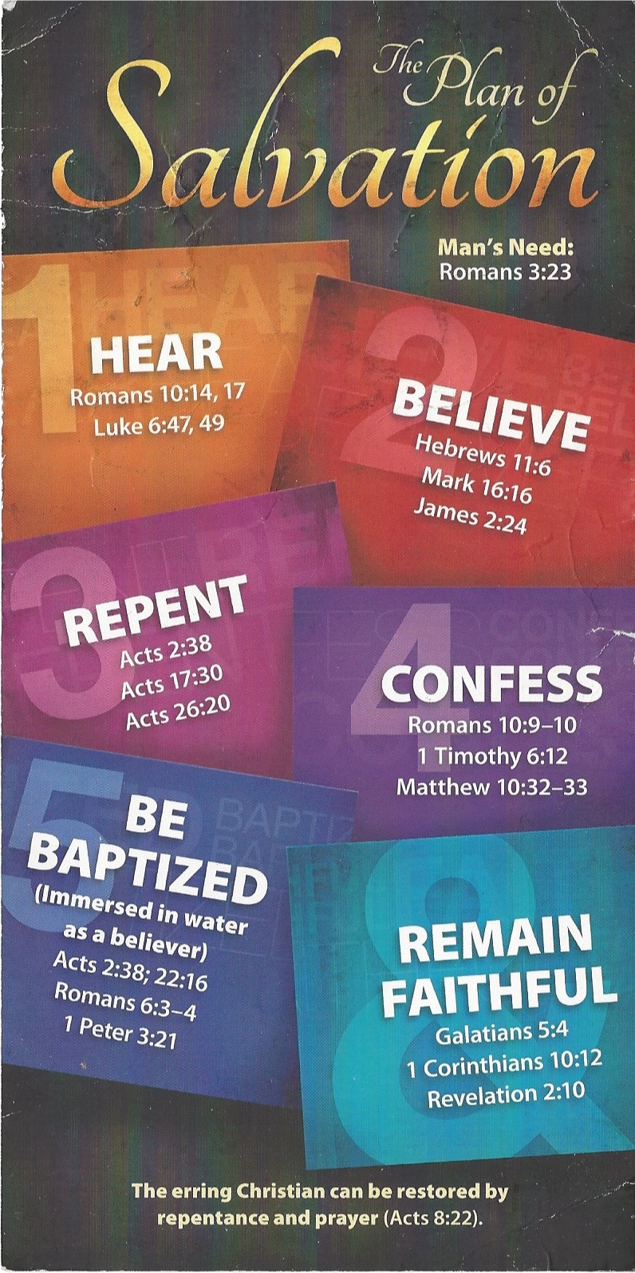
³² “Whoever acknowledges me before others, I will also acknowledge before my Father in heaven. ³³ But whoever disowns me before others, I will disown before my Father in heaven.
Be Baptized - Acts 22:16 (NIV)
¹⁶ And now what are you waiting for? Get up, be baptized and wash your sins away, calling on his name.’
Remain Steadfast - Revelation 2:10 (NIV)
¹⁰ Do not be afraid of what you are about to suffer. I tell you, the devil will put some of you in prison to test you, and you will suffer persecution for ten days. Be faithful, even to the point of death, and I will give you life as your victor’s crown.

