Barry G. Johnson, Sr. / General
Discovering the Church / Repent; Repentance; Fear; Reverence; Salvation / Acts 19:13–20
Do not assume or play with your salvation but move with fear in repentance toward the salvation of the Lord.
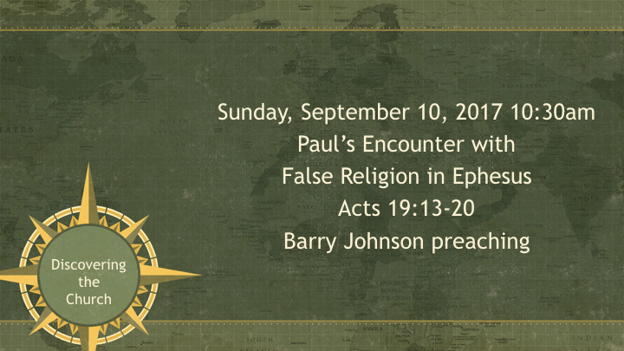

I. Don’t Assume
Acts 8:18–22 ESV
¹⁸ Now when Simon saw that the Spirit was given through the laying on of the apostles’ hands, he offered them money, ¹⁹ saying, “Give me this power also, so that anyone on whom I lay my hands may receive the Holy Spirit.” ²⁰ But Peter said to him, “May your silver perish with you, because you thought you could obtain the gift of God with money! ²¹ You have neither part nor lot in this matter, for your heart is not right before God. ²² Repent, therefore, of this wickedness of yours, and pray to the Lord that, if possible, the intent of your heart may be forgiven you.
2 Corinthians 13:5 ESV
⁵ Examine yourselves, to see whether you are in the faith. Test yourselves. Or do you not realize this about yourselves, that Jesus Christ is in you?—unless indeed you fail to meet the test!

II. The Fear of the Lord
Acts 5:5 ESV
⁵ When Ananias heard these words, he fell down and breathed his last. And great fear came upon all who heard of it.
Acts 5:9–11 ESV
⁹ But Peter said to her, “How is it that you have agreed together to test the Spirit of the Lord? Behold, the feet of those who have buried your husband are at the door, and they will carry you out.” ¹⁰ Immediately she fell down at his feet and breathed her last. When the young men came in they found her dead, and they carried her out and buried her beside her husband. ¹¹ And great fear came upon the whole church and upon all who heard of these things.
Psalm 34:11 ESV
¹¹ Come, O children, listen to me; I will teach you the fear of the Lord.
Psalm 111:10 ESV
¹⁰ The fear of the Lord is the beginning of wisdom; all those who practice it have a good understanding. His praise endures forever!
Proverbs 1:7 ESV
⁷ The fear of the Lord is the beginning of knowledge; fools despise wisdom and instruction.
2 Chronicles 19:7 ESV
⁷ Now then, let the fear of the Lord be upon you. Be careful what you do, for there is no injustice with the Lord our God, or partiality or taking bribes.”

III. Repentance for Salvation
2 Chronicles 7:14 ESV
¹⁴ if my people who are called by my name humble themselves, and pray and seek my face and turn from their wicked ways, then I will hear from heaven and will forgive their sin and heal their land.
Acts 3:19 ESV
¹⁹ Repent therefore, and turn back, that your sins may be blotted out,
Psalm 115:13 ESV
¹³ he will bless those who fear the Lord, both the small and the great.
2 Peter 3:9 ESV
⁹ The Lord is not slow to fulfill his promise as some count slowness, but is patient toward you, not wishing that any should perish, but that all should reach repentance.
2 Corinthians 7:10 ESV
¹⁰ For godly grief produces a repentance that leads to salvation without regret, whereas worldly grief produces death.

HEAR
Romans 10:17 (ESV)
¹⁷ So faith comes from hearing, and hearing through the word of Christ.

BELIEVE
Mark 16:16 (ESV)
¹⁶ Whoever believes and is baptized will be saved, but whoever does not believe will be condemned.

REPENT
Acts 17:30 (ESV)
³⁰ The times of ignorance God overlooked, but now he commands all people everywhere to repent,

CONFESS
1 Timothy 6:12 (ESV)
¹² Fight the good fight of the faith. Take hold of the eternal life to which you were called and about which you made the good confession in the presence of many witnesses.

BE BAPTIZED
Romans 6:4 (ESV)
⁴ We were buried therefore with him by baptism into death, in order that, just as Christ was raised from the dead by the glory of the Father, we too might walk in newness of life.

REMAIN FAITHFUL
Revelation 2:10 (ESV)
¹⁰ Do not fear what you are about to suffer. Behold, the devil is about to throw some of you into prison, that you may be tested, and for ten days you will have tribulation. Be faithful unto death, and I will give you the crown of life.

