Even on the Gentiles
Barry G. Johnson, Sr. / General
Discovering the Church / Impartial; Gentiles / Acts 10:34–48
The ability to be unbiased towards any one race, class or person. This attitude is demonstrated by God and is to be emulated by the human race.
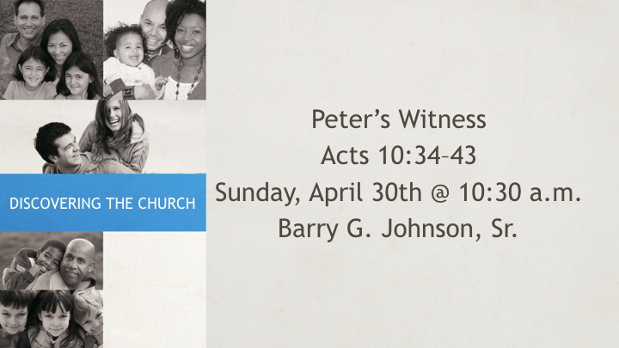
Acts 10:34–48 (ESV)
³⁴ So Peter opened his mouth and said: “Truly I understand that God shows no partiality, ³⁵ but in every nation anyone who fears him and does what is right is acceptable to him. ³⁶ As for the word that he sent to Israel, preaching good news of peace through Jesus Christ (he is Lord of all), ³⁷ you yourselves know what happened throughout all Judea, beginning from Galilee after the baptism that John proclaimed: ³⁸ how God anointed Jesus of Nazareth with the Holy Spirit and with power. He went about doing good and healing all who were oppressed by the devil, for God was with him. ³⁹ And we are witnesses of all that he did both in the country of the Jews and in Jerusalem. They put him to death by hanging him on a tree, ⁴⁰ but God raised him on the third day and made him to appear, ⁴¹ not to all the people but to us who had been chosen by God as witnesses, who ate and drank with him after he rose from the dead. ⁴² And he commanded us to preach to the people and to testify that he is the one appointed by God to be judge of the living and the dead. ⁴³ To him all the prophets bear witness that everyone who believes in him receives forgiveness of sins through his name.”
The Holy Spirit Falls on the Gentiles
⁴⁴ While Peter was still saying these things, the Holy Spirit fell on all who heard the word. ⁴⁵ And the believers from among the circumcised who had come with Peter were amazed, because the gift of the Holy Spirit was poured out even on the Gentiles. ⁴⁶ For they were hearing them speaking in tongues and extolling God. Then Peter declared, ⁴⁷ “Can anyone withhold water for baptizing these people, who have received the Holy Spirit just as we have?” ⁴⁸ And he commanded them to be baptized in the name of Jesus Christ. Then they asked him to remain for some days.
Sermons / Outline

I. God is Impartial
Deuteronomy 10:17 ESV
¹⁷ For the Lord your God is God of gods and Lord of lords, the great, the mighty, and the awesome God, who is not partial and takes no bribe.

A. God treats people impartially
Matthew 5:45 ESV
⁴⁵ so that you may be sons of your Father who is in heaven. For he makes his sun rise on the evil and on the good, and sends rain on the just and on the unjust.

B. God judges impartially
Colossians 3:25 ESV
²⁵ For the wrongdoer will be paid back for the wrong he has done, and there is no partiality.

C. God does not distinguish between people on the basis of external appearance
1 Samuel 16:7 ESV
⁷ But the Lord said to Samuel, “Do not look on his appearance or on the height of his stature, because I have rejected him. For the Lord sees not as man sees: man looks on the outward appearance, but the Lord looks on the heart.”

D. God does not discriminate against different races or classes
Galatians 3:28 ESV
²⁸ There is neither Jew nor Greek, there is neither slave nor free, there is no male and female, for you are all one in Christ Jesus.
Acts 15:7–9 ESV
⁷ And after there had been much debate, Peter stood up and said to them, “Brothers, you know that in the early days God made a choice among you, that by my mouth the Gentiles should hear the word of the gospel and believe.
⁸ And God, who knows the heart, bore witness to them, by giving them the Holy Spirit just as he did to us,
⁹ and he made no distinction between us and them, having cleansed their hearts by faith.

II. The impartiality of Jesus Christ

A. Jesus Christ’s teaching was impartial
Luke 20:21 ESV
²¹ So they asked him, “Teacher, we know that you speak and teach rightly, and show no partiality, but truly teach the way of God.

B. Jesus Christ showed impartiality in his dealings with people
John 4:9 (ESV)
⁹ The Samaritan woman said to him, “How is it that you, a Jew, ask for a drink from me, a woman of Samaria?” (For Jews have no dealings with Samaritans.)

III. Impartiality commended
James 2:1 ESV
¹ My brothers, show no partiality as you hold the faith in our Lord Jesus Christ, the Lord of glory.
James 2:9 ESV
⁹ But if you show partiality, you are committing sin and are convicted by the law as transgressors.

Humanity should judge impartially
Proverbs 24:23–25 ESV
²³ These also are sayings of the wise. Partiality in judging is not good.
²⁴ Whoever says to the wicked, “You are in the right,” will be cursed by peoples, abhorred by nations,
²⁵ but those who rebuke the wicked will have delight, and a good blessing will come upon them.

IV. Showing impartiality to all people is commanded

A. Impartiality to foreigners
Exodus 22:21 ESV
²¹ “You shall not wrong a sojourner or oppress him, for you were sojourners in the land of Egypt.

B. Impartiality to children
Deuteronomy 21:15–17 ESV
¹⁵ “If a man has two wives, the one loved and the other unloved, and both the loved and the unloved have borne him children, and if the firstborn son belongs to the unloved,
¹⁶ then on the day when he assigns his possessions as an inheritance to his sons, he may not treat the son of the loved as the firstborn in preference to the son of the unloved, who is the firstborn,
¹⁷ but he shall acknowledge the firstborn, the son of the unloved, by giving him a double portion of all that he has, for he is the firstfruits of his strength. The right of the firstborn is his.

C. Impartiality to the poor
Exodus 23:6 ESV
⁶ “You shall not pervert the justice due to your poor in his lawsuit.

V. Ways to avoid partiality

A. By not accepting bribes
Exodus 23:8 ESV
⁸ And you shall take no bribe, for a bribe blinds the clear-sighted and subverts the cause of those who are in the right.

B. By not following the crowd
Exodus 23:2 ESV
² You shall not fall in with the many to do evil, nor shall you bear witness in a lawsuit, siding with the many, so as to pervert justice,
Mark 15:15 ESV
¹⁵ So Pilate, wishing to satisfy the crowd, released for them Barabbas, and having scourged Jesus, he delivered him to be crucified.

VI. Christians should be partial towards spiritual principles
Matthew 6:24 ESV
²⁴ “No one can serve two masters, for either he will hate the one and love the other, or he will be devoted to the one and despise the other. You cannot serve God and money.

Hear - Romans 10:17 (NIV)
¹⁷ Consequently, faith comes from hearing the message, and the message is heard through the word about Christ.
Believe - Hebrews 11:6 (NIV)
⁶ And without faith it is impossible to please God, because anyone who comes to him must believe that he exists and that he rewards those who earnestly seek him.
Repent - Acts 17:30 (NIV)
³⁰ In the past God overlooked such ignorance, but now he commands all people everywhere to repent.
Confess - 1 Timothy 6:12 (NIV)
¹² Fight the good fight of the faith. Take hold of the eternal life to which you were called when you made your good confession in the presence of many witnesses.
Be Baptized - Acts 2:38 (ESV)
³⁸ And Peter said to them, “Repent and be baptized every one of you in the name of Jesus Christ for the forgiveness of your sins, and you will receive the gift of the Holy Spirit.
Remain Steadfast - Revelation 2:10 (NIV)
¹⁰ Do not be afraid of what you are about to suffer. I tell you, the devil will put some of you in prison to test you, and you will suffer persecution for ten days. Be faithful, even to the point of death, and I will give you life as your victor’s crown.

