Barry G. Johnson, Sr. / www.barrygjohnsonsr.com
Natural Evangelism: Entering the Field / Evangelism / Mark 16:15–16
Christians are called on to evangelize the world, be compelled by the message and don't let circumstances deter our efforts.
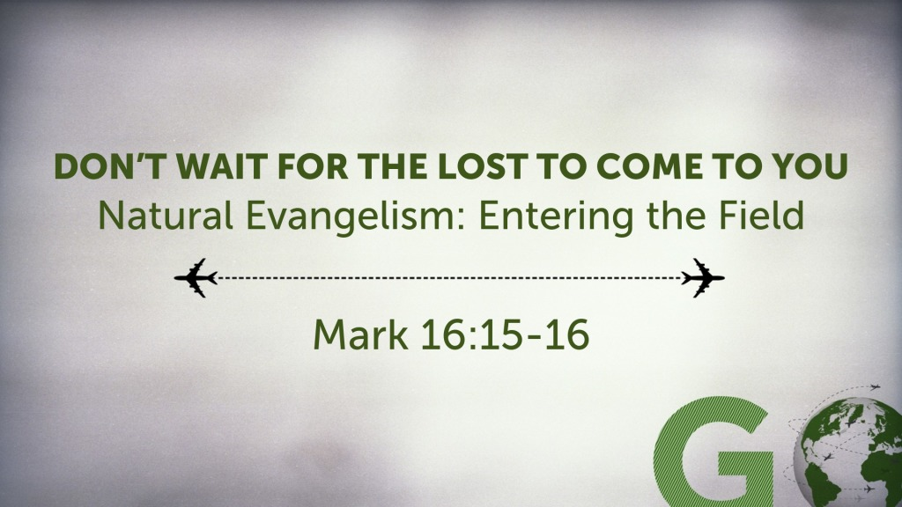
Mark 16:15–16 ESV
¹⁵ And he said to them, “Go into all the world and proclaim the gospel to the whole creation. ¹⁶ Whoever believes and is baptized will be saved, but whoever does not believe will be condemned.

The call to Go is on all God’s people
Psalm 96:2–3 ESV
² Sing to the Lord, bless his name;
tell of his salvation from day to day.
³ Declare his glory among the nations,
his marvelous works among all the peoples!
Matthew 28:19 ESV
¹⁹ Go therefore and make disciples of all nations, baptizing them in the name of the Father and of the Son and of the Holy Spirit,
John 20:21 ESV
²¹ Jesus said to them again, “Peace be with you. As the Father has sent me, even so I am sending you.”
Acts 1:8 ESV
⁸ But you will receive power when the Holy Spirit has come upon you, and you will be my witnesses in Jerusalem and in all Judea and Samaria, and to the end of the earth.”

Don’t let circumstances stop us
Acts 8:4 ESV
⁴ Now those who were scattered went about preaching the word.
Acts 18:1–2 ESV
¹ After this Paul left Athens and went to Corinth. ² And he found a Jew named Aquila, a native of Pontus, recently come from Italy with his wife Priscilla, because Claudius had commanded all the Jews to leave Rome. And he went to see them,

Be compelled by the message
Acts 4:18–20 ESV
¹⁸ So they called them and charged them not to speak or teach at all in the name of Jesus. ¹⁹ But Peter and John answered them, “Whether it is right in the sight of God to listen to you rather than to God, you must judge, ²⁰ for we cannot but speak of what we have seen and heard.”
1 Corinthians 9:16 ESV
¹⁶ For if I preach the gospel, that gives me no ground for boasting. For necessity is laid upon me. Woe to me if I do not preach the gospel!
2 Corinthians 5:14 ESV
¹⁴ For the love of Christ controls us, because we have concluded this: that one has died for all, therefore all have died;

God’s Salvation Invitation

Hear - Believe - Confess - Repent - Be Baptized - Be Faithful
Matthew 7:24 ESV
²⁴ “Everyone then who hears these words of mine and does them will be like a wise man who built his house on the rock.
John 1:12 ESV
¹² But to all who did receive him, who believed in his name, he gave the right to become children of God,
1 John 2:23 ESV
²³ No one who denies the Son has the Father. Whoever confesses the Son has the Father also.
Luke 13:3 ESV
³ No, I tell you; but unless you repent, you will all likewise perish.
Galatians 3:27 ESV
²⁷ For as many of you as were baptized into Christ have put on Christ.
James 1:3–4 ESV
³ for you know that the testing of your faith produces steadfastness. ⁴ And let steadfastness have its full effect, that you may be perfect and complete, lacking in nothing.

