Barry G. Johnson, Sr. / General
Discovering the Church / Providence; Decision; Guidance; Help; Prophecy; Persecution / Acts 21:7–14
People need guidance from God about how they should make up their minds on difficult issues. God gives them this through the Holy Spirit, the Scriptures, individuals, groups and other external means.
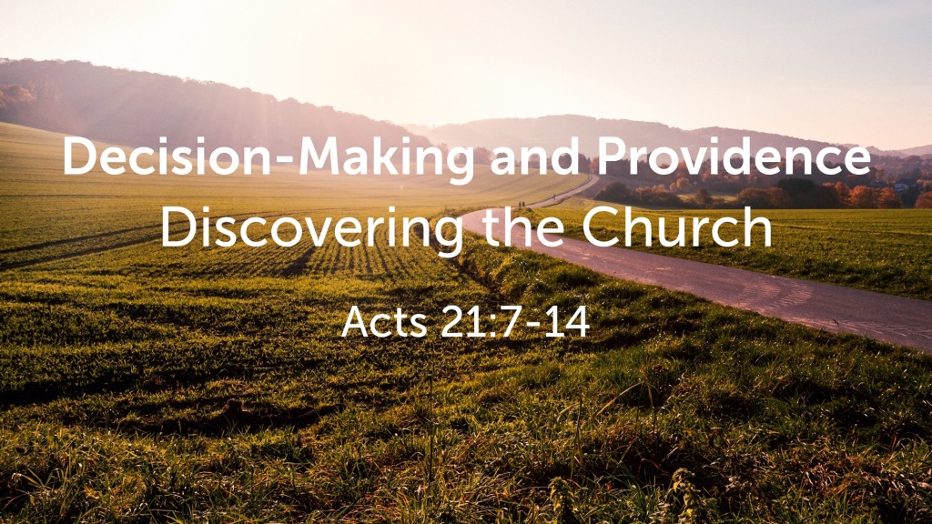
Acts 21:7–14 ESV
⁷ When we had finished the voyage from Tyre, we arrived at Ptolemais, and we greeted the brothers and stayed with them for one day. ⁸ On the next day we departed and came to Caesarea, and we entered the house of Philip the evangelist, who was one of the seven, and stayed with him. ⁹ He had four unmarried daughters, who prophesied. ¹⁰ While we were staying for many days, a prophet named Agabus came down from Judea. ¹¹ And coming to us, he took Paul’s belt and bound his own feet and hands and said, “Thus says the Holy Spirit, ‘This is how the Jews at Jerusalem will bind the man who owns this belt and deliver him into the hands of the Gentiles.’ ” ¹² When we heard this, we and the people there urged him not to go up to Jerusalem. ¹³ Then Paul answered, “What are you doing, weeping and breaking my heart? For I am ready not only to be imprisoned but even to die in Jerusalem for the name of the Lord Jesus.” ¹⁴ And since he would not be persuaded, we ceased and said, “Let the will of the Lord be done.”

Decisions should be grounded in a relationship with God
Proverbs 3:5–6 ESV
⁵ Trust in the Lord with all your heart, and do not lean on your own understanding. ⁶ In all your ways acknowledge him, and he will make straight your paths.
Matthew 6:31–33 ESV
³¹ Therefore do not be anxious, saying, ‘What shall we eat?’ or ‘What shall we drink?’ or ‘What shall we wear?’ ³² For the Gentiles seek after all these things, and your heavenly Father knows that you need them all. ³³ But seek first the kingdom of God and his righteousness, and all these things will be added to you.

God guides decision-making

Through Scripture
2 Timothy 3:16–17 ESV
¹⁶ All Scripture is breathed out by God and profitable for teaching, for reproof, for correction, and for training in righteousness, ¹⁷ that the man of God may be complete, equipped for every good work.

The temptation of Jesus Christ is a good example of how Scripture can inform decision-making:
Matthew 4:4 ESV
⁴ But he answered, “It is written, “ ‘Man shall not live by bread alone, but by every word that comes from the mouth of God.’ ”
Deuteronomy 8:3 ESV
³ And he humbled you and let you hunger and fed you with manna, which you did not know, nor did your fathers know, that he might make you know that man does not live by bread alone, but man lives by every word that comes from the mouth of the Lord.
Matthew 4:7 ESV
⁷ Jesus said to him, “Again it is written, ‘You shall not put the Lord your God to the test.’ ”
Deuteronomy 6:16 ESV
¹⁶ “You shall not put the Lord your God to the test, as you tested him at Massah.
Matthew 4:10 ESV
¹⁰ Then Jesus said to him, “Be gone, Satan! For it is written, “ ‘You shall worship the Lord your God and him only shall you serve.’ ”
Deuteronomy 6:13 ESV
¹³ It is the Lord your God you shall fear. Him you shall serve and by his name you shall swear.

Through divine intervention
Acts 18:9 ESV
⁹ And the Lord said to Paul one night in a vision, “Do not be afraid, but go on speaking and do not be silent,

Through prayer
James 1:5–6 ESV
⁵ If any of you lacks wisdom, let him ask God, who gives generously to all without reproach, and it will be given him. ⁶ But let him ask in faith, with no doubting, for the one who doubts is like a wave of the sea that is driven and tossed by the wind.

Through circumstances
Acts 6:1–4 ESV
¹ Now in these days when the disciples were increasing in number, a complaint by the Hellenists arose against the Hebrews because their widows were being neglected in the daily distribution. ² And the twelve summoned the full number of the disciples and said, “It is not right that we should give up preaching the word of God to serve tables. ³ Therefore, brothers, pick out from among you seven men of good repute, full of the Spirit and of wisdom, whom we will appoint to this duty. ⁴ But we will devote ourselves to prayer and to the ministry of the word.”

The work of the Holy Spirit in decision-making
John 14:16–17 ESV
¹⁶ And I will ask the Father, and he will give you another Helper, to be with you forever, ¹⁷ even the Spirit of truth, whom the world cannot receive, because it neither sees him nor knows him. You know him, for he dwells with you and will be in you.

Motivation in decision-making
Colossians 3:17 ESV
¹⁷ And whatever you do, in word or deed, do everything in the name of the Lord Jesus, giving thanks to God the Father through him.

Humility is essential for divine guidance
Psalm 25:9 ESV
⁹ He leads the humble in what is right, and teaches the humble his way.

The need to test guidance
1 Thessalonians 5:19–22 ESV
¹⁹ Do not quench the Spirit. ²⁰ Do not despise prophecies, ²¹ but test everything; hold fast what is good. ²² Abstain from every form of evil.
God’s Plan of Salvation
Hear - Romans 10:17 (NIV)
¹⁷ Consequently, faith comes from hearing the message, and the message is heard through the word about Christ.
Believe - John 8:24 (NIV)
²⁴ I told you that you would die in your sins; if you do not believe that I am he, you will indeed die in your sins.”
Repent - Acts 17:30 (NIV)
³⁰ In the past God overlooked such ignorance, but now he commands all people everywhere to repent.
Confess - Matthew 10:32–33 (NIV)
³² “Whoever acknowledges me before others, I will also acknowledge before my Father in heaven. ³³ But whoever disowns me before others, I will disown before my Father in heaven.
Be Baptized - Acts 2:38 (NIV)
³⁸ Peter replied, “Repent and be baptized, every one of you, in the name of Jesus Christ for the forgiveness of your sins. And you will receive the gift of the Holy Spirit.
Remain Faithful - Revelation 2:10 (NIV)
¹⁰ Do not be afraid of what you are about to suffer. I tell you, the devil will put some of you in prison to test you, and you will suffer persecution for ten days. Be faithful, even to the point of death, and I will give you life as your victor’s crown.

