Thesis:

Men hearts are pricked as God reveals His Word.

I. God commands that his word be heeded

Isaiah 1:10 ESV
Hear the word of the LORD,
you rulers of Sodom!
Give ear to the teaching of our God,
you people of Gomorrah!
Mark 4:9 ESV
And he said, “He who has ears to hear, let him hear.”
Revelation 2:7 ESV
He who has an ear, let him hear what the Spirit says to the churches. To the one who conquers I will grant to eat of the tree of life, which is in the paradise of God.’

II. The Natural Man does not receive the things of God
A. They fail to recognize God’s revelation in Jesus Christ
Matthew 11:25–27 ESV
At that time Jesus declared, “I thank you, Father, Lord of heaven and earth, that you have hidden these things from the wise and understanding and revealed them to little children; yes, Father, for such was your gracious will. All things have been handed over to me by my Father, and no one knows the Son except the Father, and no one knows the Father except the Son and anyone to whom the Son chooses to reveal him.
See also Jn 5:37–40; Jn 6:44–45; Jn 10:24–26; Jn 12:37–41; Jn 14:9; Ro 9:31–10:4; 1 Co 1:18–25; 1 Co 2:8; 2 Co 4:4
B. They fail to understand God’s revelation in general
1 Corinthians 2:14 ESV
The natural person does not accept the things of the Spirit of God, for they are folly to him, and he is not able to understand them because they are spiritually discerned.
See also Mk 4:11–12; Is 6:9–10; Jn 8:43–47; 2 Co 3:14–16; 2 Th 2:11–13

III. God cuts by Spirit not human wisdom
A. He reveals and teaches truth
1 Corinthians 2:12–13 ESV
Now we have received not the spirit of the world, but the Spirit who is from God, that we might understand the things freely given us by God. And we impart this in words not taught by human wisdom but taught by the Spirit, interpreting spiritual truths to those who are spiritual.
See also Je 31:31–34; Mt 16:17; Jn 3:3–10; Jn 14:16–17; Jn 14:25–26; Jn 16:12–15; Php 3:15
B. He reveals through prayer for understanding
Psalm 119:27 ESV
Make me understand the way of your precepts,
and I will meditate on your wondrous works.
Ephesians 1:17–18 ESV
that the God of our Lord Jesus Christ, the Father of glory, may give you the Spirit of wisdom and of revelation in the knowledge of him, having the eyes of your hearts enlightened, that you may know what is the hope to which he has called you, what are the riches of his glorious inheritance in the saints,

IV. Understanding God’s revelation carries special responsibility

Luke 12:47–48 ESV
And that servant who knew his master’s will but did not get ready or act according to his will, will receive a severe beating. But the one who did not know, and did what deserved a beating, will receive a light beating. Everyone to whom much was given, of him much will be required, and from him to whom they entrusted much, they will demand the more.
See also Mt 13:11–12; Mt 25:14–30

V. God’s revelation of himself will only be fully understood at the second coming of Jesus Christ

1 Corinthians 13:12 ESV
For now we see in a mirror dimly, but then face to face. Now I know in part; then I shall know fully, even as I have been fully known.
See also 1 Pe 1:13; 1 Jn 3:2

VI. The consequences of responding to revelation

A. Repentance

Acts 2:38 ESV
And Peter said to them, “Repent and be baptized every one of you in the name of Jesus Christ for the forgiveness of your sins, and you will receive the gift of the Holy Spirit.
See also Mt 4:17; Ac 3:19; Ac 26:20; 2 Co 7:10
B. Faith
Romans 10:17 ESV
So faith comes from hearing, and hearing through the word of Christ.
See also Ro 10:8–10; Ro 10:14–15; 1 Co 2:4–5
C. Obedience
Romans 1:5 ESV
through whom we have received grace and apostleship to bring about the obedience of faith for the sake of his name among all the nations,
See also Jdg 2:17; Phm 21; 1 Pe 1:2

Hear - Romans 10:17 (NIV)
¹⁷ Consequently, faith comes from hearing the message, and the message is heard through the word about Christ.
Believe - Hebrews 11:6 (NIV)
⁶ And without faith it is impossible to please God, because anyone who comes to him must believe that he exists and that he rewards those who earnestly seek him.
Repent - Acts 17:30 (NIV)
³⁰ In the past God overlooked such ignorance, but now he commands all people everywhere to repent.
Confess - 1 Timothy 6:12 (NIV)
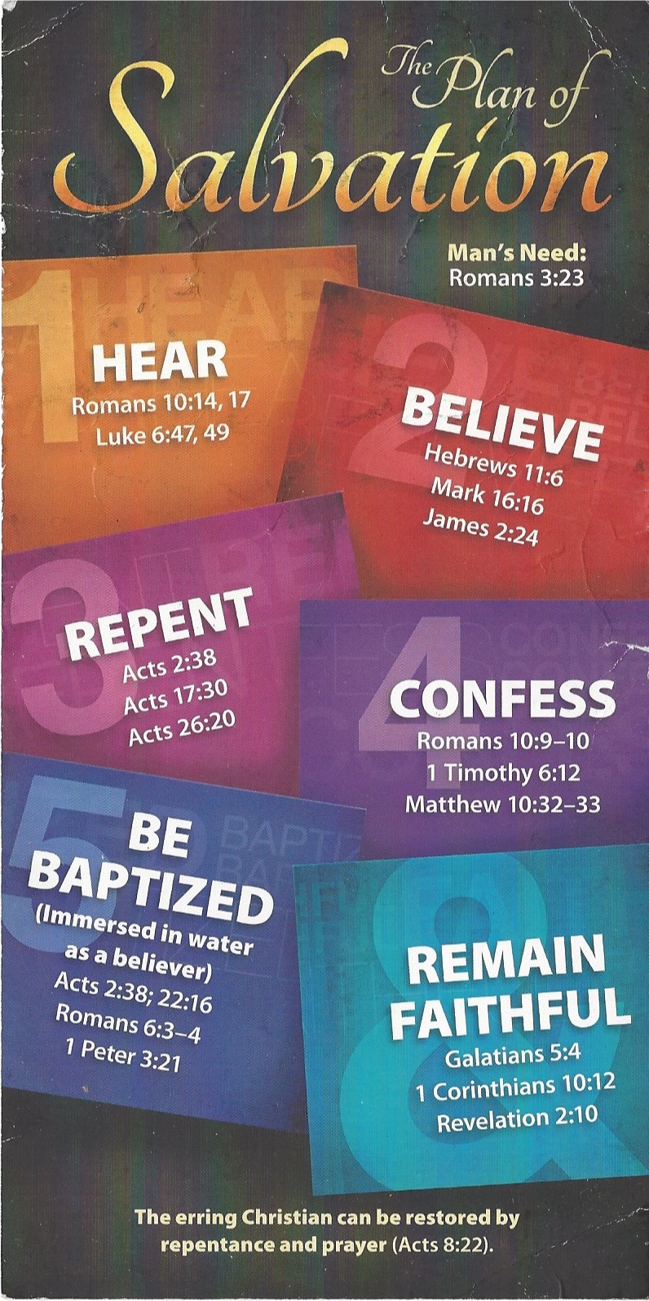
¹² Fight the good fight of the faith. Take hold of the eternal life to which you were called when you made your good confession in the presence of many witnesses.

Be Baptized - Acts 22:16 (NIV)
¹⁶ And now what are you waiting for? Get up, be baptized and wash your sins away, calling on his name.’
Remain Steadfast - Revelation 2:10 (NIV)
¹⁰ Do not be afraid of what you are about to suffer. I tell you, the devil will put some of you in prison to test you, and you will suffer persecution for ten days. Be faithful, even to the point of death, and I will give you life as your victor’s crown.

