Barry G. Johnson, Sr. / General
Walking Christian / Relationships; Courtship, Dating and Romantic Relationships; Family Life and Relations / Galatians 6:1–5
The primary problem with codependency can be called “idolatry”—giving a greater priority to anything or anyone other than God Himself.
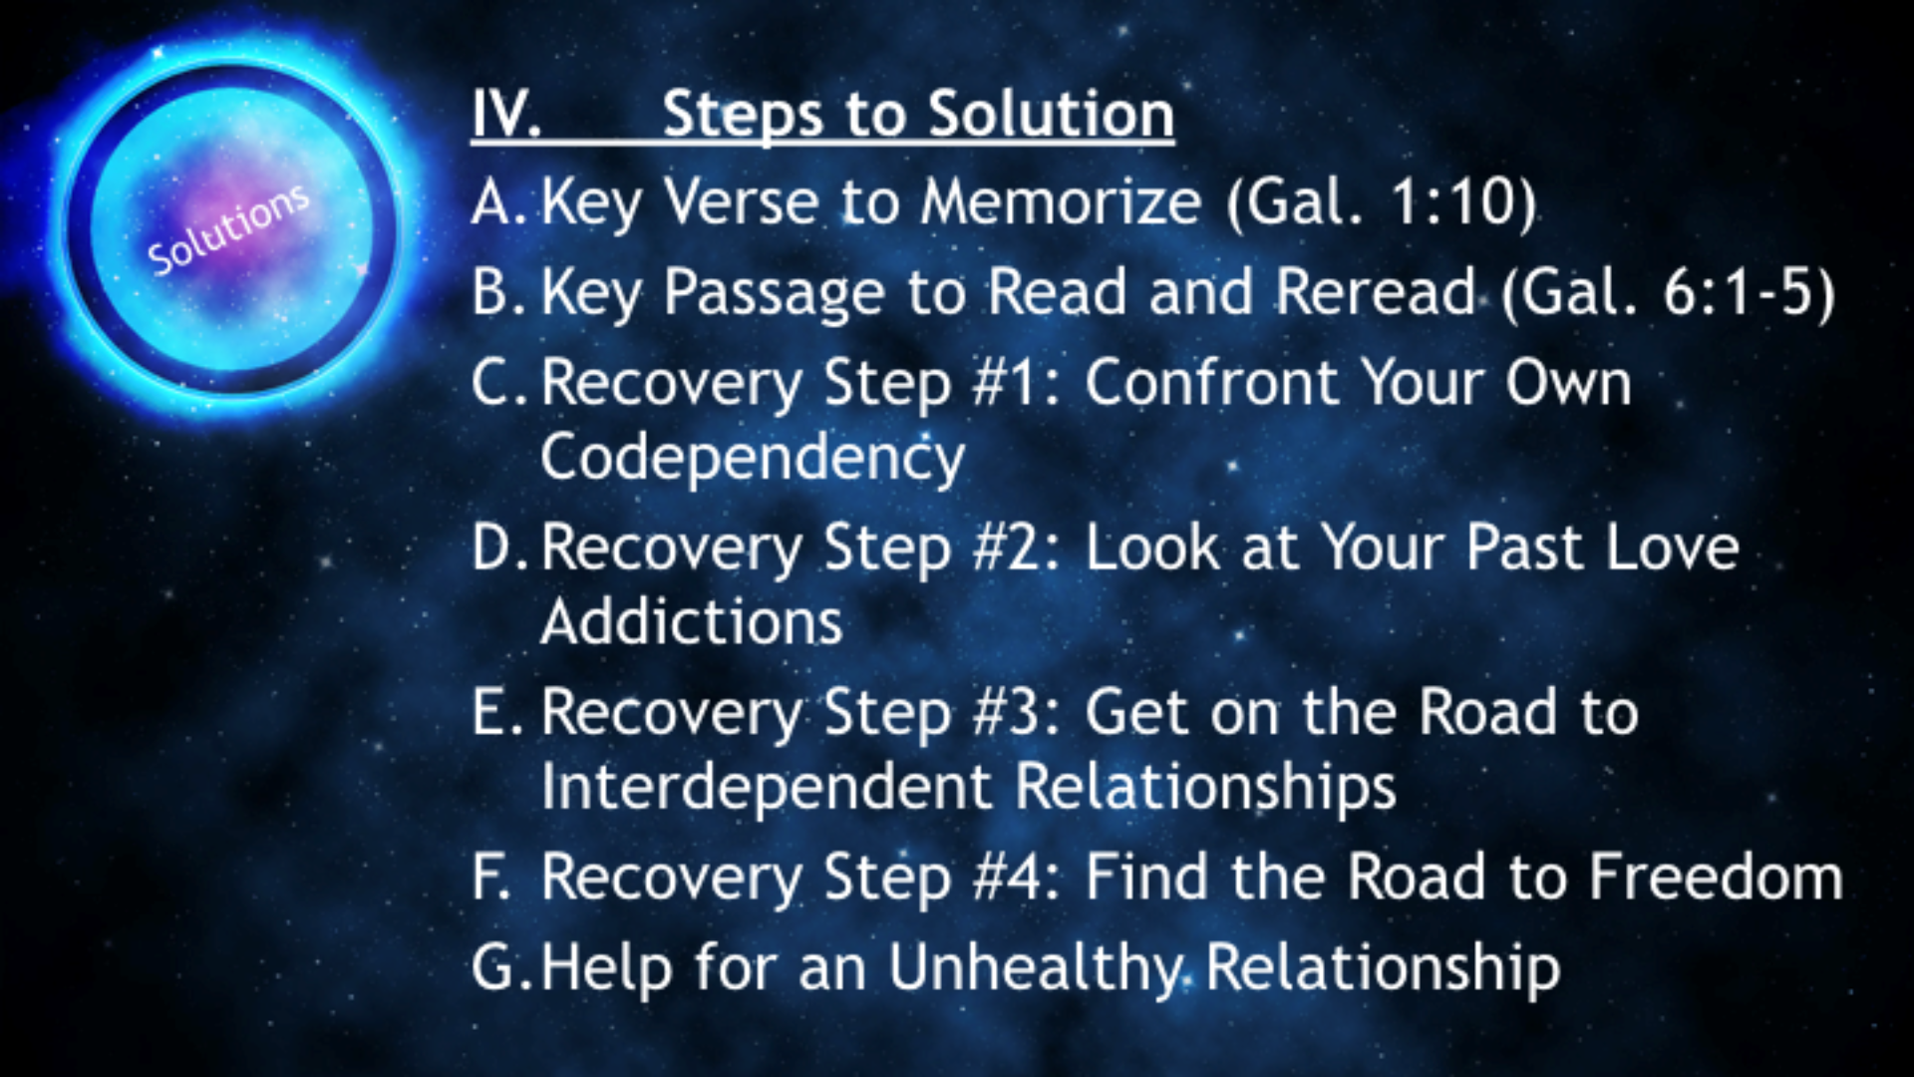

IV. Steps to Solution
• Your excessive care causes you to compromise your .
• Your excessive loyalty leaves you without healthy .
• Your excessive “love” allows you to say yes when you should say .
(Deuteronomy 6:5)

A. Key Verse to Memorize
(Galatians 1:10)

B. Key Passage to Read and Reread
(Galatians 6:1–5)
Does Scripture Contradict Itself?
Verse 2 says, “Carry each other’s burdens,” and verse 5 says, “Each one should carry his own load.” Since these two clear-cut directives seem contradictory to each other, which one is true? When you carefully analyze what is being said, there is no contradiction.
Conclusion: Those who are codependent try to get their needs met by carrying loads that others should be carrying. To move out of a codependent relationship, both individuals need to quit trying to be the other person’s “all-in-all” and instead encourage each other to take responsibility for their own lives and to live dependently on the strength of God.

C. Recovery Step #1: Confront Your Own Codependency
(Deuteronomy 30:19–20)

• Confront the That You Are Codependent.
— Admit the truth to yourself. Before you can be free from the grasp of codependency, you must be honest with yourself about your emotional addiction to another person.
(James 5:16)

• Confront the of Your Codependency.
— Accept responsibility for how your past experiences and reactions have hurt your adult relationships (such as your becoming manipulative, controlling, possessive, or angry).
(Proverbs 28:13)

• Confront Your Painful .
— Understand that you will have pain no matter what you choose. If you leave the codependent relationship, you will hurt, but if you stay, you will hurt. However, the only hope for future healing is leaving the codependent lifestyle.
(Proverbs 27:9)

• Confront Your “ Addictions.”
— Recognize that, in an effort to numb the emotional pain of the relationship, codependency often leads to other addictions, such as a chemical dependency, sexual addiction, compulsive eating, or excessive spending.
(Proverbs 18:15)

• Confront Your Codependent Relationship.
— Acknowledge the natural pain of emotional withdrawal (common to the healing of addictions) and focus on God’s purpose (conforming you to the character of Christ).
(Romans 8:29)

• Confront Your Codependent .
— Stop focusing on what the other person is doing and start focusing on what you need to do in order to become emotionally healthy.
(Proverbs 14:8)

• Confront Your Codependent .
— Do not allow yourself to become trapped in heated arguments or to become emotionally hooked by the bad behavior of the other person. Instead, say to yourself several times, I will not argue—and then disengage from the conflict. Decide ahead of time that, when agitation begins, you will distance yourself.
(2 Timothy 2:23)

• Confront Your Codependent .
— Remind yourself that “problem people” have the right to choose wrong. Don’t react to their problem behavior—they are independent of you.
(1 Peter 3:9, 15–16)

• Confront What You Need to Leave in Order to .
— Leave your childhood and your dependent thinking. (I can’t live without you.) Then enter into healthy adulthood. (I want you in my life, but if something were to happen, I could still live without you.) That is reality.
(Proverbs 27:6)

• Confront Your Need to Build Non-codependent Relationships.
— Establish several interdependent relationships—not just one exclusive relationship. You need mature relationships in which your codependency issues can be resolved and your needs can be met in healthy ways.
(Hebrews 6:1)

D. Recovery Step #2: Look at Your Past Love Addictions
(Proverbs 19:8)
#1 Write out …
— How did you meet and how were you attracted to this person?
Conclude by answering …
— How do you think God felt about your choices?
(Ezekiel 6:9)
#2 Write out …
— How did the relationship progress through various stages (Fascination, Fantasy, Fog, Fear, Forsaking, Fixation, Frenzy)?
Conclude by answering …
— How did you fail to involve God in your life during each stage?
(Isaiah 50:2–3)
#3 Write out …
— How did you become preoccupied with the relationship?
Conclude by answering …
— How did you start neglecting God and when did you stop relying on Him?
(Jeremiah 2:21)
#4 Write out …
— How has this relationship replicated your painful childhood experiences?
Conclude by answering …
— How is God replacing (or wanting to replace) your self-destructive, love-addicted patterns with constructive, healthy, holy patterns?
(Psalm 27:10)
#5 Write out …
— How have you experienced fear, envy, jealousy, abandonment, and anger in the relationship?
Conclude by answering …
— How can you appropriate “the mind of Christ” in order to overcome destructive feelings and to live out of your resources in Christ?
(1 Corinthians 2:16)
#6 Write out …
— How do you feel about the person and the relationship now?
Conclude by answering …
— How do you think God has been involved in changing your perspective?
(Philippians 1:6)

E. Recovery Step #3: Get on the Road to Interdependent Relationships
(Isaiah 41:10)
• Make it your goal to develop an intimate relationship with God and to form interdependent relationships with significant people in your life.
(Hebrews 10:25)
• Make a plan to move toward maturity in your relationships.
(James 1:4)
• Make your relationship with your parents complete.
(Romans 12:19)
• Make a vow to be a person of integrity in thought, word, and deed.
(1 Peter 1:13–15)
• Make a new job description.
(Job 27:6)
• Make a new commitment to yourself.
(2 Corinthians 5:17)
• Make maturity, not emotional relationships, your highest goal.
(1 Samuel 23:16)

F. Recovery Step #4: Find the Road to Freedom
Recognize that you are overly dependent on a person and instead place your dependency on God.
Admit that your codependency is a sin.
(Deuteronomy 6:5)
Examine your patterns of codependent thinking.
Don’t believe that pleasing people is always Christlike.
(Psalm 51:6)
Let go of your “super responsible” mentality.
Confess that you are trying to be like God in the life of another person.
(Exodus 18:17–18)
Extend forgiveness to those who have caused you pain.
Reflect on any type of abuse you have experienced in the past—verbal, emotional, physical, or sexual.
(Colossians 3:13)
Appropriate your identity in Christ.
Learn to live out of your resources in Christ Jesus.
• Know the truth: “I can be emotionally set free because Christ lives in me.”
(John 8:36)
• Believe the truth: “I can change my dependency on people through the power of Christ in me.”
(Philippians 4:13)
• Appropriate the truth: “I will nurture only healthy, godly relationships because I have been given Christ’s divine nature.”
(2 Peter 1:3–4)
Set healthy boundaries.
• Establish what you need to ask forgiveness for.
• Establish what your limits of responsibility will be.
• Establish your limits of involvement.
(Proverbs 27:12)
Exchange your emotional focus for spiritual focus.
Make God and your spiritual growth your first priority.
(Psalm 119:35–37)
The cure for codependency is rooted in developing an ever-deepening relationship with the Lord. Your increased intimacy with Him will naturally conform you to His character.
(John 16:33)

G. Help for an Unhealthy Relationship
Releasing You
Releasing is not to stop loving you,
but is to love enough to stop leaning on you.
Releasing is not to stop caring for you,
but is to care enough to stop controlling you.
Releasing is not to turn away from you,
but is to turn to Christ, trusting His control over you.
Releasing is not to harm you,
but is to realize “my help” has been harmful.
Releasing is not to hurt you,
but is to be willing to be hurt for healing.
Releasing is not to judge you,
but is to let the divine Judge judge me.
Releasing is not to restrict you,
but is to restrict my demands of you.
Releasing is not to refuse you,
but is to refuse to keep reality from you.
Releasing is not to cut myself off from you,
but is to prune the unfruitful away from you.
Releasing is not to prove my power over you,
but is to admit I am powerless to change you.
Releasing is not to stop believing in you,
but is to believe the Lord alone will build character in you.
Releasing you is not to condemn the past,
but is to cherish the present and commit our future to God.
—June Hunt
My Commitment because of Christ in Me
Because Jesus lives in me
… I will conquer codependency.
Because Christ was not a “people-pleaser”
… I will not be a “people-pleaser.”
Because Christ refused to compromise
… I will not yield to compromise.
Because Christ kept healthy boundaries
… I will keep healthy boundaries.
Because Christ stood up to pressure
… I will not cave in to pressure.
Because Jesus lives in me
… I will conquer codependency!
—June Hunt
(Galatians 2:20)
Hunt, J. (2008). Biblical Counseling Keys on Codependency: Balancing an Unbalanced Relationship (pp. 20–32). Dallas, TX: Hope For The Heart.

