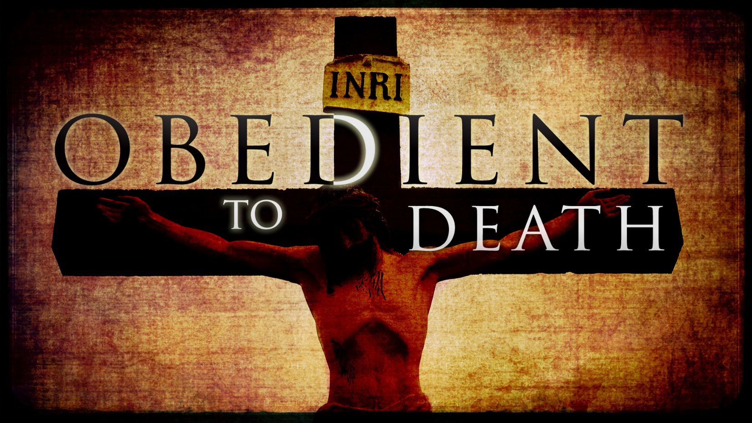
Luke 23:34–43 (NIV)
³⁴ Jesus said, “Father, forgive them, for they do not know what they are doing.” And they divided up his clothes by casting lots.
³⁵ The people stood watching, and the rulers even sneered at him. They said, “He saved others; let him save himself if he is God’s Messiah, the Chosen One.”
³⁶ The soldiers also came up and mocked him. They offered him wine vinegar ³⁷ and said, “If you are the king of the Jews, save yourself.”
³⁸ There was a written notice above him, which read: this is the king of the jews.
³⁹ One of the criminals who hung there hurled insults at him: “Aren’t you the Messiah? Save yourself and us!”
⁴⁰ But the other criminal rebuked him. “Don’t you fear God,” he said, “since you are under the same sentence? ⁴¹ We are punished justly, for we are getting what our deeds deserve. But this man has done nothing wrong.”
⁴² Then he said, “Jesus, remember me when you come into your kingdom.”
⁴³ Jesus answered him, “Truly I tell you, today you will be with me in paradise.”

Jesus Christ foretold his death on the cross
Matthew 20:18–19 ESV
“See, we are going up to Jerusalem. And the Son of Man will be delivered over to the chief priests and scribes, and they will condemn him to death and deliver him over to the Gentiles to be mocked and flogged and crucified, and he will be raised on the third day.”
See also Mt 26:2; Jn 3:14–15; Jn 8:28; Jn 12:32–33; Jn 18:32

The facts of Jesus Christ’s death on the cross

Carrying Jesus Christ’s cross
Jn 19:17 Though Jesus Christ began to carry his cross, the Romans soon forced Simon of Cyrene to continue with it.
See also Mt 27:32

Jesus Christ refused the comfort of wine, which would have lessened the pains of his suffering
Matthew 27:34 ESV
they offered him wine to drink, mixed with gall, but when he tasted it, he would not drink it.

Jesus Christ was nailed to the cross
Luke 23:33 ESV
And when they came to the place that is called The Skull, there they crucified him, and the criminals, one on his right and one on his left.

Jesus Christ’s words from the cross
Luke 23:34 ESV
And Jesus said, “Father, forgive them, for they know not what they do.” And they cast lots to divide his garments.
Luke 23:43 ESV
And he said to him, “Truly, I say to you, today you will be with me in paradise.”
John 19:26–27 ESV
When Jesus saw his mother and the disciple whom he loved standing nearby, he said to his mother, “Woman, behold, your son!” Then he said to the disciple, “Behold, your mother!” And from that hour the disciple took her to his own home.
Matthew 27:46 ESV
And about the ninth hour Jesus cried out with a loud voice, saying, “Eli, Eli, lema sabachthani?” that is, “My God, my God, why have you forsaken me?”
Psalm 22:1 ESV
My God, my God, why have you forsaken me?
Why are you so far from saving me, from the words of my groaning?
Luke 23:46 ESV
Then Jesus, calling out with a loud voice, said, “Father, into your hands I commit my spirit!” And having said this he breathed his last.
John 19:28–30 ESV
After this, Jesus, knowing that all was now finished, said (to fulfill the Scripture), “I thirst.” A jar full of sour wine stood there, so they put a sponge full of the sour wine on a hyssop branch and held it to his mouth. When Jesus had received the sour wine, he said, “It is finished,” and he bowed his head and gave up his spirit.

Signs accompanying Jesus Christ’s death on the cross

Darkness over the whole land for three hours:
Mt 27:45; Mk 15:33
Matthew 27:45 ESV
Now from the sixth hour there was darkness over all the land until the ninth hour.

The temple curtain torn from top to bottom:
Mt 27:51; Mt 27:52–53 the dead come back to life

People at the scene of the cross

The Roman centurion and his men:
Matthew 27:35–36 ESV
And when they had crucified him, they divided his garments among them by casting lots. Then they sat down and kept watch over him there.

The two criminals crucified with Jesus Christ:
Luke 23:39–43 ESV
One of the criminals who were hanged railed at him, saying, “Are you not the Christ? Save yourself and us!” But the other rebuked him, saying, “Do you not fear God, since you are under the same sentence of condemnation? And we indeed justly, for we are receiving the due reward of our deeds; but this man has done nothing wrong.” And he said, “Jesus, remember me when you come into your kingdom.” And he said to him, “Truly, I say to you, today you will be with me in paradise.”
Matthew 27:39–43 ESV
And those who passed by derided him, wagging their heads and saying, “You who would destroy the temple and rebuild it in three days, save yourself! If you are the Son of God, come down from the cross.” So also the chief priests, with the scribes and elders, mocked him, saying, “He saved others; he cannot save himself. He is the King of Israel; let him come down now from the cross, and we will believe in him. He trusts in God; let God deliver him now, if he desires him. For he said, ‘I am the Son of God.’ ”

Jesus Christ’s mother and other women:
Mt 27:55–56; Lk 23:49
John 19:26–27 ESV
When Jesus saw his mother and the disciple whom he loved standing nearby, he said to his mother, “Woman, behold, your son!” Then he said to the disciple, “Behold, your mother!” And from that hour the disciple took her to his own home.

Responsibility for the cross

The cross as God’s plan
Acts 2:23 ESV
this Jesus, delivered up according to the definite plan and foreknowledge of God, you crucified and killed by the hands of lawless men.
See also Is 53:10; Mt 26:39; Mt 26:42; Jn 14:30–31; Ac 4:25–28; Ps 2:1–2; Re 13:8

The crowd’s call for Jesus Christ’s crucifixion
Mt 27:21–22; Mt 27:25; Ac 2:36; 1 Th 2:14–15
Acts 2:36 ESV
Let all the house of Israel therefore know for certain that God has made him both Lord and Christ, this Jesus whom you crucified.”
1 Thessalonians 2:14–15 ESV
For you, brothers, became imitators of the churches of God in Christ Jesus that are in Judea. For you suffered the same things from your own countrymen as they did from the Jews, who killed both the Lord Jesus and the prophets, and drove us out, and displease God and oppose all mankind

Jewish and Roman leaders’ responsibility
Mt 27:1; Mt 27:20; Mt 27:26; Lk 23:24–25; Jn 19:6–7; Ac 4:10; 1 Co 2:8
Acts 4:10 ESV
let it be known to all of you and to all the people of Israel that by the name of Jesus Christ of Nazareth, whom you crucified, whom God raised from the dead—by him this man is standing before you well.
1 Corinthians 2:8 ESV
None of the rulers of this age understood this, for if they had, they would not have crucified the Lord of glory.

The triumph of the cross
Colossians 2:15 ESV
He disarmed the rulers and authorities and put them to open shame, by triumphing over them in him.

The cross brings glory to Jesus Christ
Jn 17:1 Jesus Christ refers to his approaching death, the climax of his earthly life.
See also Jn 12:28; Jn 13:31–32; Jn 17:5; Php 2:8–11; Heb 12:2; Re 5:8–14
Philippians 2:8–11 ESV
And being found in human form, he humbled himself by becoming obedient to the point of death, even death on a cross. Therefore God has highly exalted him and bestowed on him the name that is above every name, so that at the name of Jesus every knee should bow, in heaven and on earth and under the earth, and every tongue confess that Jesus Christ is Lord, to the glory of God the Father.
Hebrews 12:2 ESV
looking to Jesus, the founder and perfecter of our faith, who for the joy that was set before him endured the cross, despising the shame, and is seated at the right hand of the throne of God.

The cross brings reconciliation
Ephesians 2:13–17 ESV
But now in Christ Jesus you who once were far off have been brought near by the blood of Christ. For he himself is our peace, who has made us both one and has broken down in his flesh the dividing wall of hostility by abolishing the law of commandments expressed in ordinances, that he might create in himself one new man in place of the two, so making peace, and might reconcile us both to God in one body through the cross, thereby killing the hostility. And he came and preached peace to you who were far off and peace to those who were near.
See also Ro 5:9–10; 2 Co 5:18–19; Col 1:20

Identification with the crucified Christ releases believers from their old way of life
Galatians 2:20 ESV
I have been crucified with Christ. It is no longer I who live, but Christ who lives in me. And the life I now live in the flesh I live by faith in the Son of God, who loved me and gave himself for me.
See also Ro 6:5–13; Ga 5:24–25; Ga 6:14; Col 2:13–14

Jesus Christ’s cross is central to the Christian message
1 Corinthians 2:2 ESV
For I decided to know nothing among you except Jesus Christ and him crucified.
See also Ac 2:23–24; Ac 3:13; Ac 5:30; Ac 13:27–29; Ga 3:1

Jesus Christ’s cross is the symbol of Christian discipleship
Matthew 16:24 ESV
Then Jesus told his disciples, “If anyone would come after me, let him deny himself and take up his cross and follow me.
See also Mt 10:38; Jn 21:18–19
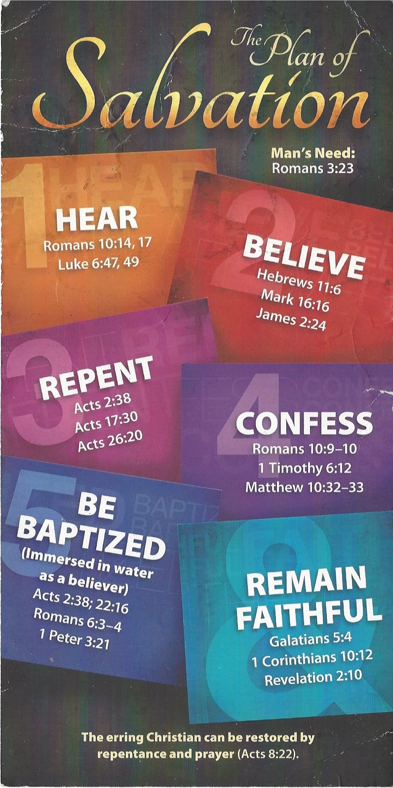
Hear - Romans 10:17 (NIV)
¹⁷ Consequently, faith comes from hearing the message, and the message is heard through the word about Christ.
Believe - Hebrews 11:6 (NIV)
⁶ And without faith it is impossible to please God, because anyone who comes to him must believe that he exists and that he rewards those who earnestly seek him.
Repent - Acts 17:30 (NIV)
³⁰ In the past God overlooked such ignorance, but now he commands all people everywhere to repent.
Confess - 1 Timothy 6:12 (NIV)
¹² Fight the good fight of the faith. Take hold of the eternal life to which you were called when you made your good confession in the presence of many witnesses.

Be Baptized - Acts 22:16 (NIV)
¹⁶ And now what are you waiting for? Get up, be baptized and wash your sins away, calling on his name.’
Remain Steadfast - Revelation 2:10 (NIV)
¹⁰ Do not be afraid of what you are about to suffer. I tell you, the devil will put some of you in prison to test you, and you will suffer persecution for ten days. Be faithful, even to the point of death, and I will give you life as your victor’s crown.

