Barry G. Johnson, Sr. / General www.barrygjhnsonsr.com
Discovering the Church / Prophecy: Fulfillment; Prophecy: Jesus; Messiah; Jesus; Jesus: Birth; Jesus: Death; Jesus: Divinity / Acts 13:13–25

The OT points ahead to the person and ministry of Jesus Christ. Christ’s fulfilment of OT prophecy is often noted by NT writers as a demonstration of God’s faithfulness to his promises of salvation and as confirmation of the divine authority of Jesus Christ.
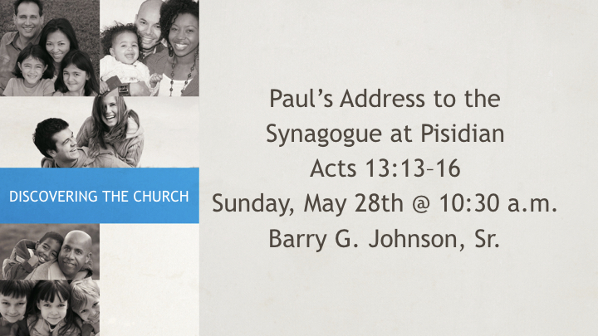

I. Jesus Christ fulfils OT prophecy

A. He fulfils the OT as a whole
Luke 24:27 ESV
²⁷ And beginning with Moses and all the Prophets, he interpreted to them in all the Scriptures the things concerning himself.
See also Mt 5:17; Lk 24:44; 2 Co 1:20

B. He fulfils God’s promises to Abraham
Galatians 3:14 ESV
¹⁴ so that in Christ Jesus the blessing of Abraham might come to the Gentiles, so that we might receive the promised Spirit through faith.
See also Lk 1:54–55; Lk 1:72–74; Ga 3:16

C. He fulfils God’s promises through the prophets
Acts 10:43 ESV
⁴³ To him all the prophets bear witness that everyone who believes in him receives forgiveness of sins through his name.”
See also Mt 26:56; Ac 3:18; Ac 3:24; Ac 13:27; Ro 1:2; 1 Pe 1:10

II. Prophecies about Jesus Christ’s birth
Matthew 1:23 ESV
²³ “Behold, the virgin shall conceive and bear a son, and they shall call his name Immanuel” (which means, God with us).
See also Is 7:14; Mt 1:21; Lk 1:31–32; Is 9:6; Mt 2:6–7; Mic 5:2; Mt 2:15; Ho 11:1

III. Prophecies about Jesus Christ’s ministry

A. He brings good news
Luke 4:17–19 ESV
¹⁷ And the scroll of the prophet Isaiah was given to him. He unrolled the scroll and found the place where it was written,
¹⁸ “The Spirit of the Lord is upon me, because he has anointed me to proclaim good news to the poor. He has sent me to proclaim liberty to the captives and recovering of sight to the blind, to set at liberty those who are oppressed,
¹⁹ to proclaim the year of the Lord’s favor.”
See also Is 61:1–2; Mt 4:13–16; Is 9:1–2

B. He divides people and is rejected
Luke 2:34–35 ESV
³⁴ And Simeon blessed them and said to Mary his mother, “Behold, this child is appointed for the fall and rising of many in Israel, and for a sign that is opposed
³⁵ (and a sword will pierce through your own soul also), so that thoughts from many hearts may be revealed.”
See also Mt 3:11–12; Mt 21:42; Ps 118:22–23; Jn 13:18; Ps 41:9

C. He teaches in parables
Matthew 13:35 ESV
³⁵ This was to fulfill what was spoken by the prophet: “I will open my mouth in parables; I will utter what has been hidden since the foundation of the world.”
See also Ps 78:2; Mt 13:13–15; Is 6:9–10

IV. Prophecies about Jesus Christ’s death

A. The Lord’s Supper
Matthew 26:28 ESV
²⁸ for this is my blood of the covenant, which is poured out for many for the forgiveness of sins.
See also Is 53:12; Je 31:34

B. The betrayal
Matthew 27:9–10 ESV
⁹ Then was fulfilled what had been spoken by the prophet Jeremiah, saying, “And they took the thirty pieces of silver, the price of him on whom a price had been set by some of the sons of Israel,
¹⁰ and they gave them for the potter’s field, as the Lord directed me.”
See also Je 19:1–13; Zec 11:12–13; Jn 18:9; Jn 6:39

C. The cross
Matthew 27:46 ESV
⁴⁶ And about the ninth hour Jesus cried out with a loud voice, saying, “Eli, Eli, lema sabachthani?” that is, “My God, my God, why have you forsaken me?”
See also Ps 22:1; Mt 27:35; Ps 22:18; Lk 23:46; Ps 31:5

V. Prophecies about Jesus Christ’s resurrection and ascension
Matthew 12:39–40 ESV
³⁹ But he answered them, “An evil and adulterous generation seeks for a sign, but no sign will be given to it except the sign of the prophet Jonah.
⁴⁰ For just as Jonah was three days and three nights in the belly of the great fish, so will the Son of Man be three days and three nights in the heart of the earth.
See also Jon 1:17; Ac 2:25–28; Ps 16:8–11; Ac 2:31; Ac 13:35; Ac 2:34; Ps 110:1; Eph 4:8; Ps 68:18

VI. Prophecies about Jesus Christ’s titles

A. Jesus Christ as Son of God
Acts 13:32–33 ESV
³² And we bring you the good news that what God promised to the fathers,
³³ this he has fulfilled to us their children by raising Jesus, as also it is written in the second Psalm, “ ‘You are my Son, today I have begotten you.’
See also Ps 2:7; Heb 1:5; Heb 5:5; Mt 22:44; Ps 110:1; Heb 1:8–9; Ps 45:6–7

B. Jesus Christ as Son of Man
Matthew 26:64 ESV
⁶⁴ Jesus said to him, “You have said so. But I tell you, from now on you will see the Son of Man seated at the right hand of Power and coming on the clouds of heaven.”
See also Da 7:13–14; Mk 8:31

C. Jesus Christ as Son of David
Revelation 22:16 ESV
¹⁶ “I, Jesus, have sent my angel to testify to you about these things for the churches. I am the root and the descendant of David, the bright morning star.”
See also 2 Sa 7:12–16; Lk 1:32–33; Is 9:7; Ac 13:34; Is 55:3; Ro 15:12; Is 11:1

D. Jesus Christ as the coming Messianic king
Matthew 21:4–5 ESV
⁴ This took place to fulfill what was spoken by the prophet, saying,
⁵ “Say to the daughter of Zion, ‘Behold, your king is coming to you, humble, and mounted on a donkey, on a colt, the foal of a beast of burden.’ ”
See also Mt 26:31; Zec 13:7; Zec 9:9

E. Jesus Christ as the suffering servant
Acts 8:32–35 ESV
³² Now the passage of the Scripture that he was reading was this: “Like a sheep he was led to the slaughter and like a lamb before its shearer is silent, so he opens not his mouth.
³³ In his humiliation justice was denied him. Who can describe his generation? For his life is taken away from the earth.”
³⁴ And the eunuch said to Philip, “About whom, I ask you, does the prophet say this, about himself or about someone else?”
³⁵ Then Philip opened his mouth, and beginning with this Scripture he told him the good news about Jesus.
See also Is 53:7–8; Mt 12:17–21; Is 42:1–4

F. Jesus Christ as the prophet who is to come
Acts 3:22 ESV
²² Moses said, ‘The Lord God will raise up for you a prophet like me from your brothers. You shall listen to him in whatever he tells you.
See also Dt 18:18; Lk 4:18–19; Is 61:1–2; Jn 6:14

G. Jesus Christ as priest
Hebrews 7:21 ESV
²¹ but this one was made a priest with an oath by the one who said to him: “The Lord has sworn and will not change his mind, ‘You are a priest forever.’ ”
See also Ps 110:4; Heb 5:5–6; Heb 7:17

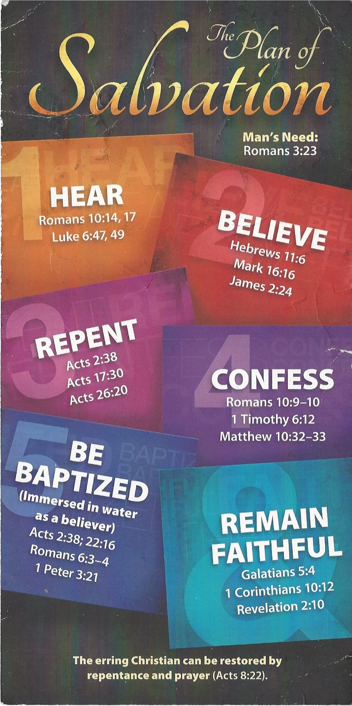
Hear - Romans 10:17 (NIV)
¹⁷ Consequently, faith comes from hearing the message, and the message is heard through the word about Christ.
Believe - Hebrews 11:6 (NIV)
⁶ And without faith it is impossible to please God, because anyone who comes to him must believe that he exists and that he rewards those who earnestly seek him.
Repent - Acts 17:30 (NIV)
³⁰ In the past God overlooked such ignorance, but now he commands all people everywhere to repent.
Confess - 1 Timothy 6:12 (NIV)
¹² Fight the good fight of the faith. Take hold of the eternal life to which you were called when you made your good confession in the presence of many witnesses.
Be Baptized - Acts 2:38 (ESV)
³⁸ And Peter said to them, “Repent and be baptized every one of you in the name of Jesus Christ for the forgiveness of your sins, and you will receive the gift of the Holy Spirit.
Remain Steadfast - Revelation 2:10 (NIV)
¹⁰ Do not be afraid of what you are about to suffer. I tell you, the devil will put some of you in prison to test you, and you will suffer persecution for ten days. Be faithful, even to the point of death, and I will give you life as your victor’s crown.

