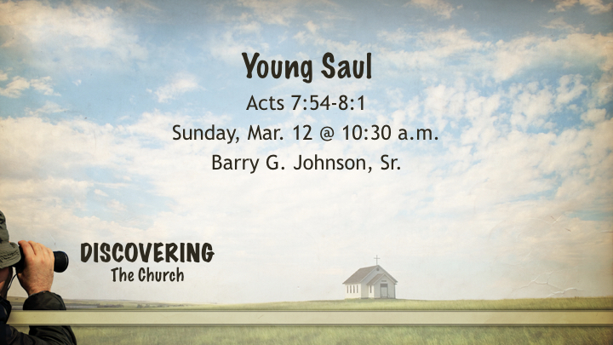
Thesis/ Central Idea:
Young Saul like us can find ourselves standing on the wrong side of righteousness with a need to be converted by the truth and not entrenched in tradition.
Questions:
- How were we like Saul?
- What can change us from Saul to Paul?
- What from Saul does God want to use in Paul?

- We were once like Saul.
1 Corinthians 6:9–11 (ESV)
⁹ Or do you not know that the unrighteous will not inherit the kingdom of God? Do not be deceived: neither the sexually immoral, nor idolaters, nor adulterers, nor men who practice homosexuality, ¹⁰ nor thieves, nor the greedy, nor drunkards, nor revilers, nor swindlers will inherit the kingdom of God. ¹¹ And such were some of you. But you were washed, you were sanctified, you were justified in the name of the Lord Jesus Christ and by the Spirit of our God.

Ephesians 2:1–3 (ESV)
And you were dead in the trespasses and sins ² in which you once walked, following the course of this world, following the prince of the power of the air, the spirit that is now at work in the sons of disobedience— ³ among whom we all once lived in the passions of our flesh, carrying out the desires of the body and the mind, and were by nature children of wrath, like the rest of mankind.

Titus 3:1–3 (ESV)
Remind them to be submissive to rulers and authorities, to be obedient, to be ready for every good work, ² to speak evil of no one, to avoid quarreling, to be gentle, and to show perfect courtesy toward all people. ³ For we ourselves were once foolish, disobedient, led astray, slaves to various passions and pleasures, passing our days in malice and envy, hated by others and hating one another.

- We need to be confronted by Jesus
Romans 12:2 (ESV)
² Do not be conformed to this world, but be transformed by the renewal of your mind, that by testing you may discern what is the will of God, what is good and acceptable and perfect.

1 Peter 1:14 (ESV)
¹⁴ As obedient children, do not be conformed to the passions of your former ignorance,

2 Timothy 2:15 (ESV)
¹⁵ Do your best to present yourself to God as one approved, a worker who has no need to be ashamed, rightly handling the word of truth.

- From Pharisee to Apostle
Philippians 3:3–6 (ESV)
³ For we are the circumcision, who worship by the Spirit of God and glory in Christ Jesus and put no confidence in the flesh— ⁴ though I myself have reason for confidence in the flesh also. If anyone else thinks he has reason for confidence in the flesh, I have more: ⁵ circumcised on the eighth day, of the people of Israel, of the tribe of Benjamin, a Hebrew of Hebrews; as to the law, a Pharisee; ⁶ as to zeal, a persecutor of the church; as to righteousness under the law, blameless.

1 Corinthians 15:9 (ESV)
⁹ For I am the least of the apostles, unworthy to be called an apostle, because I persecuted the church of God.

Ephesians 3:7–10 (ESV)
⁷ Of this gospel I was made a minister according to the gift of God’s grace, which was given me by the working of his power. ⁸ To me, though I am the very least of all the saints, this grace was given, to preach to the Gentiles the unsearchable riches of Christ, ⁹ and to bring to light for everyone what is the plan of the mystery hidden for ages in God, who created all things, ¹⁰ so that through the church the manifold wisdom of God might now be made known to the rulers and authorities in the heavenly places.

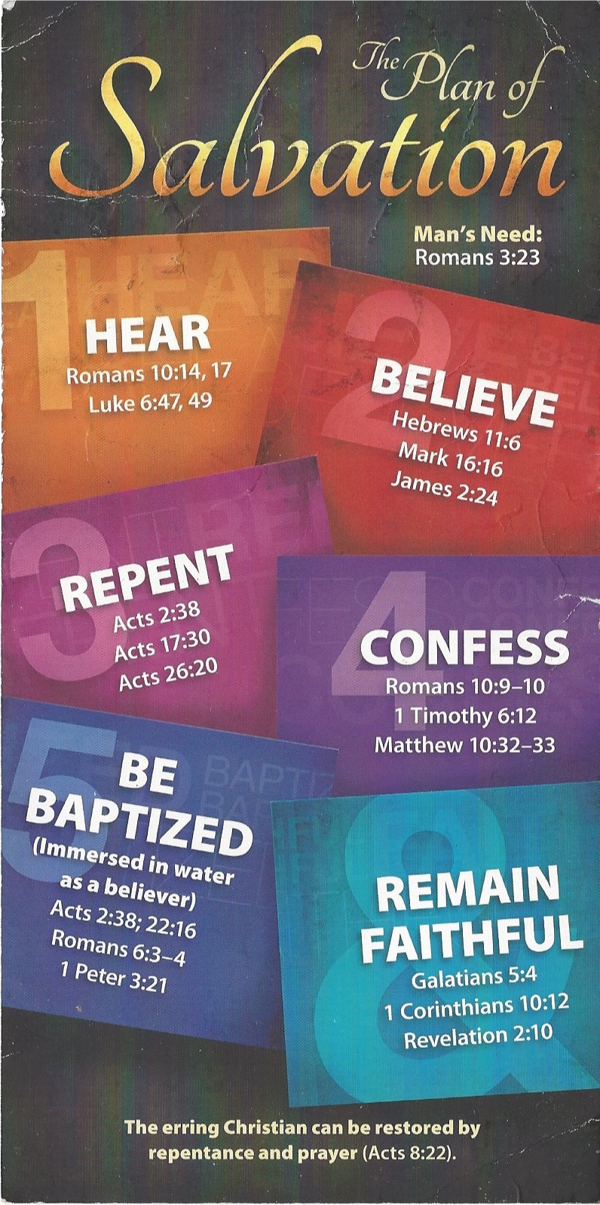
Hear - Romans 10:17 (NIV)
¹⁷ Consequently, faith comes from hearing the message, and the message is heard through the word about Christ.
Believe - Hebrews 11:6 (NIV)
⁶ And without faith it is impossible to please God, because anyone who comes to him must believe that he exists and that he rewards those who earnestly seek him.
Repent - Acts 17:30 (NIV)
³⁰ In the past God overlooked such ignorance, but now he commands all people everywhere to repent.
Confess - 1 Timothy 6:12 (NIV)
¹² Fight the good fight of the faith. Take hold of the eternal life to which you were called when you made your good confession in the presence of many witnesses.
Be Baptized - Acts 2:38 (ESV)
³⁸ And Peter said to them, “Repent and be baptized every one of you in the name of Jesus Christ for the forgiveness of your sins, and you will receive the gift of the Holy Spirit.
Remain Steadfast - Revelation 2:10 (NIV)
¹⁰ Do not be afraid of what you are about to suffer. I tell you, the devil will put some of you in prison to test you, and you will suffer persecution for ten days. Be faithful, even to the point of death, and I will give you life as your victor’s crown.

