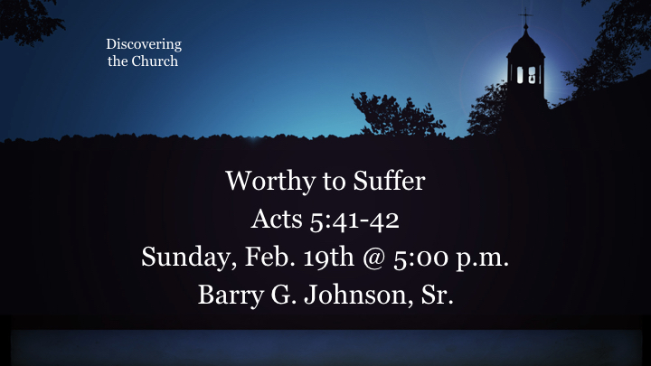
Key Topics: Suffering; Worth; Unworthy

Central Idea/ Theme/ Synopsis:

Only God truly merits honor and praise but he graciously considers those who humbly serve him with wholehearted devotion to be worthy disciples.

- God the Father is worthy of honor and praise
Psalm 145:3 ESV
Great is the LORD, and greatly to be praised,
and his greatness is unsearchable.
See also 2 Sa 22:4; 1 Ch 16:25; Ps 48:1; Re 4:11
- Jesus Christ is worthy of honor and praise
Revelation 5:12 ESV
saying with a loud voice,
“Worthy is the Lamb who was slain,
to receive power and wealth and wisdom and might
and honor and glory and blessing!”
See also Mt 3:17; Mt 17:5; Php 2:9–11; Heb 2:9; Heb 3:3; 2 Pe 1:17; Re 5:9
- People are considered worthy by others
Lk 7:4–5 Note that the centurion did not consider himself to be worthy (Lk 7:7).
See also Ge 39:4; Ge 41:38–40; 1 Sa 16:6; 1 Ki 1:42; Da 1:18–20; Da 2:46–48; Da 3:28–30; Ac 14:11–13
- God considers no person (other than Jesus Christ) to be worthy by nature
Revelation 5:4 ESV
and I began to weep loudly because no one was found worthy to open the scroll or to look into it.
See also Ps 14:3; Ps 143:2; Ec 7:20; Ro 3:10–12; Ro 3:23
- Worthiness, like righteousness, is credited to a person by God
2 Thessalonians 1:11 ESV
To this end we always pray for you, that our God may make you worthy of his calling and may fulfill every resolve for good and every work of faith by his power,
See also Lk 20:35; Ro 2:29; 2 Co 10:18
- Examples of people who are considered worthy by God
- Those who put God first and deny themselves
Matthew 10:37–38 ESV
Whoever loves father or mother more than me is not worthy of me, and whoever loves son or daughter more than me is not worthy of me. And whoever does not take his cross and follow me is not worthy of me.
See also 1 Sa 2:30; Lk 9:62; Ro 12:1–2
- Those who suffer persecution for the sake of Jesus Christ
Acts 5:41 ESV
Then they left the presence of the council, rejoicing that they were counted worthy to suffer dishonor for the name.
See also Mt 5:10–12; 2 Th 1:5; 1 Pe 2:19–20
- Those whose lives show Christlike godliness
Colossians 1:10 ESV
so as to walk in a manner worthy of the Lord, fully pleasing to him: bearing fruit in every good work and increasing in the knowledge of God;
See also 1 Sa 16:7; Eph 4:1–2; 1 Th 2:12; 1 Ti 3:8–9; 1 Ti 3:11; Tt 2:2; Re 3:4
- Those who stand firm for the gospel
Php 1:27; 1 Th 2:4; 2 Ti 2:15
- Those who are faithful in the use of resources which God has given them
Matthew 25:21–23 ESV
His master said to him, ‘Well done, good and faithful servant. You have been faithful over a little; I will set you over much. Enter into the joy of your master.’ And he also who had the two talents came forward, saying, ‘Master, you delivered to me two talents; here, I have made two talents more.’ His master said to him, ‘Well done, good and faithful servant. You have been faithful over a little; I will set you over much. Enter into the joy of your master.’
See also Mt 24:45–47; Lk 19:17; 1 Ti 5:17
- Those who welcome God’s people
Matthew 10:11 ESV
And whatever town or village you enter, find out who is worthy in it and stay there until you depart.
See also Mt 10:41–42; Ro 16:2; 3 Jn 6
- Examples of worthy people
Ge 6:8–9 Noah; Dt 1:36 Caleb; Dt 34:10 Moses; Job 1:8 Job
Da 9:23; Da 10:19 Daniel
Lk 1:28 Mary; Jas 2:23 Abraham

Hear - Romans 10:17 (NIV)
¹⁷ Consequently, faith comes from hearing the message, and the message is heard through the word about Christ.
Believe - Hebrews 11:6 (NIV)
⁶ And without faith it is impossible to please God, because anyone who comes to him must believe that he exists and that he rewards those who earnestly seek him.
Repent - Acts 17:30 (NIV)
³⁰ In the past God overlooked such ignorance, but now he commands all people everywhere to repent.
Confess - 1 Timothy 6:12 (NIV)
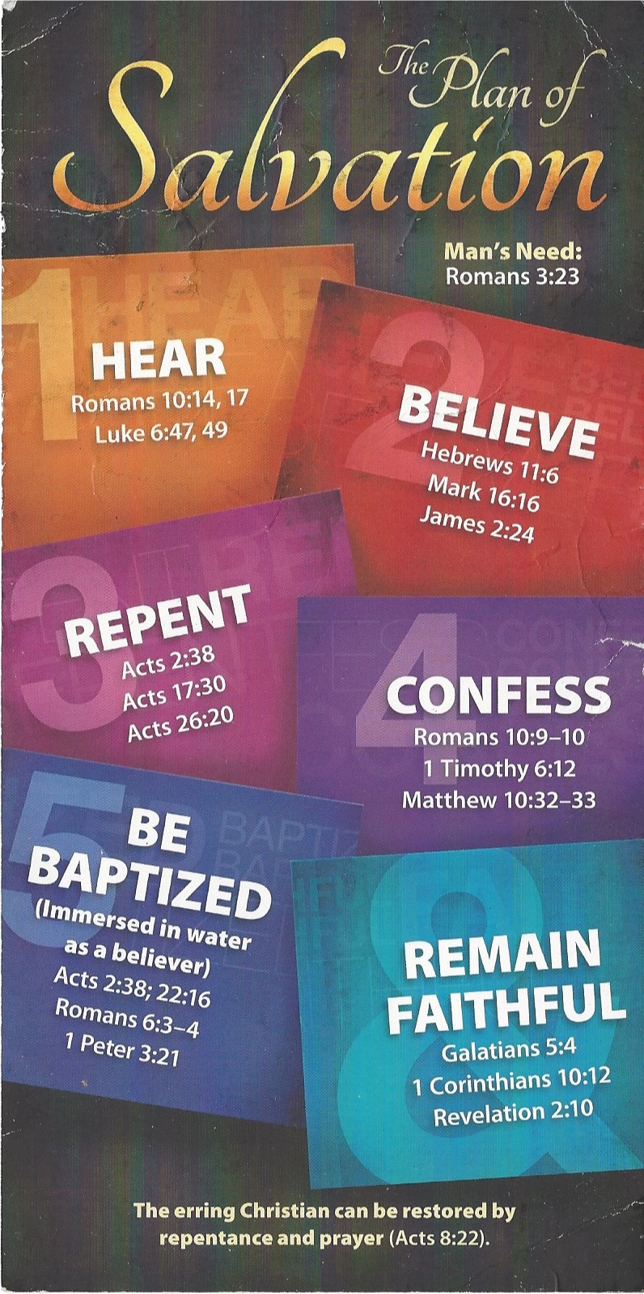
¹² Fight the good fight of the faith. Take hold of the eternal life to which you were called when you made your good confession in the presence of many witnesses.

Be Baptized - Acts 22:16 (NIV)
¹⁶ And now what are you waiting for? Get up, be baptized and wash your sins away, calling on his name.’
Remain Steadfast - Revelation 2:10 (NIV)
¹⁰ Do not be afraid of what you are about to suffer. I tell you, the devil will put some of you in prison to test you, and you will suffer persecution for ten days. Be faithful, even to the point of death, and I will give you life as your victor’s crown.

