Barry G. Johnson, Sr. / www.barrygjohnsonsr.com
Proverbs: The Way of Wisdom / Wisdom; Proverb; Fool / Proverbs 9:1–18
A picture of two women, both extending invitations, one for wisdom and one for folly.
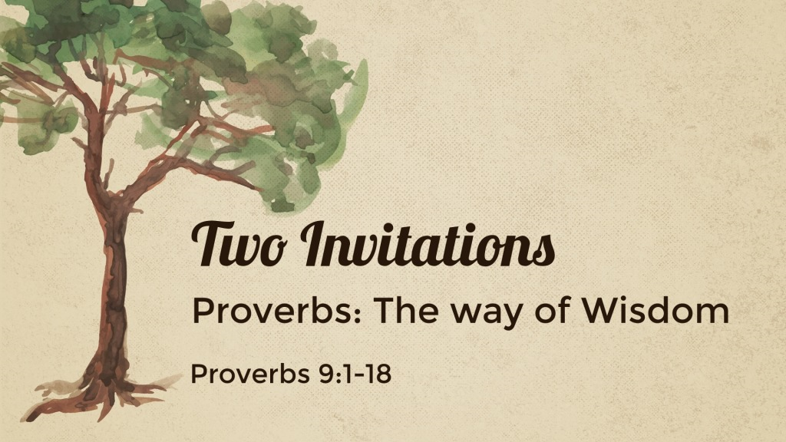

I. THE INVITATION OF LADY WISDOM (9:1-12)

A. HER PREPARATION...
1. Her beautiful home: a large house with pillars - Pro 9:1
2. Her sumptuous feast: meat and wine, a table - Pro 9:2

B. HER PLEA...
1. She wants to be - Pro 9:3
2. She invites the simple and those who lack - Pro 9:4-6
3. Why She won’t invite - Pro 9:7-9

C. HER PROMISE...
1. and understanding - Pro 9:10
2. life - Pro 9:11; cf. 3:2,16
3. To benefit one’s self - Pro 9:12

II. THE INVITATION OF WOMAN FOLLY (9:13-18)

A. HER PREPARATION...
1. She really makes no
2. Instead, she is “loud; she is seductive and knows ” (ESV) - Pro 9:13
3. The Believers’ Bible Commentary describes her as “loudmouthed, , and brazen faced”
Young folks - Check out this sermon

B. HER PLEA...
1. She at the door of her house - Pro 9:14a
2. She sits on a high seat by the places of the city - Pro 9:14b
3. She calls to those who pass by - Pro 9:15-16

C. HER PROMISE...
1. That stolen water is , and bread eaten in secret is pleasant - Pro 9:17
2. The true promise is to the simple lacking understanding - Pro 9:18

Response and Invitation
Romans 10:17 ESV
So faith comes from hearing, and hearing through the word of Christ.
James 2:19 ESV
You believe that God is one; you do well. Even the demons believe—and shudder!
Luke 12:8 ESV
“And I tell you, everyone who acknowledges me before men, the Son of Man also will acknowledge before the angels of God,
Luke 13:3 ESV
No, I tell you; but unless you repent, you will all likewise perish.
Matthew 3:16 ESV
And when Jesus was baptized, immediately he went up from the water, and behold, the heavens were opened to him, and he saw the Spirit of God descending like a dove and coming to rest on him;
1 Corinthians 15:58 ESV
Therefore, my beloved brothers, be steadfast, immovable, always abounding in the work of the Lord, knowing that in the Lord your labor is not in vain.

