Barry G. Johnson, Sr. / General
Discovering the Church / Ignorance; Idol; Idolatry / Acts 17:22–25

A lack of knowledge of God, is inexcusable by Scripture, for God has made his existence, nature and power known to all through creation.
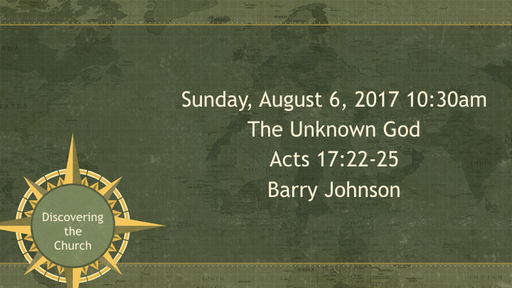

I. Ignorance of God is Inexcusable

A. God is made known through creation
Romans 1:18–20 ESV
For the wrath of God is revealed from heaven against all ungodliness and unrighteousness of men, who by their unrighteousness suppress the truth. For what can be known about God is plain to them, because God has shown it to them. For his invisible attributes, namely, his eternal power and divine nature, have been clearly perceived, ever since the creation of the world, in the things that have been made. So they are without excuse.

B. God revealed himself to Israel
Nehemiah 9:13–14 ESV
You came down on Mount Sinai and spoke with them from heaven and gave them right rules and true laws, good statutes and commandments, and you made known to them your holy Sabbath and commanded them commandments and statutes and a law by Moses your servant.

II. Ignorance of God the Result of Sin and Rebellion

A. Among the Gentiles
Ephesians 4:18–19 ESV
They are darkened in their understanding, alienated from the life of God because of the ignorance that is in them, due to their hardness of heart. They have become callous and have given themselves up to sensuality, greedy to practice every kind of impurity.

B. In Israel
Isaiah 1:2–3 ESV
Hear, O heavens, and give ear, O earth;
for the Lord has spoken:
“Children have I reared and brought up,
but they have rebelled against me.
The ox knows its owner,
and the donkey its master’s crib,
but Israel does not know,
my people do not understand.”

III. God is not Ignorant of Human Sin and Motives
Genesis 6:5 ESV
The Lord saw that the wickedness of man was great in the earth, and that every intention of the thoughts of his heart was only evil continually.
Hebrews 4:13 ESV
And no creature is hidden from his sight, but all are naked and exposed to the eyes of him to whom we must give account.

IV. Human Ignorance of Sin and the Revelation of God

A. The fall brought knowledge of sin
Genesis 3:22 ESV
Then the Lord God said, “Behold, the man has become like one of us in knowing good and evil. Now, lest he reach out his hand and take also of the tree of life and eat, and live forever—”

B. The OT law exposed the nature of sin
Romans 7:7 ESV
What then shall we say? That the law is sin? By no means! Yet if it had not been for the law, I would not have known sin. For I would not have known what it is to covet if the law had not said, “You shall not covet.”

V. Human Ignorance Does Not Excuse Sin

A. By individuals
Leviticus 5:17–19 ESV
“If anyone sins, doing any of the things that by the Lord’s commandments ought not to be done, though he did not know it, …

B. By the nation
Hebrews 9:7 ESV
but into the second only the high priest goes, and he but once a year, and not without taking blood, which he offers for himself and for the unintentional sins of the people.

C. By leaders
Leviticus 4:22–26 ESV
“When a leader sins, doing unintentionally any one of all the things that by the commandments of the Lord his God ought not to be done, …

VI. Ignorance of God and salvation

A. There is no salvation outside Jesus Christ
Acts 4:12 ESV
And there is salvation in no one else, for there is no other name under heaven given among men by which we must be saved.”

B. Believers have a responsibility to remove ignorance of the gospel
Romans 10:14–17 ESV
How then will they call on him in whom they have not believed? And how are they to believe in him of whom they have never heard? And how are they to hear without someone preaching? And how are they to preach unless they are sent? As it is written, “How beautiful are the feet of those who preach the good news!” But they have not all obeyed the gospel. For Isaiah says, “Lord, who has believed what he has heard from us?” So faith comes from hearing, and hearing through the word of Christ.

VII. Ignorance and God’s judgment

A. God’s justice
Luke 12:47–48 ESV
And that servant who knew his master’s will but did not get ready or act according to his will, will receive a severe beating. But the one who did not know, and did what deserved a beating, will receive a light beating. Everyone to whom much was given, of him much will be required, and from him to whom they entrusted much, they will demand the more.

B. God’s judgment falls on all who do not know him
2 Thessalonians 1:8–10 ESV
in flaming fire, inflicting vengeance on those who do not know God and on those who do not obey the gospel of our Lord Jesus. They will suffer the punishment of eternal destruction, away from the presence of the Lord and from the glory of his might, when he comes on that day to be glorified in his saints, and to be marveled at among all who have believed, because our testimony to you was believed.

C. God’s judgment falls severely on those who choose to disobey him
Hebrews 2:2–3 ESV
For since the message declared by angels proved to be reliable, and every transgression or disobedience received a just retribution, how shall we escape if we neglect such a great salvation? It was declared at first by the Lord, and it was attested to us by those who heard,
God’s Plan of Salvation

Hear
Luke 6:47 (ESV)
⁴⁷ Everyone who comes to me and hears my words and does them, I will show you what he is like:
Luke 6:49 (ESV)
⁴⁹ But the one who hears and does not do them is like a man who built a house on the ground without a foundation. When the stream broke against it, immediately it fell, and the ruin of that house was great.”

Believe
Mark 16:16 (ESV)
¹⁶ Whoever believes and is baptized will be saved, but whoever does not believe will be condemned.

Confess
1 Timothy 6:12 (ESV)
¹² Fight the good fight of the faith. Take hold of the eternal life to which you were called and about which you made the good confession in the presence of many witnesses.

Repent
Acts 17:30 (ESV)
³⁰ The times of ignorance God overlooked, but now he commands all people everywhere to repent,

Be Baptized
1 Peter 3:21 (ESV)
²¹ Baptism, which corresponds to this, now saves you, not as a removal of dirt from the body but as an appeal to God for a good conscience, through the resurrection of Jesus Christ,

Remain Steadfast
Revelation 2:10 (ESV)
¹⁰ Do not fear what you are about to suffer. Behold, the devil is about to throw some of you into prison, that you may be tested, and for ten days you will have tribulation. Be faithful unto death, and I will give you the crown of life.

