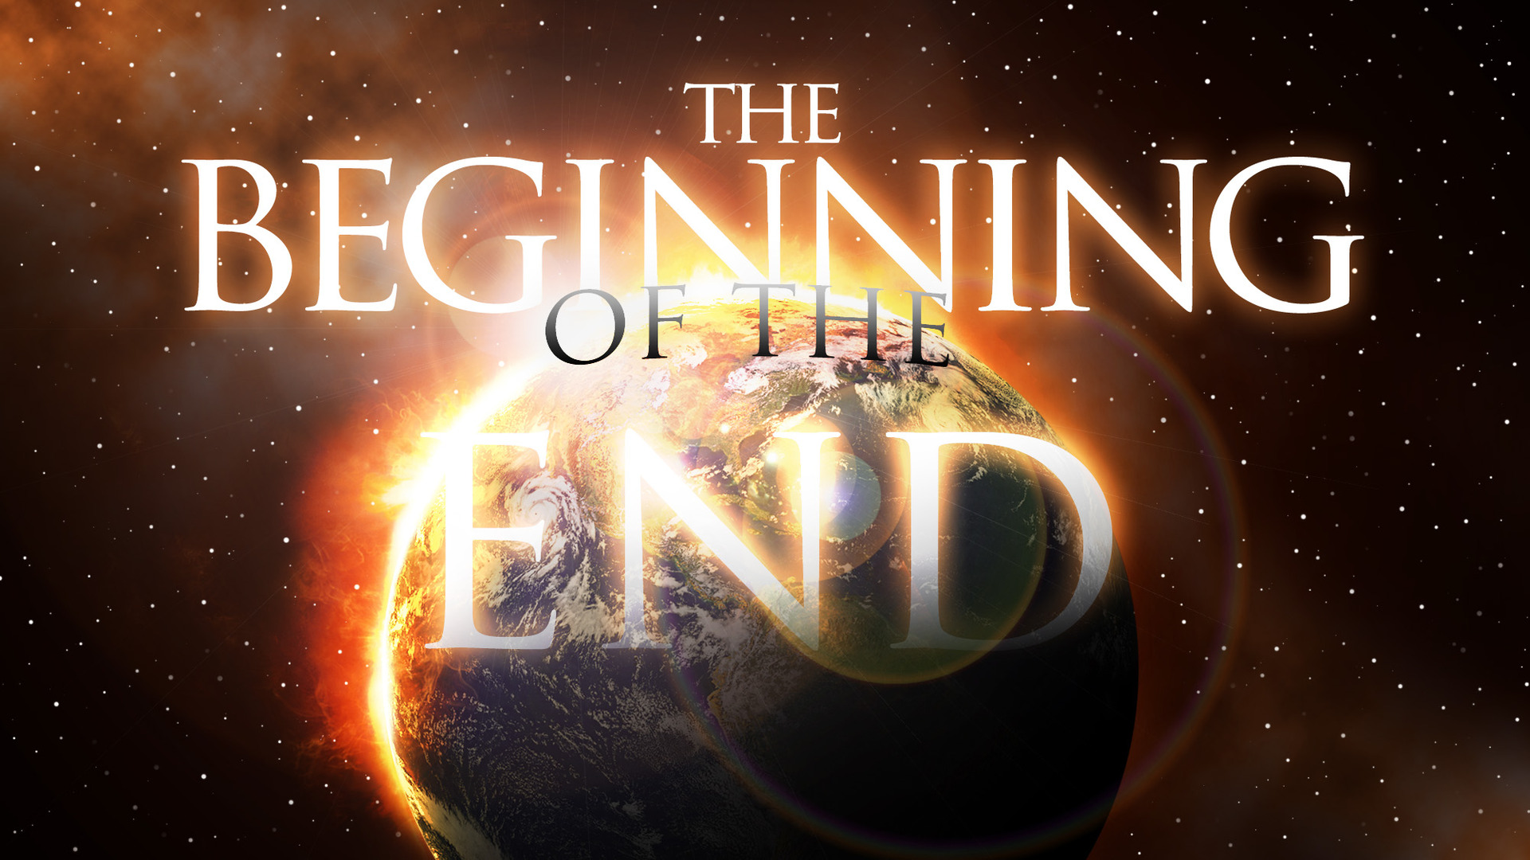
I. THE SETTING OF THE OLIVET DISCOURSE
A. THE WORDS OF JESUS IN THE TEMPLE...
1. His parables depicting Israel’s rejection of Him, and its consequence
a. The parable of the two sons - Mt 21:28-32 (cf. v.31-32)
b. The parable of the wicked vine dressers - Mt 21:33-46 (cf. v.42-45)
c. The parable of the wedding feast - Mt 22:1-14 (cf. v.7-9)
2. His condemnation of the scribes and Pharisees
a. Who would fill up the measure of their fathers’ guilt - Mt 23:29-32
b. Who kill, crucify, scourge, and persecute the prophets, wise men, and scribes He would send to them - Mt 23:33-34
c. Upon whom the blood of all the righteous would come, upon that very generation - Mt 23:35-36
3. His lamentation over Jerusalem
a. The city who kills the prophets and stones those sent to her - Mt 23:37a
b. The city unwilling to accept the love shown to her - Mt 23:37b
c. Whose house would be left desolate - Mt 23:38-39
B. THE PROPHECY OF JESUS ABOUT THE TEMPLE...
1. After his disciples were showing Him the buildings of temple - Mt 24:1
2. Declaring that not one stone would be left upon another - Mt 24:2
C. THE QUESTIONS OF THE DISCIPLES...
1. In Mark’s gospel, two questions are asked - Mk 13:4
a. “When will these things be?”
b. “What will be the sign when all these things will be fulfilled?”
2. In Luke’s gospel, the two questions are similar - Lk 21:7
a. “When will these things be?”
b. “What sign will there be when these things are about to take place?”
3. In Matthew’s gospel, the second question is worded differently - Mt 24:3
a. “When will these things be?”
b. “What will be the sign of Your coming, and of the end of the age?”
4. Observations regarding these questions:
a. Matthew wrote his gospel for a Jewish audience
b. Mark and Luke wrote their gospels to Gentiles

II. THE OLIVET DISCOURSE
A. WHAT WILL “NOT” BE THE SIGN...
1. Be careful that none deceive you, claiming to be the Christ - Mt 24:4-5
2. Don’t be troubled by wars, earthquakes, famines, pestilence - Mt 24:6-8
a. Such things will come, but the end (destruction of the temple) is not yet
b. They are only the beginning of sorrows (not the sign of the end)
3. Anticipate persecution and hard times - Mt 24:9-13
4. The gospel of the kingdom will be preached in all the world - Mt 24:14
a. As a witness to all the nations
b. Then the end (the destruction of the temple) will come
- cf. Co 2:14-17; Ep 2:14-16; He 8:13
-- Was the gospel preached to all nations prior to the destruction of the temple? Note what Paul wrote prior to 70 A.D. - Ro 10:16-18; Co 1:23
B. WHAT WILL BE THE SIGN...
1. The “abomination of desolation” - Mt 24:15; Mk 13:14
a. Standing in the holy place (the holy city Jerusalem)
b. As foretold by Daniel - cf. Dan 9:26-27
2. When you see Jerusalem surrounded by armies - Lk 21:20
a. Luke therefore explains the “abomination of desolation”
b. In 70 A.D., Roman armies surrounded and besieged Jerusalem prior to destroying it and the temple
-- Thus Jesus answers the disciples’ question: “What sign will there be when these things are about to take place?”
C. WHAT TO DO WHEN YOU SEE THE SIGN...
1. Those in Judea are to flee to the mountains - Mt 24:16-22
a. Don’t delay by going to your homes and getting your clothes
b. It will be a difficult time for pregnant and nursing mothers
c. Pray that your flight be not in winter (when travel is difficult) or on the Sabbath (when city gates are closed to travel)
d. For there will be “great tribulation”, though shortened for the elect’s sake
2. Don’t be misled by false christs and false prophets - Mt 24:23-28
a. Even those who show great signs and wonders to deceive
b. For the coming (judgment) of the Son of Man will be like lightning across the sky
- cf. Lk 17:22-24
c. Where the carcass is, there the eagles will be gathered
D. WHAT WILL HAPPEN NEXT...
1. Events to occur “immediately after the tribulation of those days”...
a. Cosmic disturbances - Mt 24:29
b. The sign of the Son of Man will appear in heaven - Mt 24:30
c. The elect will be gathered - Mt 24:31
2. Such events certainly sound like the second coming of Christ, but consider two reasons why they may not be referring to Jesus’ coming at the Last Day...
a. The events were to occur “immediately after the tribulation of those days” (“in those days, after that tribulation”) - Mt 24:29; Mk 13:24
b. The events are similar to those used to foretell God’s judgment of other nations
3. For such reasons, I suggest that even in Mt 24:29-31...
a. Jesus refers to the destruction of Jerusalem
b. Like other Jewish prophets, Jesus uses figurative language to depict:
c. Jewish prophets foretold God’s judgment upon such nations...
E. ADMONITIONS TO BE PREPARED AND PRODUCTIVE...
1. The parable of the fig tree - Mt 24:32-33
2. It would happen before “this generation” passed away - Mt 24:34
3. The words of Jesus will come to pass - Mt 24:35
4. Of that day and hour, only the Father knows - Mt 24:36
5. It will be like the days of Noah - Mt 24:37-39
6. Some will be taken away - Mt 24:40-41
7. Therefore, watch! - Mt 24:42-44
8. The parable of the faithful servant and the wicked servant - Mt 24:45-51

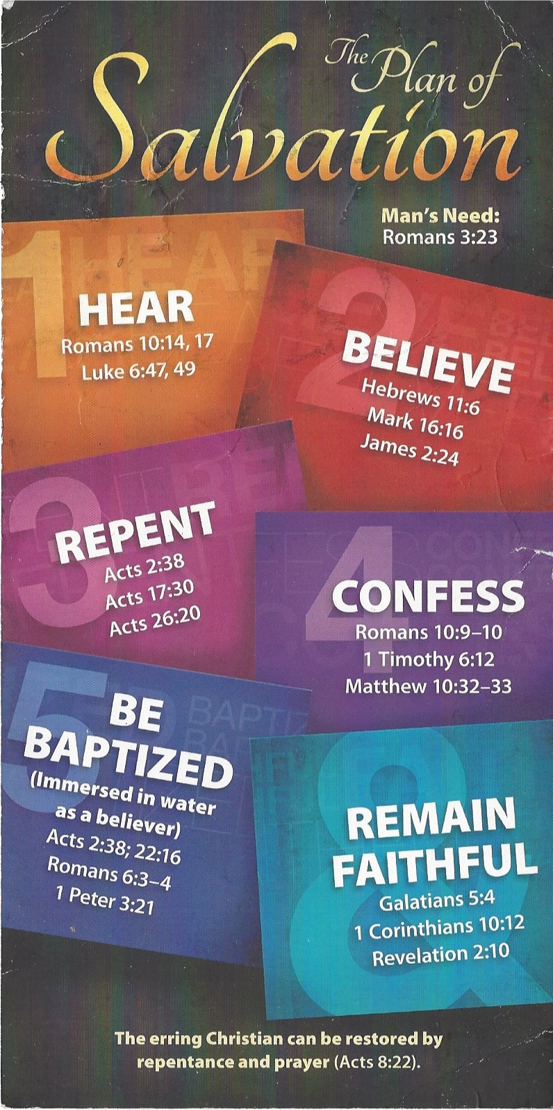
Hear - Romans 10:17 (NIV)
¹⁷ Consequently, faith comes from hearing the message, and the message is heard through the word about Christ.
Believe - Hebrews 11:6 (NIV)
⁶ And without faith it is impossible to please God, because anyone who comes to him must believe that he exists and that he rewards those who earnestly seek him.
Repent - Acts 17:30 (NIV)
³⁰ In the past God overlooked such ignorance, but now he commands all people everywhere to repent.
Confess - Matthew 10:32–33 (NIV)
³² “Whoever acknowledges me before others, I will also acknowledge before my Father in heaven. ³³ But whoever disowns me before others, I will disown before my Father in heaven.
Be Baptized - Acts 22:16 (NIV)
¹⁶ And now what are you waiting for? Get up, be baptized and wash your sins away, calling on his name.’
Remain Steadfast - Revelation 2:10 (NIV)
¹⁰ Do not be afraid of what you are about to suffer. I tell you, the devil will put some of you in prison to test you, and you will suffer persecution for ten days. Be faithful, even to the point of death, and I will give you life as your victor’s crown.

