Barry G. Johnson, Sr. / www.bgjsr22.com
Christian is Reality: All Have Sinned / Sin; Salvation; Realism; Truth / Galatians 3:21–23
Scripture indicates that the world, including human beings and institutions, are imperfect because of the contaminating influence of sin. This influence extends to the household of faith: are prone to sin and weakness.
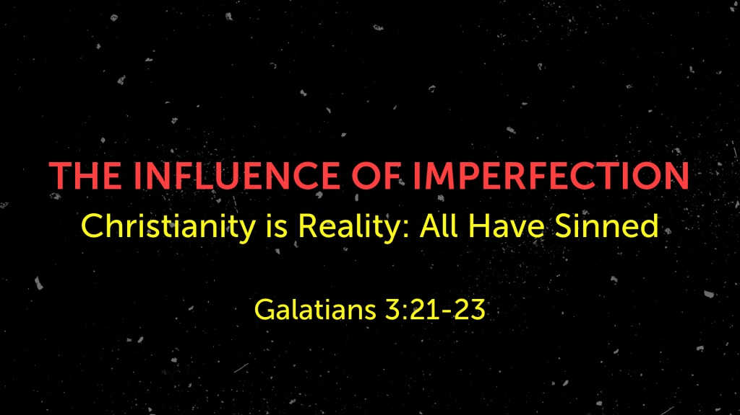
Galatians 3:21–23 ESV
²¹ Is the law then contrary to the promises of God? Certainly not! For if a law had been given that could give life, then righteousness would indeed be by the law. ²² But the Scripture imprisoned everything under sin, so that the promise by faith in Jesus Christ might be given to those who believe.
²³ Now before faith came, we were held captive under the law, imprisoned until the coming faith would be revealed.

The Influence of Imperfection on the Creation
Genesis 3:17–19 ESV
¹⁷ And to Adam he said,
“Because you have listened to the voice of your wife
and have eaten of the tree
of which I commanded you,
‘You shall not eat of it,’
cursed is the ground because of you;
in pain you shall eat of it all the days of your life;
¹⁸ thorns and thistles it shall bring forth for you;
and you shall eat the plants of the field.
¹⁹ By the sweat of your face
you shall eat bread,
till you return to the ground,
for out of it you were taken;
for you are dust,
and to dust you shall return.”

The Influence of Imperfection is Expressed in Death
Psalm 103:15–16 ESV
¹⁵ As for man, his days are like grass;
he flourishes like a flower of the field;
¹⁶ for the wind passes over it, and it is gone,
and its place knows it no more.

The Influence of Imperfection on the Spiritual
Job 4:18 ESV
¹⁸ Even in his servants he puts no trust,
and his angels he charges with error;

The Universal Influence of Imperfection on Humans
Romans 3:23 ESV
²³ for all have sinned and fall short of the glory of God,

The Influence of Imperfection on the Household of Faith

Israel and her leaders

The Christian church and its leaders
2 Corinthians 12:20 ESV
²⁰ For I fear that perhaps when I come I may find you not as I wish, and that you may find me not as you wish—that perhaps there may be quarreling, jealousy, anger, hostility, slander, gossip, conceit, and disorder.

How to Overcome Imperfection

Hear God’s Word - Romans 10:17

Believe God’s Word - Hebrews 11:6

Repent of your Sins - Luke 13:3

Confess Jesus as the Son of God - 1 John 4:3

Be Baptized for the Remission of Sin - Acts 22:16

Remain Steadfast for Life - 1 Corinthians 15:58

