Barry G. Johnson, Sr. / General
Judges: A Modern Day Spiral / Corrupt; Corruptible; Corruption; Restoration; Foundation / Judges 18:1–6
As people we compound our errors by making decisions from previous bad decisions.

Judges 18:1–6 ESV
¹ In those days there was no king in Israel. And in those days the tribe of the people of Dan was seeking for itself an inheritance to dwell in, for until then no inheritance among the tribes of Israel had fallen to them. ² So the people of Dan sent five able men from the whole number of their tribe, from Zorah and from Eshtaol, to spy out the land and to explore it. And they said to them, “Go and explore the land.” And they came to the hill country of Ephraim, to the house of Micah, and lodged there. ³ When they were by the house of Micah, they recognized the voice of the young Levite. And they turned aside and said to him, “Who brought you here? What are you doing in this place? What is your business here?” ⁴ And he said to them, “This is how Micah dealt with me: he has hired me, and I have become his priest.” ⁵ And they said to him, “Inquire of God, please, that we may know whether the journey on which we are setting out will succeed.” ⁶ And the priest said to them, “Go in peace. The journey on which you go is under the eye of the Lord.”

I. Wickedness of Men Greatly Increase on the Earth
Genesis 6:5–8 ESV
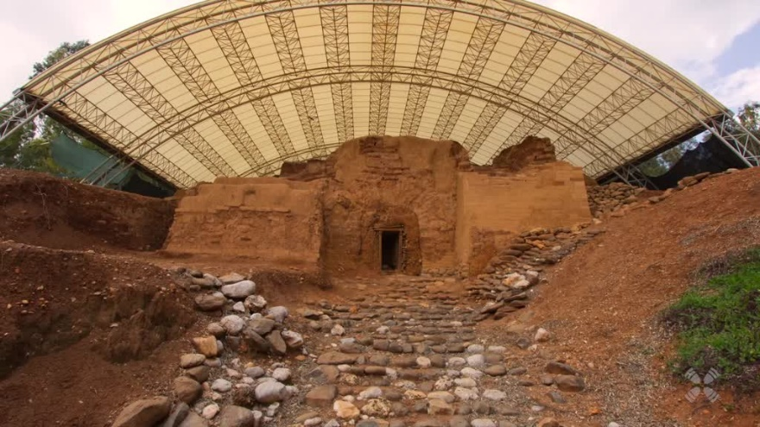
⁵ The Lord saw that the wickedness of man was great in the earth, and that every intention of the thoughts of his heart was only evil continually. ⁶ And the Lord regretted that he had made man on the earth, and it grieved him to his heart. ⁷ So the Lord said, “I will blot out man whom I have created from the face of the land, man and animals and creeping things and birds of the heavens, for I am sorry that I have made them.” ⁸ But Noah found favor in the eyes of the Lord.
Figure 1 – Dan click on this graphic to see a short video
Psalm 14:1–4 ESV
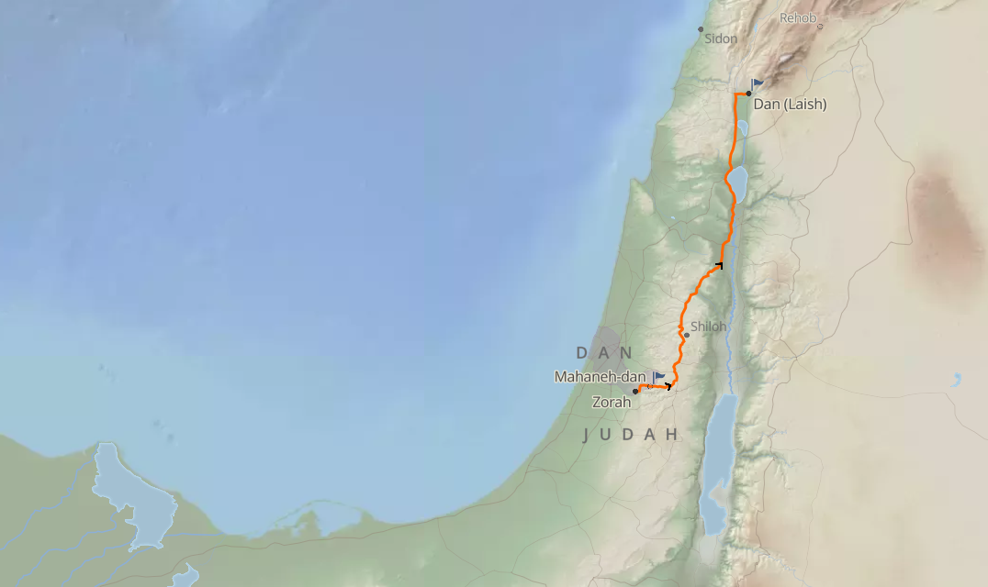
¹ The fool says in his heart, “There is no God.”
They are corrupt, they do abominable deeds;
there is none who does good.
² The Lord looks down from heaven on the children of man,
to see if there are any who understand,
who seek after God.
³ They have all turned aside; together they have become corrupt;
there is none who does good,
not even one.
⁴ Have they no knowledge, all the evildoers
who eat up my people as they eat bread
and do not call upon the Lord?
Figure 2 - Danites capture a city and choose a priest

II. Faulty Foundations
Judges 17:7–13 ESV
⁷ Now there was a young man of Bethlehem in Judah, of the family of Judah, who was a Levite, and he sojourned there. ⁸ And the man departed from the town of Bethlehem in Judah to sojourn where he could find a place. And as he journeyed, he came to the hill country of Ephraim to the house of Micah. ⁹ And Micah said to him, “Where do you come from?” And he said to him, “I am a Levite of Bethlehem in Judah, and I am going to sojourn where I may find a place.” ¹⁰ And Micah said to him, “Stay with me, and be to me a father and a priest, and I will give you ten pieces of silver a year and a suit of clothes and your living.” And the Levite went in. ¹¹ And the Levite was content to dwell with the man, and the young man became to him like one of his sons. ¹² And Micah ordained the Levite, and the young man became his priest, and was in the house of Micah. ¹³ Then Micah said, “Now I know that the Lord will prosper me, because I have a Levite as priest.”

III. Making Decisions from Bad Premise
Judges 18:22–31 ESV
²² When they had gone a distance from the home of Micah, the men who were in the houses near Micah’s house were called out, and they overtook the people of Dan. ²³ And they shouted to the people of Dan, who turned around and said to Micah, “What is the matter with you, that you come with such a company?” ²⁴ And he said, “You take my gods that I made and the priest, and go away, and what have I left? How then do you ask me, ‘What is the matter with you?’ ” ²⁵ And the people of Dan said to him, “Do not let your voice be heard among us, lest angry fellows fall upon you, and you lose your life with the lives of your household.” ²⁶ Then the people of Dan went their way. And when Micah saw that they were too strong for him, he turned and went back to his home.
²⁷ But the people of Dan took what Micah had made, and the priest who belonged to him, and they came to Laish, to a people quiet and unsuspecting, and struck them with the edge of the sword and burned the city with fire. ²⁸ And there was no deliverer because it was far from Sidon, and they had no dealings with anyone. It was in the valley that belongs to Beth-rehob. Then they rebuilt the city and lived in it. ²⁹ And they named the city Dan, after the name of Dan their ancestor, who was born to Israel; but the name of the city was Laish at the first. ³⁰ And the people of Dan set up the carved image for themselves, and Jonathan the son of Gershom, son of Moses, and his sons were priests to the tribe of the Danites until the day of the captivity of the land. ³¹ So they set up Micah’s carved image that he made, as long as the house of God was at Shiloh.

God’s Plan of Salvation

Hear
Romans 10:17 ESV
So faith comes from hearing, and hearing through the word of Christ.

Believe
1 Corinthians 1:21 ESV
For since, in the wisdom of God, the world did not know God through wisdom, it pleased God through the folly of what we preach to save those who believe.

Confess
Philippians 2:9–11 ESV
Therefore God has highly exalted him and bestowed on him the name that is above every name, so that at the name of Jesus every knee should bow, in heaven and on earth and under the earth, and every tongue confess that Jesus Christ is Lord, to the glory of God the Father.

Repent
Luke 13:3 ESV
No, I tell you; but unless you repent, you will all likewise perish.

Be Baptized
Acts 2:41 ESV
So those who received his word were baptized, and there were added that day about three thousand souls.

Remain Faithful
Revelation 2:10 ESV
Do not fear what you are about to suffer. Behold, the devil is about to throw some of you into prison, that you may be tested, and for ten days you will have tribulation. Be faithful unto death, and I will give you the crown of life.
My Decision Today
- I would like to be baptized today
- I would like to renew my life to Christ
- I would like to learn more about Jesus and the Bible
What are my next steps?
- Come forward to be baptized
- Request a Bible Study to learn more
- Attend Bible Class to grow and mature
- Find a place to serve others

