Barry G. Johnson, Sr. / www.barrygjohnsonsr.com
Judges: A Modern Day Religious Spiral? / Test; Testing; Consequence; War / Judges 3:1–6
We are tested, and it is confirmed where we stand with the Lord, reaping the consequences of our actions.

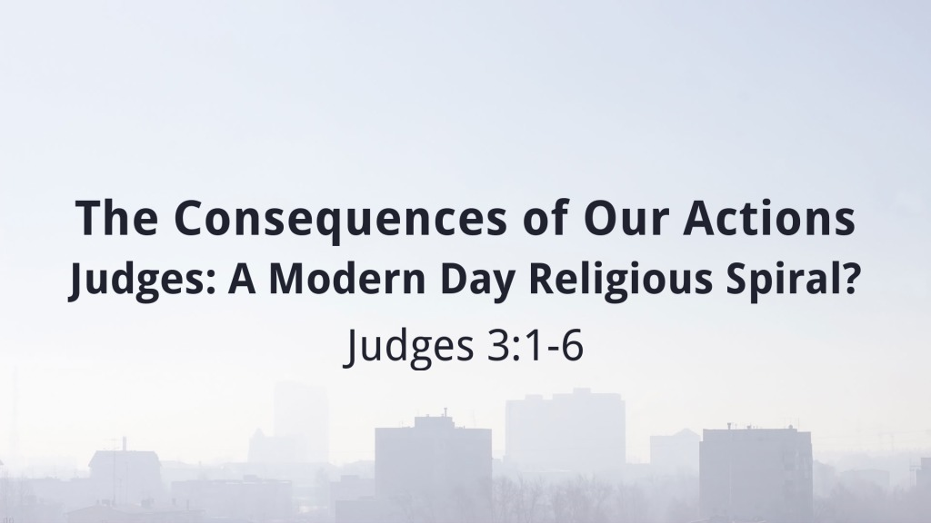I. Nature of the Test

A. The test of war
Deuteronomy 13:3 ESV
³ you shall not listen to the words of that prophet or that dreamer of dreams. For the Lord your God is testing you, to know whether you love the Lord your God with all your heart and with all your soul.
Luke 2:35 ESV
³⁵ (and a sword will pierce through your own soul also), so that thoughts from many hearts may be revealed.”
1 John 2:19 ESV
¹⁹ They went out from us, but they were not of us; for if they had been of us, they would have continued with us. But they went out, that it might become plain that they all are not of us.
2 Corinthians 13:5–7 ESV
⁵ Examine yourselves, to see whether you are in the faith. Test yourselves. Or do you not realize this about yourselves, that Jesus Christ is in you?—unless indeed you fail to meet the test! ⁶ I hope you will find out that we have not failed the test. ⁷ But we pray to God that you may not do wrong—not that we may appear to have met the test, but that you may do what is right, though we may seem to have failed.

B. Building experience
Hebrews 12:6 ESV
⁶ For the Lord disciplines the one he loves,
and chastises every son whom he receives.”
Ephesians 6:12 ESV
¹² For we do not wrestle against flesh and blood, but against the rulers, against the authorities, against the cosmic powers over this present darkness, against the spiritual forces of evil in the heavenly places.

C. Mountain Strongholds
Matthew 17:20 ESV
²⁰ He said to them, “Because of your little faith. For truly, I say to you, if you have faith like a grain of mustard seed, you will say to this mountain, ‘Move from here to there,’ and it will move, and nothing will be impossible for you.”

II. Purpose of the Test

A. To inform about the Lord
Judges 2:10 ESV
¹⁰ And all that generation also were gathered to their fathers. And there arose another generation after them who did not know the Lord or the work that he had done for Israel.

B. To overcome sin
Romans 7:23 ESV
²³ but I see in my members another law waging war against the law of my mind and making me captive to the law of sin that dwells in my members.

C. To trust in God’s ways
2 Corinthians 10:3 ESV
³ For though we walk in the flesh, we are not waging war according to the flesh.

D. To expel sin
1 Peter 2:11 ESV
¹¹ Beloved, I urge you as sojourners and exiles to abstain from the passions of the flesh, which wage war against your soul.

III. Results of the Test

A. Failure
Deuteronomy 7:3–4 ESV
³ You shall not intermarry with them, giving your daughters to their sons or taking their daughters for your sons, ⁴ for they would turn away your sons from following me, to serve other gods. Then the anger of the Lord would be kindled against you, and he would destroy you quickly.
Deuteronomy 7:5 ESV
⁵ But thus shall you deal with them: you shall break down their altars and dash in pieces their pillars and chop down their Asherim and burn their carved images with fire.

B. Success
John 14:21 ESV
²¹ Whoever has my commandments and keeps them, he it is who loves me. And he who loves me will be loved by my Father, and I will love him and manifest myself to him.”
1 Corinthians 11:19 ESV
¹⁹ for there must be factions among you in order that those who are genuine among you may be recognized.
Hear - Believe - Repent - Confess - Be Baptized - Be Faithful
Romans 10:17 ESV
¹⁷ So faith comes from hearing, and hearing through the word of Christ.
John 20:31 ESV
³¹ but these are written so that you may believe that Jesus is the Christ, the Son of God, and that by believing you may have life in his name.
Luke 13:3 ESV
³ No, I tell you; but unless you repent, you will all likewise perish.
Romans 10:9–10 ESV
⁹ because, if you confess with your mouth that Jesus is Lord and believe in your heart that God raised him from the dead, you will be saved. ¹⁰ For with the heart one believes and is justified, and with the mouth one confesses and is saved.
Colossians 2:12 ESV
¹² having been buried with him in baptism, in which you were also raised with him through faith in the powerful working of God, who raised him from the dead.
Acts 11:23 ESV
²³ When he came and saw the grace of God, he was glad, and he exhorted them all to remain faithful to the Lord with steadfast purpose,

